New Registration and student dashboard



### **User Manual for Login/Registration Screen**

#### **Purpose:**

This screen serves as the entry point for users to log in or register for the platform. It is designed for returning students, teachers, coordinators, and new users looking to register.

### **Components:**

#### **1. Logo and Branding:**

* Displays the platform logo and tagline for easy identification.
* Adds a colorful, friendly design for an engaging user experience.

#### **2. Login Section:**

* **Sign in with ManaBadi ID:**
  + Button for existing users (students, teachers, coordinators) to log in using their ManaBadi credentials.
* **Recover Password?**
  + Link to help users recover their forgotten password.
  + Clicking it will redirect to a password recovery process.

#### **3. New Registration Section:**

* **New Student Registration:**
  + Button for new students to create an account.
  + Clicking this will open the registration form to input student details.

#### **4. Help Section:**

* **Help Video for Sign In/Registration:**
  + Link to a video tutorial that guides users through the login and registration process.
* **Contact Us:**
  + Phone Support: 1 (844) 626-BADI (2234)
  + Email Support: support@manabadi.siliconandhra.org

### **How to Use This Screen:**

1. **Returning Users:**
   * Click on "Sign in with ManaBadi ID."
   * Enter your username and password.
   * Press the login button to access your account.
2. **Forgot Password:**
   * Click on the "Recover Password?" link.
   * Follow the steps to reset your password using your registered email.
3. **New Users:**
   * Click on the "New Student Registration" button.
   * Fill out the registration form with accurate details.
   * Submit the form to create a new account.
4. **Help and Support:**
   * Watch the help video for guidance.
   * Contact support via the provided phone number or email for further assistance.

**New Registration:**

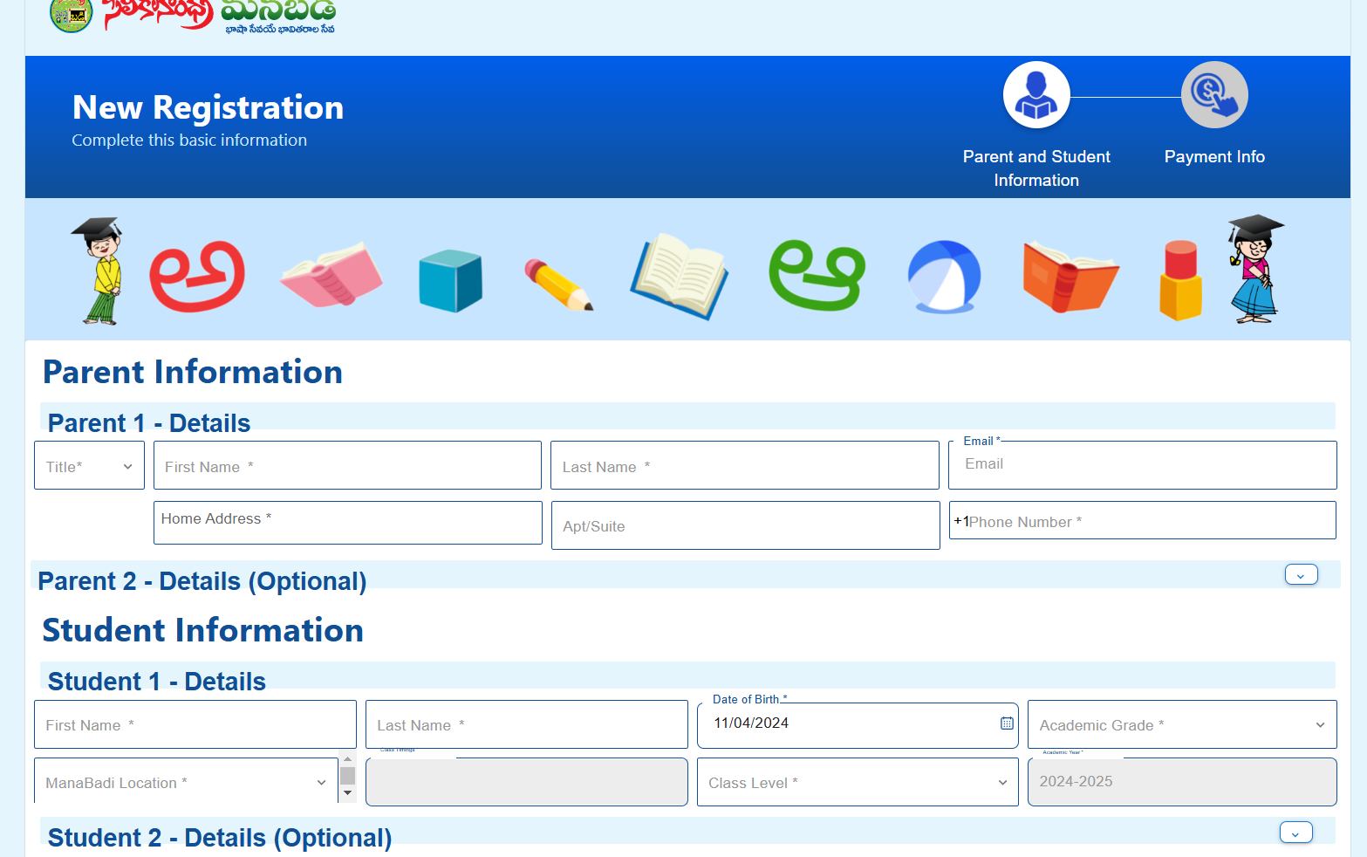

The Registration section enables a new user to create an account in the web application by gathering essential information through two sections: Parent and Student. In the Parent section, details such as the title, first and last names of parents, phone number, and address are collected. The Student section captures essential information, including the student's first name, last name, date of birth, academic grade, Manabadi location, and Manabadi class level.

Each field includes validations, with mandatory fields marked by a star (*). Data-specific validations are applied, and any incorrect input or missing required fields will trigger validation error messages.

**Validation for each field:**

**Parent Information:** Parent 1 information is mandatory to complete registration

**Title:** The Title field is a required field and must be filled out before the registration can proceed.

* Mr.
* Mrs.
* Ms.
* Miss.

**First and last name:** The First and Last Name field is required and must be filled out to proceed with the registration.The First Name must only contain alphabetic characters (A-Z, a-z).Special characters, numbers, and symbols are not allowed.

**Email:** The Parent Email field is required and must be filled out to proceed with the registration.The email must be in a valid format (e.g., [user@example.com](mailto:user@example.com)).

The email address must not already be registered in the system. If a user attempts to use an email that is already associated with an existing account of students an error message should be displayed like “**This email address is already registered”**.

**If a parent is already registered as a teacher or coordinator using their Gmail account, they can use the same email for student registration. Similarly, if the email was used for student registration, it can be used for teacher or coordinator registration. However, the same email cannot be used for new registrations in subsequent years.**

**Home Address:** The Home Address field is required and must be filled out to proceed with the registration.Users must select an address from the Google suggested addresses after typing their address.

If the user does not select an address from the Google suggestions “Error message will popup”

**"Address is invalid. Please select an address from the Google suggested list."**

**Apt/suite:** The 'Apt' or 'Suite' field is not mandatory, but if a full address is required to receive materials from the school, any apartment or suite number should be included in the address.

**Phone Number:** The phone number field is mandatory for users from the USA and Canada and must be formatted correctly. The accepted format should conform to standard North American numbering conventions, ensuring that the number includes the area code and is displayed as +1 (XXX) XXX-XXXX. If the phone number is not in the correct format, a validation error message will be displayed, prompting the user to enter a valid phone number.

**This information will be helpful for password recovery. Users must provide a valid phone number, which will be used to send recovery links. If the phone number is linked to an email account, recovery links will be sent to that registered email. Ensuring users can securely regain access to their accounts if they forget their passwords.**

**Note: Entering information for Parent 2 is optional. However, once any field is filled out (e.g., title, first name), all other fields—such as last name, email, and phone number—become mandatory.**

**Student Information:**

The Student Information section gathers essential details about the student, such as the first name, middle name, last name, date of birth, and academic grade etc. These fields include validations.

**First Name and Last Name:** These are required fields used to identify the student. Both fields are validated to ensure they do not contain special characters or numbers.

**Additionally, we have implemented validation for the first and last names in sibling accounts.**

**the First Name cannot be identical to the sibling's First Name, while the Last Name must match the sibling's Last Name.**

**If parents register siblings at the same time, they will receive a sibling discount, which will be displayed on the payment page. For families with more than two children, parents must first complete the registration for the first two students and set up a password using the link in the welcome email to log in to the student dashboard. From there, they can add additional siblings.**

**Date of Birth (DOB)**: This field records the student’s birthdate, which is used to calculate their age. Based on the age, the appropriate **Manabadi class level** will be displayed, ensuring the student is placed in the correct academic category.

**Academic Grade**: Indicates the student's current academic level.

**Manabadi Location:** Based on the home address, the nearest Manabadi locations will be displayed. A validation is in place to ensure that if there is no Manabadi location within 20 miles, the online Manabadi location(Intinta manabad) will be shown at the top as the primary option for selection.

**Class Timings:** Class timings will be displayed based on the selected location.

**Manabadi class level:** The Manabadi class level will be displayed based on the student's age and the base courses(Balabadi-I,Balabadi-II Pravesam Telugu 1) available at the selected Manabadi location. Courses appropriate to the student's age will be shown under the Manabadi class level options.

**Course selection is based on the child’s age:**

* **BalaBadi-I** is available for children aged between **4 to 6 years**.
* **BalaBadi-II** is available for children aged **above 6 years but below 7 years**.
* **Pravesam is available for children age 6 years**
* **Telugu 1 is available for 6 and above and we have some more validations to see Telugu 1**

**Validations:**

* **In New registration or Spot registration, If a child is 6 years old then he/she will see BalaBadi-II and Pravesam courses to enroll. If a child age is 7 years and above then he/she will see only Pravesam**
* **Additional validations are in place for displaying FLC courses. FLC courses are only available at specific locations and require certain criteria to be met for the Telugu 1 course to appear under the Manabadi course level. The following conditions must be fulfilled: the student must be over 6 years of age, the academic grade must be 7 or above, and the selected Manabadi location must offer FLC courses. Only when these conditions are met will the Telugu 1 FLC course be displayed.**

**Academic year:** By defaults current academic year will display

**Click save and continue**

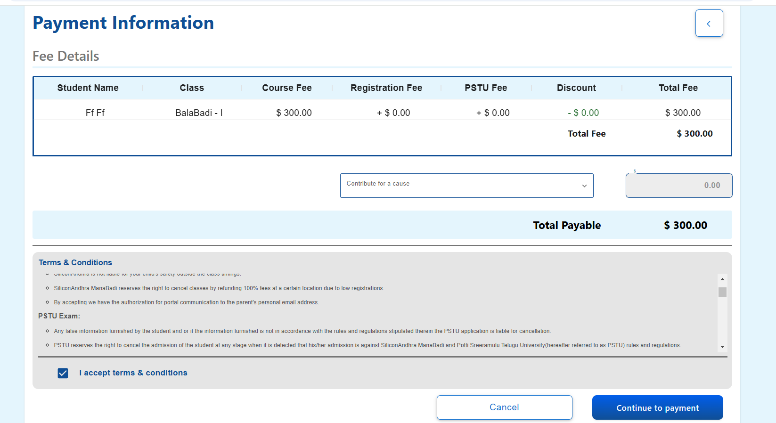

**On the payment page, parents can view the fee details and have the option to make a donation by selecting a contribution cause and entering a donation amount is mandatory once we select contribution for cause. They must then check the terms and conditions acceptance box to proceed. Once ready, they can continue to the PayPal page to complete the payment.**

**On the PayPal payment page, there are two options for completing the payment: one is through a PayPal account, and the other one is via credit or debit card.**

**There is a validation in place to ensure that if parents are paying with a credit or debit card and enter their PayPal-registered email ID, the payment gateway provides the option to complete the payment as a guest without logging into a PayPal account.**

**Once the payment is completed, parents will see a 'Registration Successful' message and receive a welcome email. The email will include details for all registered students, such as their Manabadi email, registered course, location, coordinator details, class timings, and a link to set a password for accessing the student dashboard and so on.**

**Student Dashboard:**

As a returning student, the system should allow me to access the portal using my student MB email

**Recovery Password:** If a parent forgets their password and clicks on "Recover Password," the system will use the student's phone number, Parent email, and Manabadi email to send a recovery link. If any of these (phone number, Parent email, or Manabadi email) are linked to the account, the recovery link will be sent to the associated registered email. This ensures a secure way for parents to regain access to their accounts.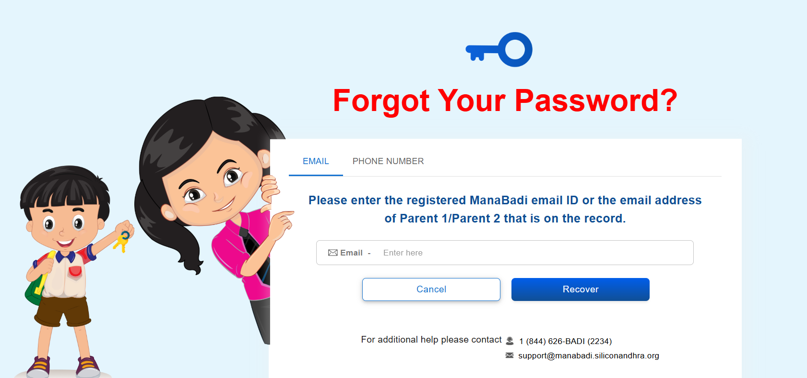

**The reset password link is valid for one year unless it is used. Once the link has been used, it will no longer be valid for resetting the password.**

As a student/parent, should be able to view the complete details of the student and their siblings. This will help parents monitor academic progress, attendance, and other important information in one place.

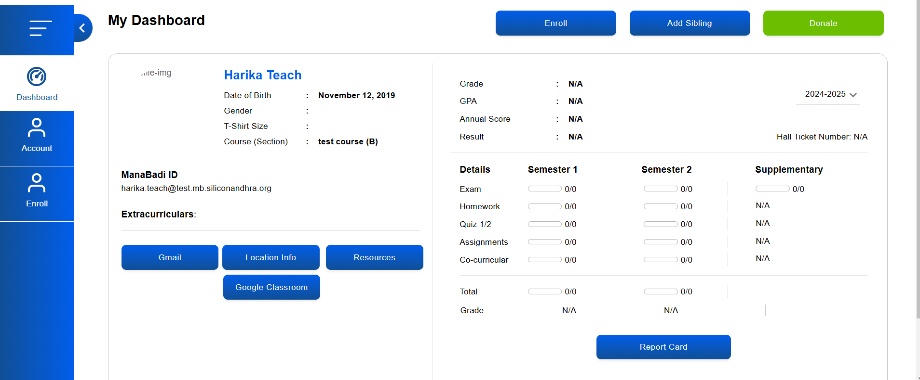

**Student Dashboard Overview**:  
Once logged into the student dashboard, users will see the following options:

* **Enroll**
* **Add Sibling**
* **Donation**
* **Student Details**

**Enrollment Button Functionality:** The "Enroll" button should be highlighted and active only when the registration dates are open, and the student's results are recorded as either "Pass" or "Fail."

**Course Enrollment Validation**: For courses like  **Prasunam, Prakasam, Pramodam,** and **Prabhasam**, the system should validate that the student has completed and passed any required prerequisite courses before allowing enrollment.

* When a student clicks on the **"Enroll"** button, they will be redirected to a new page displaying a pre-populated form of student details.
* The form will include editable fields for student .
* Students can modify the Parent details directly on the enrollment form if needed.

The form will pre-populate the following student information, which will be editable and some non editable:

* **First Name- Non editable**
* **Middle Name** (optional, not a mandatory field)-**Non editable**
* **Last Name- Non editable**
* **Date of Birth (DOB)- Non editable**
* **Gender-Editable**
* **Extracurricular Activities-Editable**
* **Location-Editable**
* **T-shirt Size-Editable**
* **Academic Grade-Editable**
* **Academic School-Editable**
* **Academic Year**: Automatically filled based on the current academic year and is non-editable.
* **Class Level**:
* If the student has **passed** their current level, the form will pre-select the next available course. If multiple courses are possible, a dropdown list will appear for the student to choose.
* If the student has **failed**, the form will default to the same course with no other options in the dropdown.

**Add sibling :** The Add Sibling feature in the Student Dashboard allows users to register a sibling by providing the following details:

1. First Name: A mandatory field to input the sibling’s first name.**the First Name cannot be identical to the sibling's First Name,**
2. Middle Name: This field is optional and not mandatory.
3. Last Name: A required field to specify the sibling’s last name.**while the Last Name must match the sibling's Last Name.**
4. Date of Birth (DOB): A mandatory field to capture the sibling’s birthdate.
5. Gender: A required field to identify the sibling's gender.
6. Extracurricular Activities: This is also a required field to record the sibling's interests and activities.
7. Location: A mandatory field to specify the sibling's location.
8. T-shirt Size: This field must be filled.
9. Academic Grade: A required field that specifies the sibling’s current academic level.
10. Academic School: A mandatory field to mention the sibling’s school.
11. Academic Year: This field is auto-filled based on the current academic year and is non-editable.
12. Class Level: Displays the sibling’s class level based on their age and academic grade.

**Course selection is based on the child’s age:**

* **BalaBadi-I** is available for children aged between **4 to 6 years**.
* **BalaBadi-II** is available for children aged **above 6 years but below 7 years**.

**Additional validations are in place for displaying FLC courses. FLC courses are only available at specific locations and require certain criteria to be met for the Telugu 1 course to appear under the Manabadi course level. The following conditions must be fulfilled: the student must be over 6 years of age, the academic grade must be 7 or above, and the selected Manabadi location must offer FLC courses. Only when these conditions are met will the Telugu 1 FLC course be displayed.**

In the **Student Dashboard**, the **left-side** panel displays key details about the student, including:

1. **Student Details**:
   * Name
   * Date of Birth (DOB)
   * Class/section
   * Gender
   * Profile Image
   * T Shirt Size
   * Extracurricular Activities
   * Student Manabadi Email
2. **Actionable Buttons**: Gmail Account
   * A button to log in to the student’s **Manabadi Gmail account**.
   * A button to view the student’s **Location Information**:
     + Clicking this tab shows the **Location Name**, assigned **Teacher**, and **LC (Location Coordinator)** details.
3. **Resources Tab**:
   * Provides access to **Registered Course Resources** for the current academic year.
   * Includes access to **Resources from Previous Courses**.
4. **Google Classroom Tab**:
   * Clicking this tab navigates the user directly to the **Google Classroom** for the student’s courses.

On the **right side** of the Student Dashboard, the following academic performance details are displayed:

1. **Grade**: Displays the student's grade (e.g…A).
2. **GPA**: Shows the student’s current GPA.
3. **Annual Score**: Indicates the student’s annual percentage score (e.g., 94%).
4. **Result**: Displays the overall academic result (e.g., Pass).
5. **Academic Year**: Shows the current academic year (e.g., 2024–2025).
6. **Hall Ticket Number**: Displays the student’s hall ticket number (if applicable). If unavailable, it will show as "N/A."

The student's marks are displayed semester-wise, allowing users to view the grades for each semester. Additionally, the marks section includes the semester-wise grades, offering a clear breakdown of the student's performance over different academic periods.

In the student dashboard, there is a "Report Card" button. When clicked, it displays the student's grades, GPA, annual score, result, semester-wise marks, hall ticket number (if available, otherwise marked as N/A), and the total weeks of attendance. Additionally, parents can print the report with all the detailed information provided.

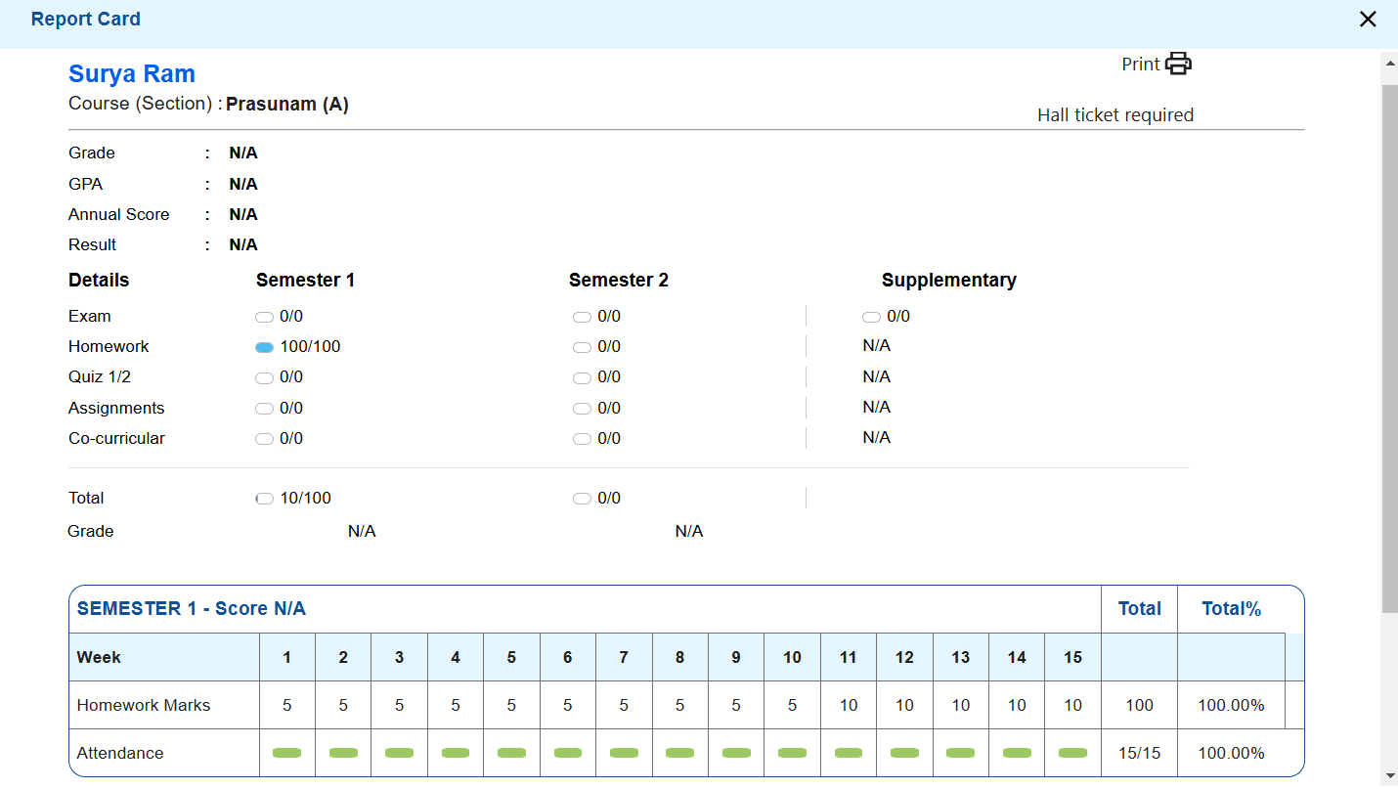

**Donate:** Donate” button located at the top right of the Student Dashboard is clicked, a donation pop-up screen will be displayed.

In the **donation pop-up screen**, if there are siblings in the student's account, the **“Donation from ………”** dropdown will be enabled, allowing the student to select either their name or a sibling's name. If there is only one student ID, the field will directly show **“Donation for {student name}”** without any dropdown options.

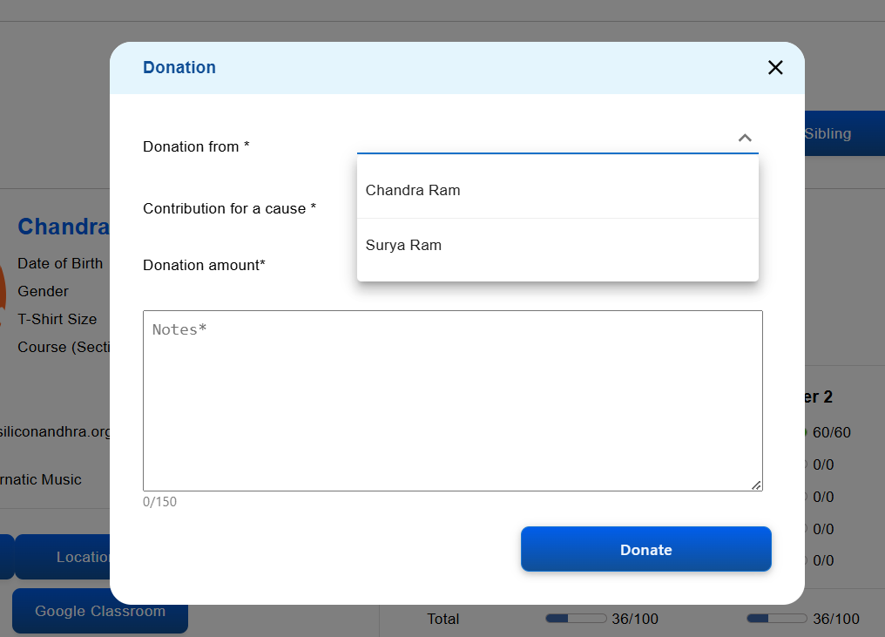

Additionally, the **“Contribution for Cause”** dropdown will be available in the pop-up, and the student must select a cause for the donation. This is a **mandatory field**.

**The "Donate" option is specifically intended for making donations only and should not be used for enrollment purposes.**

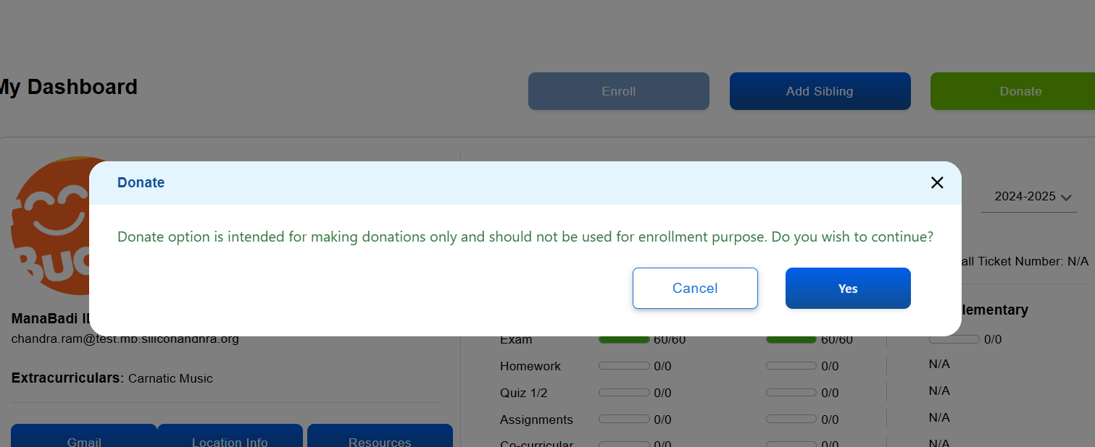

**Sibling Discount:** If two students are registering at the same time, only the secondary sibling will receive the sibling discount. At least one student must pay the full amount.

**Repeating Discount:** If a repeating student enrolls for the same course, they will pay half the course fee. However, if they add a new sibling during the enrollment process, the first new sibling will not be eligible for any sibling discount.

**LateFee:**  A late fee of $50 will be applied to all courses if parents register after the specified end date, except for Balabadi-I, where registration remains open throughout.

Location Panel

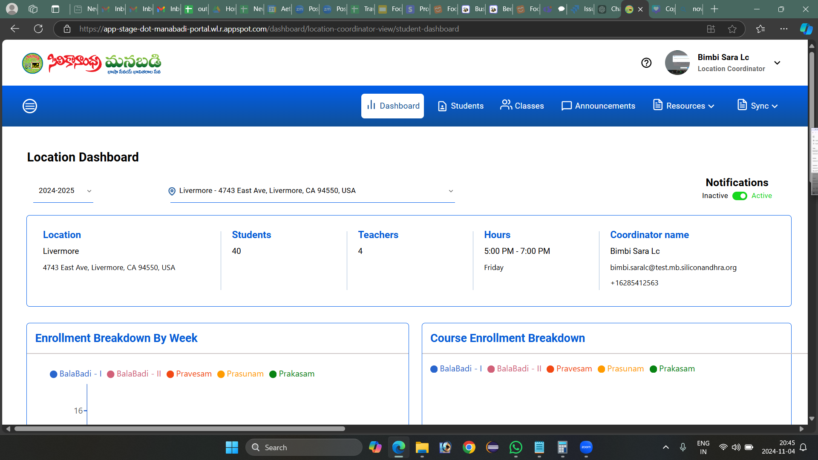

### **Location Dashboard**

#### Overview

The Location Dashboard provides an overview of essential details for each location, including student and teacher counts, hours, and course enrollment breakdowns. This guide walks through the main features and how to interpret the data presented.

### 1. Accessing the Location Dashboard

* Step 1: Log into the system with Location coordinator credentials.
* Step 2: Navigate to the dashboard by selecting "Dashboard" from the main navigation menu.

**Hamburger Icon for Navigation**:

* A **hamburger icon** is located at the top-left corner of the dashboard.
* Clicking on this icon opens a **navigation menu**.
* From this menu, the coordinator can access the **Teacher Panel**:
  + The **Teacher Panel** allows coordinators to manage teacher-related tasks

### 2. Dashboard Sections

#### 2.1. Location Details

* Location Name: Displays the name of the location (e.g., Livermore).
* Address: Shows the complete address, which helps in identifying the exact location.
* Students: Indicates the total number of students enrolled at this location.
* Teachers: Displays the number of teachers associated with the location.
* Hours: Specifies the operational hours (e.g., 5:00 PM - 7:00 PM on Fridays).
* Coordinator Details: Contains the Primary coordinator's name, email, and contact number.

#### 2.2. Notifications

**Notification Status:** Indicates whether notifications for the location are active or inactive. Toggle to change the status.

* **Active:** When notifications are active, the Location Coordinator will receive notifications via Gmail whenever students register for the assigned location or when students are moved from one location to another.
* **Inactive:** When notifications are inactive, no notifications will be sent.

#### 2.3. Enrollment Breakdown by Week

* Purpose: This section shows weekly enrollment statistics across various courses.
* Graph Interpretation: Each color represents a specific course (e.g., BalaBadi - I, BalaBadi - II, Pravesam, Prasnam, Prakasam).
* How to Use: Hover over each bar to view the number of enrollments per course in a particular week.

#### 2.4. Course Enrollment Breakdown

* Purpose: Provides a pie chart showing the distribution of enrollments across different courses.
* Color Code: Each section is color-coded to represent different courses, helping in quick visual interpretation.
* Interpreting the Chart: Hover over sections of the pie chart to view the exact number of enrollments for each course.

### 3. Test Scores

The Test Scores section provides an overview of student performance across various courses. This area includes score categories and allows for the selection of specific test sessions (e.g., S1, S2, PSTU, and Supplementary).

#### 3.1. Test Session Selection

* Options: Choose from S1, S2, PSTU, or Supplementary to view scores for each respective test session.
* How to Select: Click the radio button next to the desired session to update the score data displayed below.

#### 3.2. Score Breakdown Table

* Columns by Course: Each course, such as BalaBadi - I, BalaBadi - II, Pravesam, etc., is represented as a column.
* Rows by Score Range:
  + Not Scored: Shows the number of students who haven't yet received scores.
  + Absent: Number of students who were absent for the test.
  + Score Ranges: Includes ranges (e.g., 0-64, 64-75, 76-100) to reflect the number of students who fall within each score bracket.
* How to Use: Review the table to identify students’ performance distribution across courses and score ranges.

### 4. Teachers (Scores to be Updated)

The Teachers (Scores to be Updated) section lists teachers with pending scores that need to be entered for their students.

#### 4.1. Teacher Details

* Teacher Column: Shows each teacher's name along with a unique identifier.
* Students (Not Scored): Indicates the number of students under each teacher whose scores have not been recorded.
* Actions: Provides a mail icon to send reminders or messages to teachers directly, if needed.
* How to Use: Click the mail icon in the "Actions" column to notify teachers with pending scores, helping ensure timely score updates.

### 5. Additional Actions

#### 5.1. Viewing Students

* Click on the "Students" tab in the main menu to view a detailed list of students enrolled at the location.

#### 5.2. Viewing Classes

* Select the "Classes" tab to see a schedule of classes for the location, including timing, instructor information, and enrolled students.

#### 5.3. Announcements

* Navigate to "Announcements" to post or review any notices related to the location.

#### 5.4. Resources and Sync

* Resources: Access resources specific to location coordinators, such as guides and forms.
* Sync: Update or synchronize data to ensure all information is current.

### 6. Troubleshooting & FAQs

* Issue with Notification Toggle: Check permissions if unable to activate/deactivate notifications.
* Incorrect Enrollment Numbers: Verify with the student records or sync data if the numbers seem outdated.

### 7. Contact Support

For any issues or additional support, reach out to the system administrator or help desk.

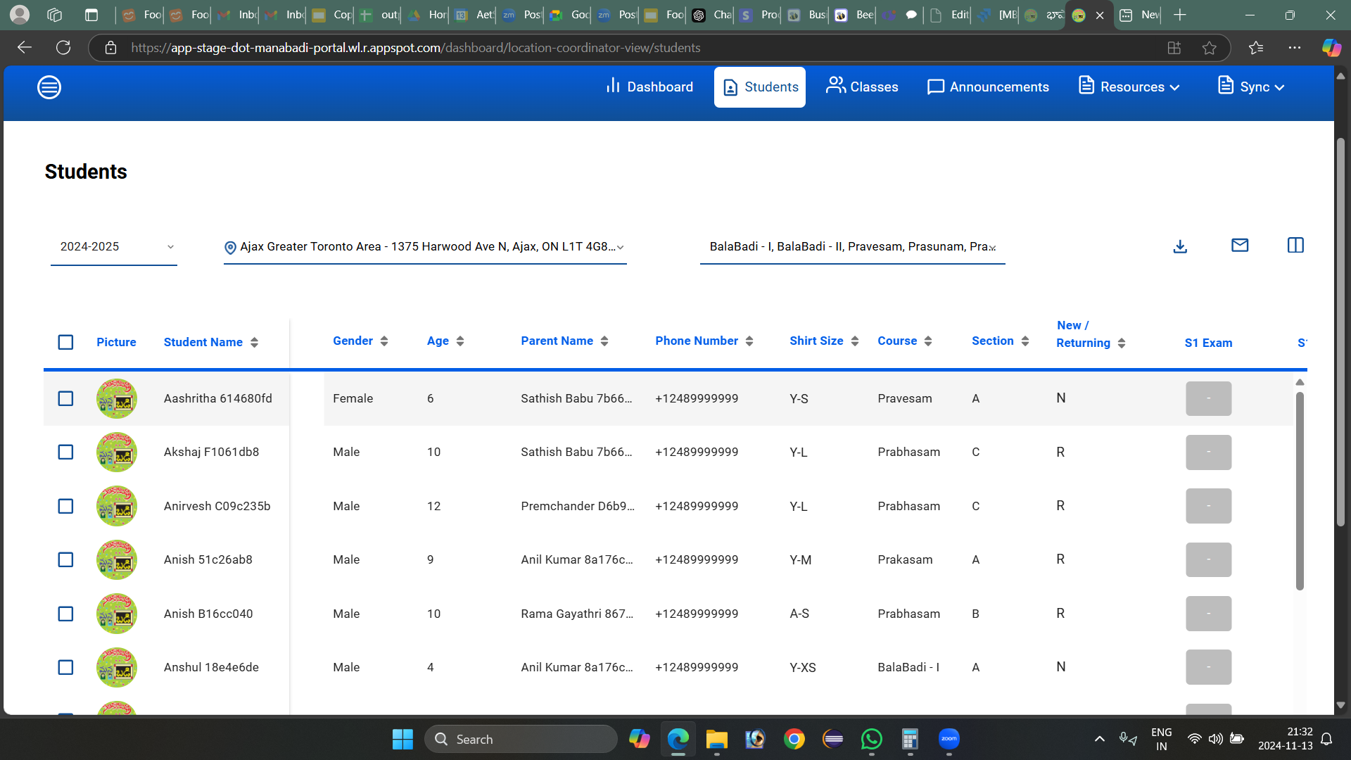

**User Manual for Students Screen**

#### **1. Navigation Bar (Top Section)**

* Dashboard: Takes you to the main overview page.
* Students: User is currently on this page. It lists all students enrolled in the system for the selected year and location.

#### **2. Academic Year and Location Selector**

* **Year Dropdown (2024-2025)**: Allows you to select a specific academic year to view students enrolled in that period.
* **Location Selector**: Specifies the location (e.g., "Ajax Greater Toronto Area"). You can choose other locations if available.

#### **3. Course and Section Filter**

* **Courses**: Displays the types of classes (e.g., Pravesam, Prabhasam, Prakasam, BalaBadi-I).
* **Sections**: Filters based on the sections available for the courses.

#### **4. Student List Table**

* **Checkbox (Left)**: Select individual students for batch actions (like messaging or downloading details).
* **Picture**: Student profile picture or placeholder image.
* **Student Name**: Name of the student.
* **Gender**: Shows whether the student is male or female.
* **Age**: Displays the student’s age.
* **Parent Name**: Shows the name of the parent or guardian.
* **Phone Number**: Displays the contact number for the parent or guardian.
* **Shirt Size**: Indicates the size of a shirt for uniform or event purposes.
* **Course**: Shows the course or program the student is enrolled in.
* **Section**: Displays the section (e.g., A, B, C) assigned to the student.
* **New/Returning**: Indicates if the student is new or returning for the academic year.
* **S1 Exam / S2 Exam**: Likely placeholders for Semester 1 and Semester 2 exam statuses, which may show scores or pass/fail indicators once entered.
* **S1 Exam**: The main exam score for Semester 1.
* **S1 HW**: Score for Semester 1 homework assignments.
* **S1 Quiz 1**: Score for the first quiz in Semester 1.
* **S1 Assignment**: Score for assignments completed during Semester 1.
* **S1 Co-curricular**: Score for co-curricular activities or participation.
* **S1 Total**: The total score for all Semester 1 components.
* **S1 Grade**: The overall grade for Semester 1, which may be automatically calculated based on the total score.
* **S2 Exam**: The main exam score for Semester 2.
* **S2 HW**: Score for Semester 2 homework assignments.
* **S2 Quiz 1**: Score for the first quiz in Semester 2.
* **S2 Assignment**: Score for assignments completed during Semester 2.
* **S2 Co-curricular**: Score for co-curricular activities or participation.
* **S2 Total**: The total score for all Semester 2 components.
* **S2 Grade**: The overall grade for Semester 2, which may be automatically calculated based on the total score.
* **PSTU / Supplementary Marks**: This field is likely for entering additional or makeup exam scores, particularly if a student requires a supplementary evaluation for Semester 1 or Semester 2.
* **Grade**: Shows the final letter grade or overall assessment result for the student based on cumulative scores from both semesters and supplementary exams.
* **GPA**: Displays the student's Grade Point Average for the academic year, calculated from the scores and grades of each semester.
* **Annual Score**: The total score for the academic year, likely combining the Semester 1 and Semester 2 scores along with any supplementary scores.

**Actions:**

### **Changing the Section of a Student**

#### **Overview**

Location coordinators can use the swap section feature to change a student's section within the same course and location. This feature is represented by a swap icon on the "Actions" panel next to each student's name.

#### **Steps to Change a Student's Section**

1. **Identify the Student**: Locate the student you wish to reassign to a different section. On the "Actions" panel, find the row associated with the student's record.
2. **Access the Swap Section**: Click the swap icon (↔️) next to the student's name in the "Actions" panel. This will open the "Swap Section" popup.
3. **View Swap Section Popup**: The popup displays several fields that provide details about the student and their current section. Note that some fields may be disabled (grayed out) and cannot be edited.
4. **Fill in the Required Information**:
   * **Section To**: Select the new section you want to assign to the student from the dropdown labeled "Section To".
   * Verify that the information in the disabled fields is correct. These include:
     + **Student Name**: Displays the name and ID of the student.
     + **Academic Year**: Displays the current academic year.
     + **Course From and Course To**: Shows the course name; both fields are set to the student's current course.
     + **Location From and Location To**: Displays the student's current location.
5. **Confirm and Save**: After selecting the appropriate section, click the "Move Student" button to finalize the change.
6. **Cancel if Necessary**: If you do not wish to make any changes, click "Cancel" to close the popup without saving.

### **Notes**

* Ensure the new section is correct before confirming the change, as incorrect section changes may disrupt the student's schedule.
* The disabled fields cannot be altered, as they are pre-set based on the student's current enrollment details.

#### **2. Assigning Scores**

* Click on any of the boxes in the "S1 Exam," "S1 HW," "S1 Quiz 1," "S1 Assignment," or "S1 Co-curricular" columns.
* This will open an **Assign Score Popup**.

#### **3. Assign Score Popup**

**Student Information**:

* Full Name: Displays the student's name and unique identifier.
* Course: Allows selecting the course (e.g., "Pravesam").
* Semester: Allows selecting the semester (e.g., "Semester 1").

**Marks Entry**:

* Categories: Includes different sections or categories for score entry (e.g., "section1," "section2").
* Marks: Fields to enter scores for each category out of the specified maximum marks (e.g., /30).

**Notes**:

* Each category has a corresponding "Notes" field to provide context or remarks (e.g., "section1," "section2").

**Attendance**:

* Toggle to mark the student's attendance as "Absent" or "Present."

**Summary Calculation**:

* **Total Marks**: Auto-calculates the sum of marks entered across categories.
* **Weightage of Marks**: Allows specifying the weightage of the entered marks, which might contribute to final grades.

**Actions**:

* **Cancel**: Discards changes made in the popup.
* **Update**: Saves the scores and updates the student's record.

#### **4. Score Calculation**

* **S1 Total**: Once individual scores are entered in each component (exam, homework, quiz, assignment, co-curricular), the system may automatically calculate the total score and display it in the "S1 Total" column.
* **S1 Grade**: Based on the S1 Total score, the system might assign a grade (e.g., A, B, C, D) in the "S1 Grade" column according to the grading schema.

#### **5. Editing Scores**

* To modify an existing score, click on the relevant box to reopen the Assign Score Popup.
* Adjust the score as needed and save the changes.

#### **6. Navigation Tips**

* Use the **Tab** key to quickly move between score entry fields, which can be helpful for entering data for multiple students in sequence.
* **Save** frequently to ensure that data is not lost.

#### **5. Bulk Action Icons (Top Right)**

* **Download Icon**: Export the student list as a file (likely CSV or PDF format).
* **Email Icon**: Send a message or notification to selected students or their parents.
* **Customized View Icon:** (often represented as a gear or settings icon) allows users to tailor the display of columns in the student management table. By clicking on this icon, you can access the **Column Settings** popup, where you can choose which data fields to display or hide in the table.

#### **How to Use:**

1. **Accessing the Column Settings**:
   * Click on the **Customized View Icon** at the top of the student management screen. This will open the **Column Settings** popup.
2. **Selecting Columns**:
   * The popup displays a list of available columns with checkboxes next to each option.
   * Columns include fields like *Student Name*, *Gender*, *Age*, *S1 Exam*, *S2 Grade*, *GPA*, etc.
   * Check or uncheck the boxes to show or hide specific columns in the student table view.
3. **Saving Changes**:
   * After selecting your preferred columns, click **Save** to apply the changes.
   * The student management table will update to reflect your selections, displaying only the columns you chose.
4. **Canceling Changes**:
   * If you do not want to apply the changes, click **Cancel** to close the popup without modifying the column view.

#### **Key Features:**

* **Customization**: Allows users to personalize the table view for easier data management.
* **Flexible Display**: Toggle columns on or off based on the information you need to view or edit.
* **Efficient Workflow**: Streamline your view by only showing essential data fields, reducing screen clutter.

#### **6. Sorting & Filtering Options**

* Click on any column header (e.g., Student Name, Gender, Age) to sort the list by that category.

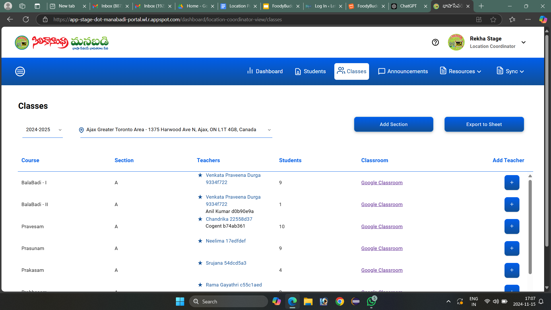

**Classes Tab Functionality**

This screen is from the "Classes" section of the Manabadi portal, specifically for a location coordinator. Here’s a breakdown of its elements and a brief guide on how to use it:

1. **Header and Navigation Bar**:
   * The header displays the academic year (2024-2025) and the selected location (Ajax Greater Toronto Area).
   * At the top right, you can see options like **Dashboard**, **Students**, **Classes**, **Announcements**, **Resources**, and **Sync**.
2. **Classes Overview**:
   * This table provides a summary of classes for the selected academic year and location.
   * Columns include:
     + **Course**: The name of the course (e.g., BalaBadi - I).
     + **Section**: The section within the course (e.g., Section A).
     + **Teachers**: Lists teachers assigned to each section along with their contact information.
     + **Students**: The number of students enrolled in each section.
     + **Classroom**: A link to the Google Classroom associated with each section.
     + **Add Teacher**: A plus icon that allows adding more teachers to the section.

### **Add Teacher Screen Elements and Usage**

1. **Course Information**:
   * Displays the course name (e.g., BalaBadi - I) and the section (e.g., Sec A) to which the teacher will be assigned.
2. **Teachers**:
   * Lists currently assigned teachers for the section, including their names, IDs, and email addresses.
   * You can click the "X" next to a teacher's name to remove them if necessary.
3. **Find User**:
   * Type in the name or ID of a teacher to search for them in the system.
   * When you find the correct teacher, select their profile to add them to the list.
4. **Change Log**:
   * Enter a note in the **Change Log** field to document the reason for adding or removing a teacher, or any other relevant details.
5. **Buttons**:
   * **View Logs**: Click to see the history of changes made to the teacher assignments for this course and section.
   * **Add Teacher**: After selecting a teacher, click this button to assign them to the section.
   * **Cancel**: Click to exit the "Add Teacher" screen without making any changes.

### **Additional Notes**

1. **Copying Teacher Email IDs**: You can copy the email addresses of assigned teachers directly from this screen by selecting and copying the text.
2. **Inactive Teachers**: If a teacher is marked as inactive in the system, they will be automatically removed from the list of assigned teachers for this section.
3. **Buttons**:
   * **Add Section**: Allows you to add a new section to any course.
   * **Export to Sheet**: Exports the displayed classes data into a spreadsheet for easy sharing and record-keeping.

### **Add Section Screen Elements and Usage**

1. **Location**:
   * Displays the selected location where the new section(s) will be added (e.g., Ajax Greater Toronto Area).
   * Sections created here will only be associated with this specified location.
2. **Course**:
   * Select the course (e.g., BalaBadi - I) for which you want to create new sections.
   * Only sections for the selected course and location will be created.
3. **Academic Year**:
   * Indicates the academic year for the sections being created (e.g., 2024-2025).
4. **Sections**:
   * Enter the number of new sections you want to create in this field.
   * For example, if BalaBadi - I currently has sections A, B, and C, and you enter "2" here, it will automatically create sections D and E.
5. **Change Log**:
   * Use this field to document the reason for adding new sections or any relevant notes for record-keeping.
6. **Buttons**:
   * **View Logs**: Allows you to see the history of changes, including previous sections added.
   * **Save**: Click this button to create the new sections as specified.
   * **Cancel**: Exit the screen without creating new sections.

### **Integration and Display**

* After adding sections, the portal will integrate them into the system, displaying them in relevant panels, including course listings, teacher assignments, and classroom integrations (e.g., Google Classroom links).
* The newly created sections will continue the naming sequence based on existing sections and will be automatically linked to the selected course and location.

### **Steps to Export Data**

1. **Locate the Export to Sheet Button**:
   * On the **Classes** screen, find the **Export to Sheet** button, typically located on the right side of the page.
2. **Click the Export to Sheet Button**:
   * When you click this button, a popup window labeled **Report** will appear.
3. **Popup Window - Report**:
   * The popup displays a message confirming that the **Student's CSV file has been exported to Google Drive**.
   * The exported CSV file contains all relevant class information, including course names, sections, teacher details, and student counts.
4. **OK Button**:
   * Click the **OK** button in the popup to close it.
   * After clicking **OK**, you can go to your Google Drive to locate and download the exported CSV file.

### **Accessing the Exported Data in Google Drive**

* The exported file will be available in Google Drive in CSV format, which can be opened using spreadsheet software like Google Sheets, Microsoft Excel, or other compatible applications.
* You can use this file to analyze, organize, or share class data as needed.

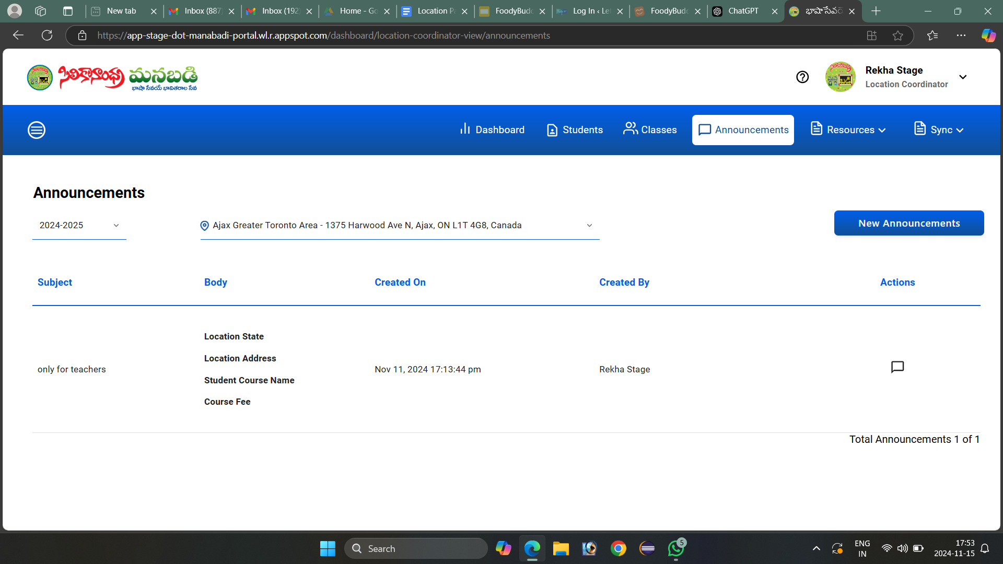

**Announcement Screen Manual**

This screen shows the "Announcements" section for a location coordinator in the Manabadi portal. Here’s a guide to navigating and using this page:

### **1. Top Bar and Navigation**

* **Location Icon and Address**: Displays the current location (Ajax Greater Toronto Area in this case). You can change locations if multiple ones are assigned to you.
* **Dashboard, Students, Classes, Announcements, Resources, Sync Tabs**: These tabs let you navigate to different sections of the portal.

### **2. Announcements Section**

* **Year Selection Dropdown (2024-2025)**: Select the academic year for viewing announcements specific to that period.
* **New Announcements Button**: Click this to create a new announcement. It may open a form where you can enter the subject, body, and other details of the announcement.

### **3. Announcement List**

* **Columns**:
  + **Subject**: Shows the subject of the announcement. For example, "only for teachers."
  + **Body**: Displays brief details or a preview of the announcement content, like "Location State, Location Address, Student Course Name, Course Fee."
  + **Created On**: Shows the date and time the announcement was created.
  + **Created By**: Indicates the name of the person who posted the announcement (in this case, "Rekha Stage").
  + **Actions**: The speech bubble icon may allow you to view or comment on the announcement (if that feature is enabled).

### **4. Total Announcements**

* Displays the count of announcements for the selected year.

**New Announcement**

### **1. Recipients Section**

* **Location, Year, Audience, and Filters**:
  + **Location**: Shows the selected location (e.g., Ajax Greater Toronto Area). If you manage multiple locations, you may be able to select different ones.
  + **Year**: Allows you to select the academic year (e.g., 2024-2025).
  + **Audience Filter (All Students)**: Choose the target audience for the announcement.
  + **Set Filter**: Provides further filtering options for targeting specific groups within the selected location.

### **2. Set Filter Options**

* **Role - User groups**: Choose groups like:
  + *All Students*: Targets all students within the location.
  + *Primary Teachers*: Targets primary-level teachers.
  + *Support Teachers*: Targets teachers in support roles.
* **Course**: Select specific courses available at that location to narrow down recipients.
* **Section**: Choose sections based on the selected courses to target students or teachers from specific sections.
* **Location**: Select from assigned locations under this coordinator’s control.
* **Student**: Target individual students by email ID.
* **User**: Choose from support coordinators or teachers associated with the location.

### **3. Announcement Content**

* **Subject**: Enter the subject of the announcement, which appears in the recipients' inbox.
* **Title**: Add a title for the announcement template.

### **4. Text Formatting Toolbar**

* Contains options for **bold**, **italic**, **underline**, **strikethrough**, **text color**, **background color**, **text alignment**, **hyperlinks**, **insert image**, and **emojis** to customize your announcement text.
* **Font Style and Size**: Adjust the font style and size to your preference.
* **Insert Substitution Tags**: Allows you to personalize the announcement with dynamic fields from the recipient’s information, such as location details or course information.

### **5. Substitution Tags**

* A list of available tags is shown on the right (Location Info, Course Info, etc.).
* To use a tag, select it from the list, and it will appear in the announcement text. Tags will auto-fill with specific information for each recipient, making the message personalized.

### **6. Action Buttons**

* **Cancel**: Discards the announcement and returns to the previous screen.
* **Send Announcements**: Sends the announcement to the selected recipients based on the applied filters.

### **Steps to Use the Select Template Field**

1. **Open the Select Template Dropdown**:
   * Click on the **Select Template** dropdown menu on the right side of the screen. This opens a list of available templates you can choose from.
2. **Browse Available Templates**:
   * You will see a list of pre-made templates, each with a predefined format and content. These templates may include standard announcements, reminders, event invitations, or updates specific to the organization.
   * If you don’t see a relevant template, check with your organization’s administrator to see if more templates can be added.
3. **Select a Template**:
   * Click on the desired template to select it. The announcement form will automatically populate with the content and formatting specified in that template, including any pre-inserted text, subject, and tags.
4. **Edit Template Content (if needed)**:
   * Once a template is selected, you can modify the content in the text editor. This includes updating any placeholders, changing the subject line, or adding additional information.
   * If the template includes **Substitution Tags**, ensure they match the target audience (e.g., location, course, or user information).
5. **Save or Create New Templates**:
   * **Make a Copy**: If you wish to use the current template as a base but make substantial changes, you can click **Make a copy** to save it as a new template with your modifications. This will keep the original template intact.
   * **Create New**: If you need a new template that isn’t available, select **Create new**. This will open a blank template form where you can add all necessary details and save it for future use.
6. **Sending the Announcement**:
   * Once the template is selected and any edits are complete, continue by setting the filters and clicking **Send Announcements** to deliver it to the intended recipients.

### **Benefits of Using Templates**

* **Consistency**: Ensures all announcements follow a standard format.
* **Efficiency**: Saves time by reusing common structures.
* **Personalization**: By combining templates with substitution tags, you can quickly send personalized messages to a large audience.

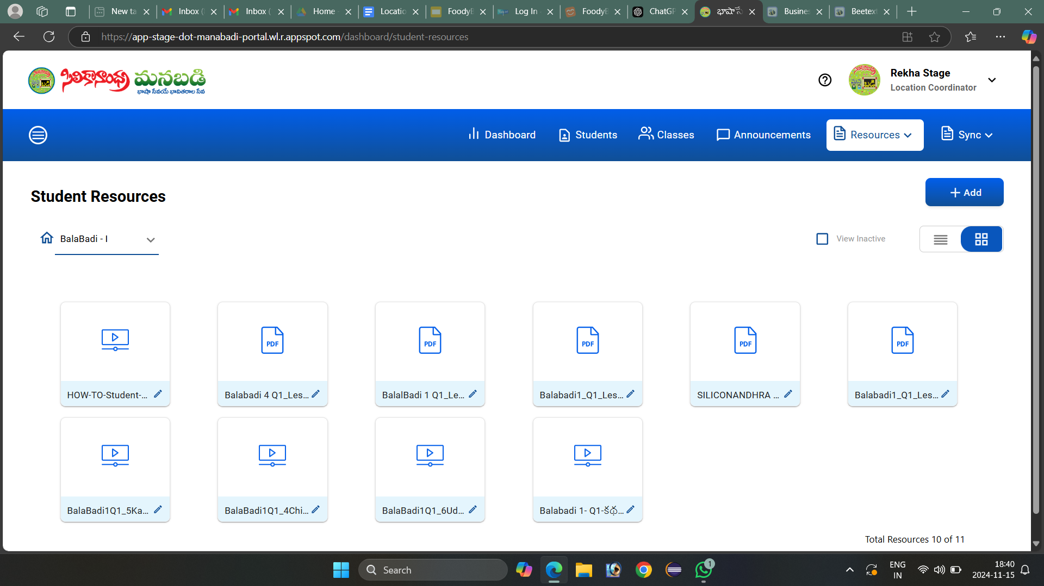

**Resources Screen Manual**

This screen shows the **Student Resources** section in the Manabadi portal, where resources are organized by user type and category (e.g., "BalaBadi - I"). Here’s a guide to using and managing resources for **students** and **teachers**.

### **General Navigation and Options**

1. **Resource Type Selection**
   * At the top, the section label (e.g., "BalaBadi - I") indicates the selected resource category or curriculum level. Use this to navigate to specific courses or sections.
   * **Student Resources** and **Teacher Resources**: Typically, you can switch between these sections. For this screen, it is currently on **Student Resources**. To switch to **Teacher Resources**, use the drop-down menu or go back to the main **Resources** tab to select the appropriate category.
2. **View and Organize Resources**
   * **Grid/List View Toggle**: Use the icons next to the "View Inactive" checkbox to switch between grid view (as seen in the screenshot) and list view, depending on your preference for displaying resources.
   * **View Inactive**: Checking this option will show inactive resources, which may be older or currently hidden resources that can be reactivated if needed.
3. **Add New Resources**
   * Click the **+ Add** button to upload a new resource. This is available for both student and teacher resources and typically opens a form to input details like:
     + **Title**: The name of the resource.
     + **Description**: A brief explanation of the content.
     + **File Upload**: Upload a PDF, video, or other relevant file format.
     + **Visibility Settings**: Set whether the resource should be active (visible) or inactive.
4. **Resource Files**
   * Each resource is displayed as a tile, showing either a video icon (for videos) or a PDF icon (for documents).
   * To **edit** a resource, click the pencil icon on the resource tile. This will allow you to rename, replace, or update any details related to that resource.
   * Resources can include various types, such as instructional PDFs, tutorial videos, guides, or lesson materials.

### **Specific Resource Types**

#### **1. Student Resources**

* **Purpose**: Contains materials intended for students, such as lesson plans, study guides, exercises, and instructional videos.
* **Usage**: Students or teachers can access these resources to aid in learning, study, or review. Materials are typically organized by levels, topics, or quarters (e.g., "BalaBadi 1 Q1 Lesson").
* **File Types**: Commonly includes PDFs and videos, though other formats may be supported depending on the system.
* **Access**: Generally accessible to students and teachers associated with that level/course.

#### **2. Teacher Resources**

* **Purpose**: Contains materials intended for teachers, such as teaching guidelines, curriculum outlines, instructional support materials, and activity plans.
* **Usage**: Teachers use these resources to plan lessons, deliver curriculum content, and provide structured learning experiences for students.
* **File Types**: Teacher resources may include lesson plans, activity instructions, assessments, and other supporting documents.
* **Access**: Typically limited to teachers and administrative staff, not accessible to students.

### **Total Resources**

* At the bottom of the screen, you’ll see the **Total Resources** count, which shows the number of resources currently in the selected category.

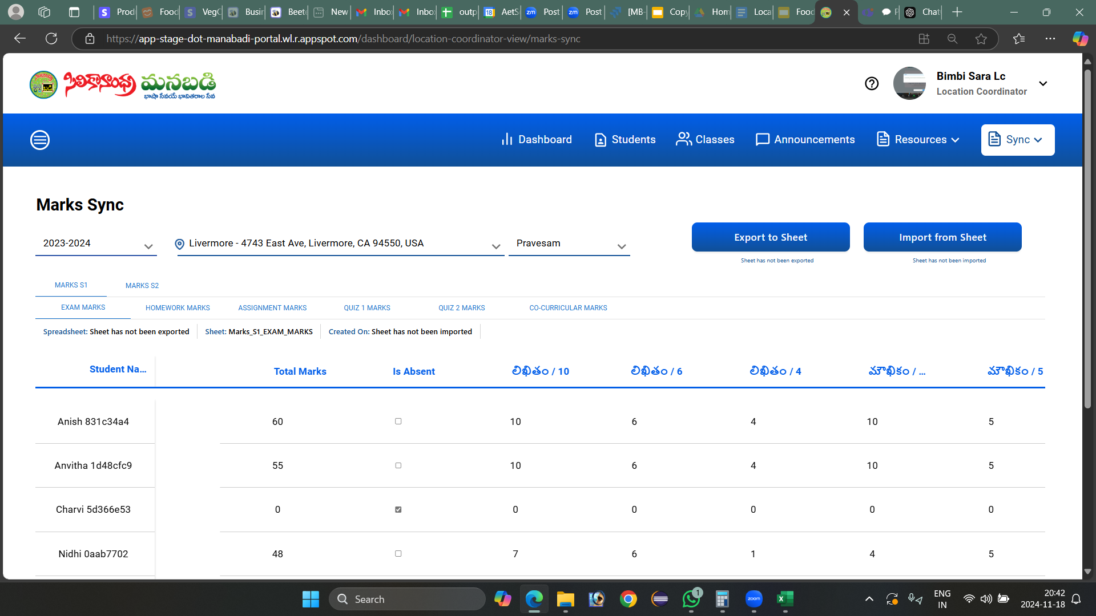

**Marks Sync User Manual:**

This screen seems to be part of a portal for managing and syncing student marks. Here's a basic user manual for understanding and working with the screen you provided:

#### **Overview**

This screen is used by coordinators to view, edit, import, and export student marks for different assessments.

#### **Key Components**

1. **Academic Year Dropdown**:
   * Located at the top-left.
   * Allows you to select the academic year (e.g., 2023-2024).
2. **Location and Course Selection**:
   * Dropdown menus to choose the location (e.g., Livermore) and Course (e.g., Pravesam).
3. **Tabs for Mark Categories**:

The screen is divided into tabs to organize marks into specific categories:

* **Marks S1**: Represents semester 1 marks for various assessments.
* **Marks S2**: Represents semester 2 marks for various assessments.

Within each term (Marks S1 or Marks S2), you will find the following categories:

* **Exam Marks**
* **Homework Marks**
* **Assignment Marks**
* **Quiz 1 Marks**
* **Quiz 2 Marks**
* **Co-curricular Marks**

Each tab displays data specific to the selected term and category.

1. **Export to Sheet Button**:
   * Exports the marks data to an external spreadsheet file for offline use or further analysis.
2. **Import from Sheet Button**:
   * Allows importing marks from an external spreadsheet to update the portal.
3. **Spreadsheet Status**:
   * Indicates whether the sheet has been exported or imported.
   * Shows the creation date and status.
4. **Student Marks Table**:
   * **Student Name/ID**: Identifies the students.
   * **Total Marks**: Displays the total marks scored.
   * **Is Absent**: Checkbox to mark the student as absent for the assessment.
   * **Subject-Wise Scores**:
     + Columns for individual components or subjects

### **How to Use**

#### **1. Viewing Marks:**

* Select the **Academic Year**, **Location**, and **Course** from the dropdown menus.
* Choose the specific marks category tab to view marks.

**2. Exporting Marks**:

**Step-by-Step Process**:

1. Click on the **Export to Sheet** button on the screen.
2. A **popup message** will appear with the message:  
   *"Student's CSV file has been exported in Google Drive."*
3. Click the **OK** button on the popup to confirm.  
   This will export the marks data as a CSV file to the linked Google Drive account.

**What Happens After Export**:

* The coordinator can access the exported CSV file in their Google Drive.
* This file contains the schema for entering or updating the marks.  
  (Each column and row corresponds to the categories and students listed in the portal.)

**Important Rules for Editing the CSV File**:

1. **Marks Range**:  
   Ensure that the entered marks are within the allowed range as per the schema.
   * For example, if a subject's maximum score is 10, you cannot enter marks above 10.
   * Any marks exceeding the total defined in the schema will cause an error during import.
2. **Avoid Unnecessary Changes**:
   * Do not alter the structure of the file (e.g., adding or removing columns, changing headers, or rearranging rows).
   * Unapproved changes, such as adding unrelated data or modifying the format, will result in the file being rejected during import.
3. **Check for Completeness**:
   * Ensure that all required marks fields are filled properly. Missing or invalid data may prevent successful import.

**Next Steps**:

* After making updates, use the **Import from Sheet** button to re-upload the updated CSV file to the portal.
* If the file meets all validation criteria, the changes will be reflected in the system.

### **4. Marking Attendance**

* **Attendance Management**:
  + Attendance for students (e.g., marking them as "Absent") **cannot be updated directly on the portal**.
  + Instead, you need to **export the marks sheet** to a CSV file via the **Export to Sheet** button.
  + Open the exported file from your Google Drive, and mark students as "Absent" in the appropriate column as per the schema.
  + Save the changes in the exported file and re-import it using the **Import from Sheet** option.
* **Note**:
  + The portal does not allow direct updates to the attendance in the table fields.

### **5. Editing Marks**

* **Marks Updates**:
  + Marks **cannot be edited directly** in the table on the portal.
  + To make any changes:
    1. **Export the Marks Sheet**: Use the **Export to Sheet** button to generate the CSV file in Google Drive.
    2. **Make Changes in the Exported Sheet**: Edit the marks in the exported sheet as per the schema, ensuring they fall within the allowed range and format.
    3. **Re-import the Updated Sheet**: Use the **Import from Sheet** option to upload the edited file.
* **Important Guidelines**:
  + You **cannot edit the existing sheet** directly on the portal and re-import it.
  + For every change, you must **export a fresh sheet**, make the updates, and then re-import it.
  + Ensure all changes adhere to the schema; otherwise, the system will reject the sheet during import.

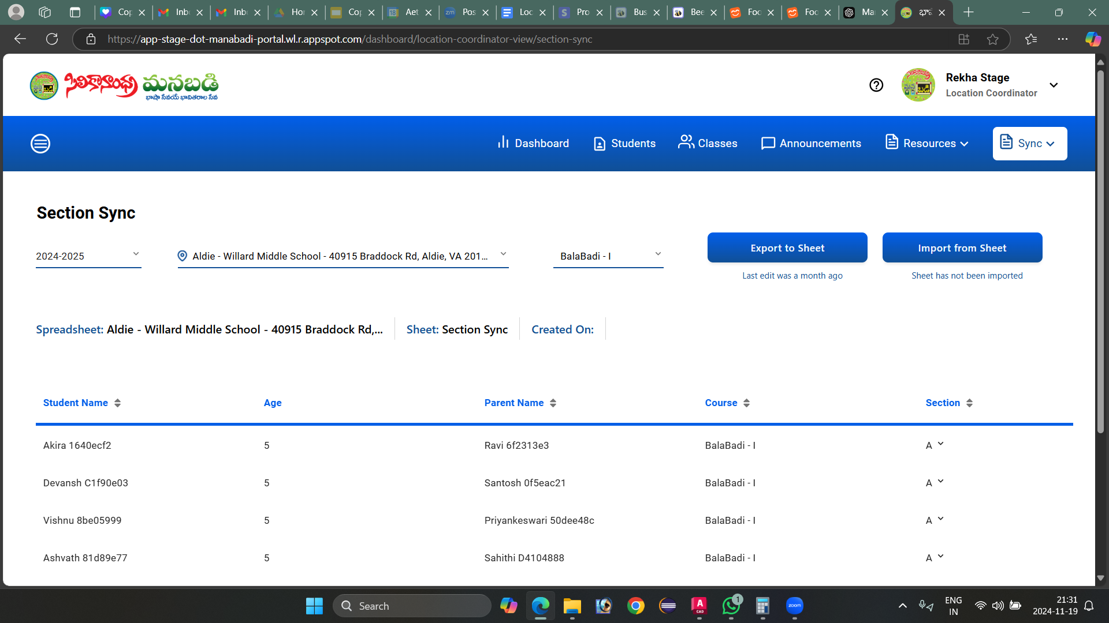

**Section Sync Screen User Manual**

**Purpose of the Screen:**The Section Sync screen is designed for **Location Coordinators** to efficiently manage student section assignments and synchronize data between the system and spreadsheets. This tool enables bulk updates to student sections, allowing coordinators to move multiple students from one section to another at once.

By using the **Export to Sheet** and **Import from Sheet** buttons, coordinators can update section assignments for all students simultaneously, reducing manual effort and saving time.

**Section Sync Title Area:**

* **Year Selector (Dropdown):** Choose the academic year (e.g., 2024-2025). (All previous academic years are available)
* **Location Dropdown:** Displays only the **assigned locations** for the logged-in Location Coordinator.
* Select the relevant location (e.g., "Ajax Greater Toronto Area - 1375 Harwood Ave N, Ajax, ON L1T 4").
* **Course Dropdown:** Select the specific course or level (e.g., BalaBadi - I).

### **Action Buttons**

#### **Export to Sheet**

* **Purpose:** Exports the current list of students and their section details to an external spreadsheet for offline editing.
* **Process:**
  + When the user clicks on **"Export to Sheet"**, a popup message will display:  
    **"Student's CSV file has been exported to Google Drive."**
  + After clicking **OK** on the popup, the data will be downloaded to the user’s Google Drive.
  + The user can edit **only the Section column** in the exported spreadsheet.
    - Allowed edits: Update section values (e.g., change "A" to "Z" or "a" to "z"). Both uppercase and lowercase letters are allowed.
    - **Important Note:** If any other columns (e.g., student name, age, or parent name) are modified, the sheet will **not be imported**, and the data will remain unchanged.
  + Once the **Export to Sheet** button is clicked, the label under the button will display:  
    **"Last edit was a few seconds ago"**.
* **Re-Exporting:**
  + If the user needs to make further changes after an import, they **must re-export** the sheet.
  + The same exported sheet **cannot** be edited and imported again.

#### **Import from Sheet**

* **Purpose:** Imports the updated spreadsheet back into the system to apply changes to the student sections.
* **Process:**
  + When the user clicks on **"Import from Sheet"**, a confirmation popup will display:  
    **"Will overwrite the students information with the data from the spreadsheet. Are you sure?"**
  + The popup will have two options:
    - **Cancel:** Stops the import process.
    - **OK:** Proceeds with importing the data.
  + If the user clicks **OK**:
    - The data from the spreadsheet will be imported, and the **section details** will be updated in the system.
    - The **Created On** date will be updated to reflect the import time.
    - The label under the **Export to Sheet** button will also update to:  
      **"Last edit was a few seconds ago"**.
* **Error Handling:**
  + If the user attempts to re-import the same sheet without exporting it again, a popup message will display:  
    **"To successfully import your sheet, you must first export it. Remember, you can only import the sheet once after exporting, so ensure everything is in order before proceeding. Don't risk losing crucial data - take the time to export your sheet now."**
* **Restrictions:**
  + Only the **Section column** can be edited in the exported sheet.
  + Any edits to other columns (e.g., Student Name, Age, or Parent Name) will be ignored, and no changes will be applied.
  + To apply further changes, the user must first re-export the sheet.

**Spreadsheet Details:**

* Displays relevant details, such as:
  + **Location:** Current location (Eg: "Ajax Greater Toronto Area").
  + **Sheet Name:** The name of the associated spreadsheet ("Section Sync").
  + **Created On:** Field for showing the creation date

**Data Table:**

* Displays the list of students, their details, and section assignments.
* **Table Columns:**
  + **Student Name:** The name and unique identifier of each student.
  + **Age:** The age of the student.
  + **Parent Name:** The parent or guardian’s name with an identifier.
  + **Course:** The enrolled course (e.g., BalaBadi - I).
  + **Section:** The assigned section (e.g., Section A).

### **Change Section for Individual Students**

The "Change Section" feature allows coordinators to manually update the section of an individual student for the current academic year.

### **Steps to Change Section**

1. **Access the Change Section Popup**:
   * In the Section Sync table, locate the **Section column** where the student’s current section is displayed (e.g., "A").
   * Click on the **down arrow** in the Section column for the desired student.
   * A popup window titled **"Change Section"** will appear.
2. **Fields Displayed**:
   * **Student Name**: Displays the student’s full name and unique ID. (Read-only)
   * **Parent Name**: Displays the parent's name and unique ID. (Read-only)
   * **Course Name**: Displays the current course (e.g., BalaBadi - I). (Read-only)
   * **Select Section**: Allows you to choose a new section for the student from the dropdown list (e.g., A, B, C).
3. **Steps to Update Section**:
   * Select the desired section from the **"Select Section"** dropdown.
   * Click the **"Save"** button to confirm the changes.
4. **Cancel Action**:
   * If you do not wish to make any changes, click the **"Cancel"** button to close the popup without saving.

### **Error Handling for Previous Academic Year Students**

* If you attempt to change the section for a student enrolled in a **previous academic year**, the system will display the following error message:  
  **"You could not change section for previous year students."**
* The **Save** button will remain disabled for these cases.

Regional Coordinator



**Regional Coordinator**

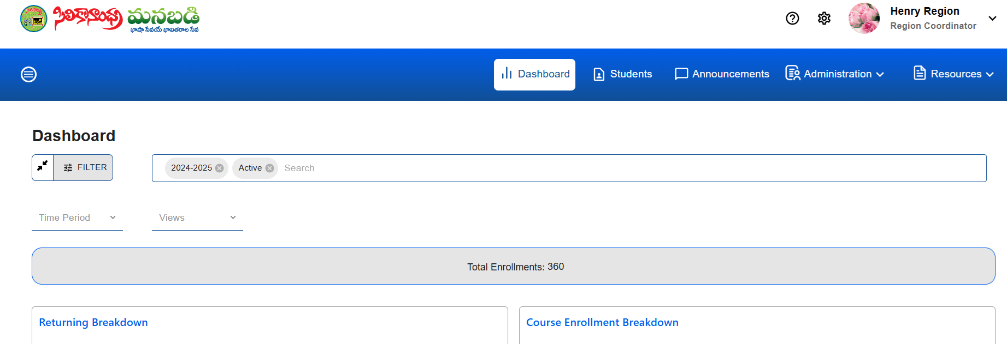

"The Region Coordinator assumes multiple responsibilities, serving as an Admin, Location Coordinator, and Teacher, ensuring smooth administrative operations, effective coordination across locations, and high-quality instruction for students."

**Hamburger Icon for Navigation**:

* A **hamburger icon** is located at the top-left corner of the dashboard.
* Clicking on this icon opens a **navigation menu**.
* From this menu, the coordinator can access the **Location Pane**l and **Teacher Panel**

**Dashboard** :

The dashboard provides a comprehensive explanation of total enrollments by utilizing multiple data visualizations and charts. This integrated use of graphical representation enables users to understand enrollment trends from multiple perspectives.

"Locations without student enrollments are not displayed on the dashboard. This ensures that only regions with active enrollments are visible, making it easier for users to focus on relevant data."

**Validation for each field :**

**FILTER** : When we click the filter field, it displays 'Search by Filters'.

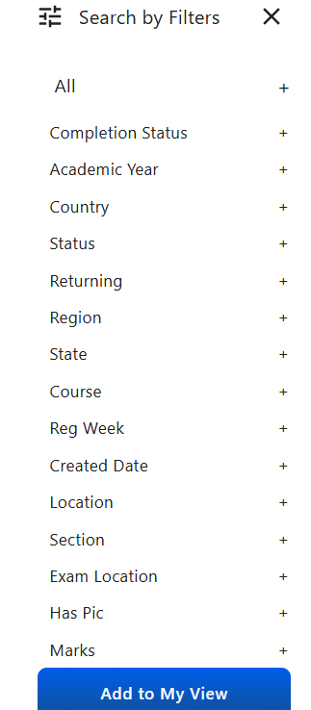

* **Filter Feature Overview: The search functionality allows users to refine results with a set of 15 filters. These filters provide flexibility in narrowing down the data based on multiple criteria.**

**Label: "Search by Filters"**

**Available Filters:**

* **Completion Status**
* **Academic Year**
* **Country**
* **Status**
* **Returning**
* **Region**
* **State**
* **Course**
* **Reg Week**
* **Created Date**
* **Location**
* **Section**
* **Exam Location**
* **Has Picture**
* **Marks**

Users can apply one or more of these 15 filters to refine their search and obtain specific results related to enrollments, courses, or student data.

The filters are working for both AND and OR conditions.

"For example, if we select Created Date and Location in the Search By filters, it will apply the OR condition, displaying results that match either the selected Created Date or Location."

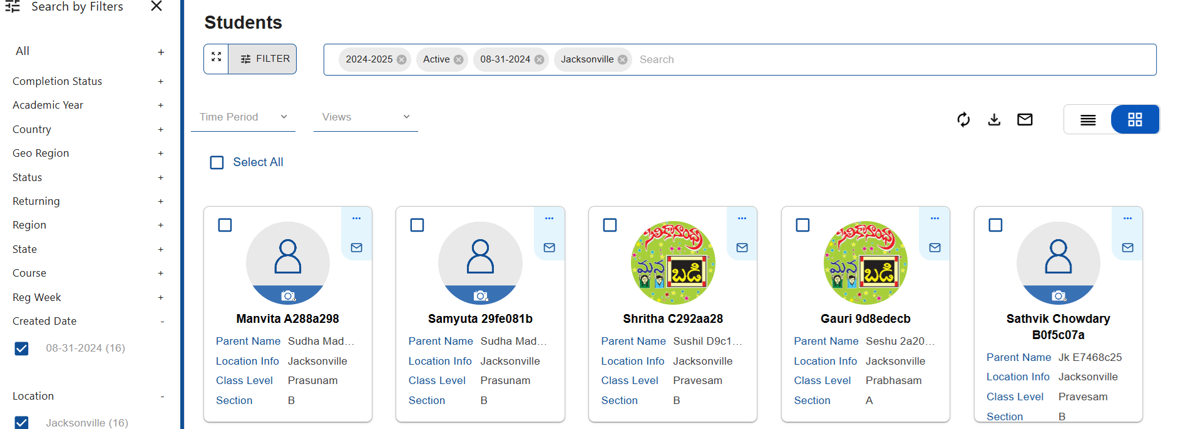

"For example, if we select Pravesam Course from the Search By filter, and Prasunam from the search bar, it will apply the AND condition, displaying results that match both the selected Pravesam Course and the Prasunam search term."

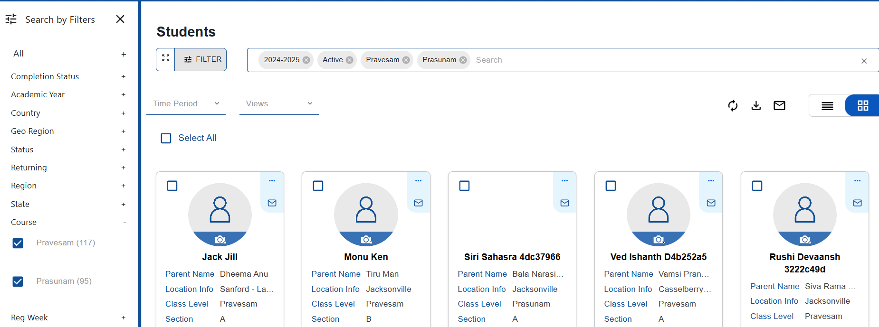

The search functionality includes a feature to allow users to customize their view by adding filters to "My View." When users apply filters, they can save their customized view with a title for easy reference.

**Add to My View**:

* When the **"Add to My View"** button is clicked, a pop-up window appears.
* The pop-up contains a **Title Field**, where users can enter a title for the saved view (e.g., "My Custom Enrollment View").
* The pop-up may also include options to save the current filters or modify them before saving.

**SEARCH BAR** : The search bar, by default, displays the current year and 'Active' status.

The **Search Bar** allows users to quickly find specific data, whether it's related to courses, enrollments, or other information. It is designed to be intuitive, allowing users to type keywords and filter results based on their input.

The **Search Bar** is prominently placed at the top ,easily accessible to users.

It is labeled with a prompt like "**Search**" to indicate its purpose.

**Functionality**:

* Users can type in keywords, such as course names, enrollment status, or other criteria.
* The system dynamically displays matching results as the user types (auto-suggestions).

A **"Search by Filters"** link can appear left of the search bar to access additional filtering options.

**TIME PERIOD** : A time period dropdown with options for Year,Today,Week, Month, and Across Year.

**Year** : When the "Year" option is selected from the time period dropdown, display the total number of enrollments categorized by each year.

**Today** : When the "Today" option is selected from the time period dropdown, display the total number of enrollments for the current day.

**Week** : When the "Week" option is selected from the time period dropdown, display the total number of enrollments for the current week.

**Month** : When the "Month" option is selected from the time period dropdown, display the total number of enrollments for the current month.

**Across Year** : When the "Across Years" option is selected from the time period dropdown, display the total number of enrollments aggregated across multiple year.

In the total enrollment display, the current year's total should be highlighted in **blue** for easy identification.

**Views Field**:

* A **Views** field (or section) displays all the saved custom views.
* Users can select from their saved views to quickly apply the same filter settings they had previously configured.

**Total Enrollments** :

The **Total Enrollments** field displays the total number of enrollments within a specified time period, allowing users to quickly view the overall enrollment count.

**Returning Breakdown :**

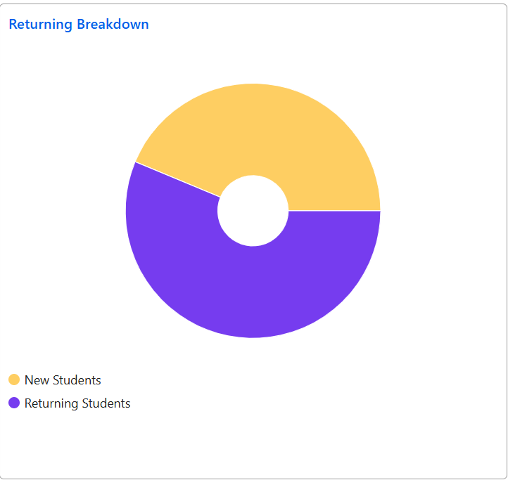

This section shows the distribution of students categorized as **New** and **Returning**.

**Categories**:

* **New Students**: Students who are enrolling for the first time.
* **Returning Students**: Students who have previously enrolled and are returning.

The data is displayed using a **Pie Chart**, where:

* One segment represents **New Students**.
* Another segment represents **Returning Students**.

The chart visually conveys the percentage of each category for easy comparison.

**Dynamic Updates**: The chart can update dynamically based on filter selections (e.g., by course, academic year, region).

**Hover-over functionality**: Users can hover over each segment to see the exact number or percentage of students in each category.

**Course Enrollment Breakdown :**

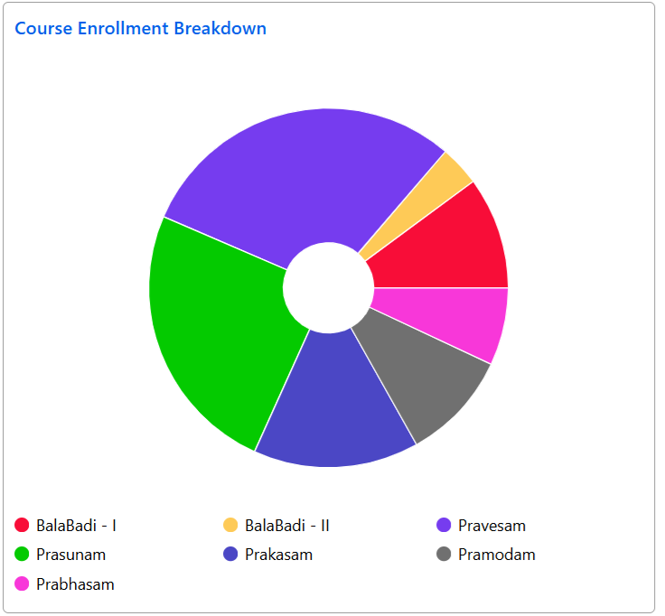

This section provides an overview of how enrollments are distributed across various courses.

**Courses Displayed**:

* The pie chart shows the following courses:
  + **BalaBadi - I**
  + **BalaBadi - II**
  + **Pravesam**
  + **Prasunam**
  + **Prakasam**
  + **Pramodam**
  + **Prabhasam**
  + **Telugu-1**
  + **Telugu-2**
  + **Telugu-3**
  + **Telugu-4**
  + **Prabodham**

**T**he data is displayed in a Pie Chart, where each course is represented as a segment of the pie.

Each segment’s size corresponds to the number of enrollments in that particular course.

The chart will display the percentage of total enrollments for each course.

**Hover-over functionality**: Users can hover over each segment of the pie chart to view the exact number of enrollments and the percentage for each course.

**Dynamic Updates**: The chart can update based on selected filters(e.g., time period, region, or status).

**Geo Region Breakdown :**

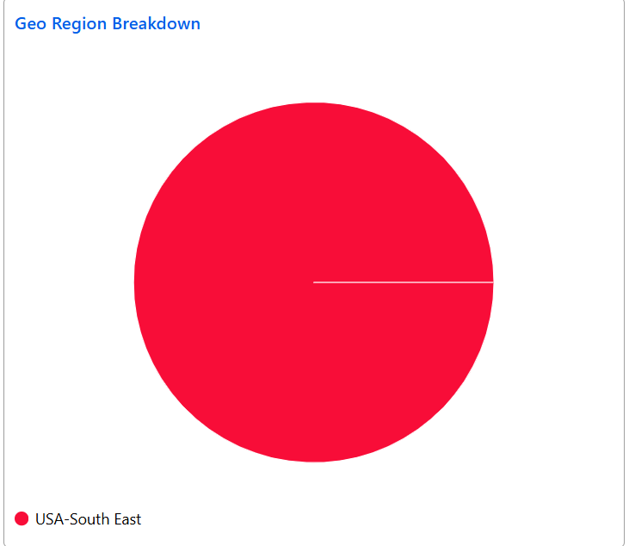

The Geo Region Breakdown pie chart provides a visual representation of data distribution within the selected geo region.

This chart is designed to help users easily compare and analyze the contribution of various areas to a selected metric, such as student enrollment.

Provides a clear and immediate visual comparison between different areas within the region.

The size of each segment reflects the percentage contribution of that area to the total value of the chosen metric.

**Maps:**

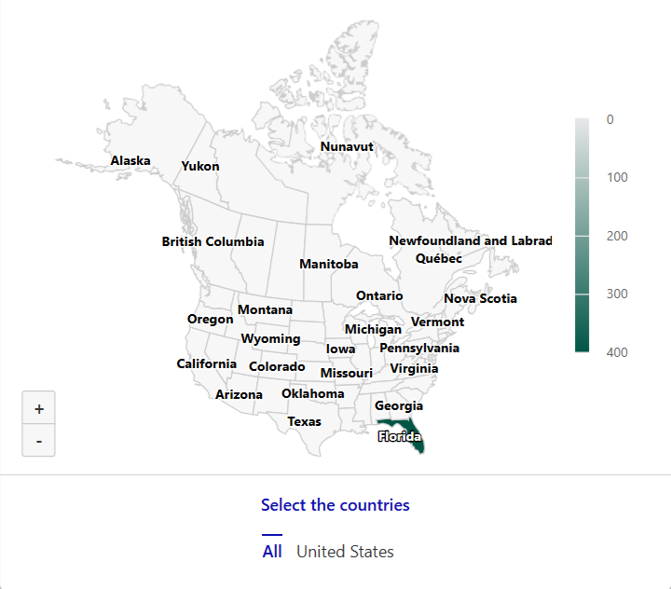

* Offers a geographical visualization of enrollment data to pinpoint where enrollments are concentrated.

**Enrollment Breakdown By Week :**

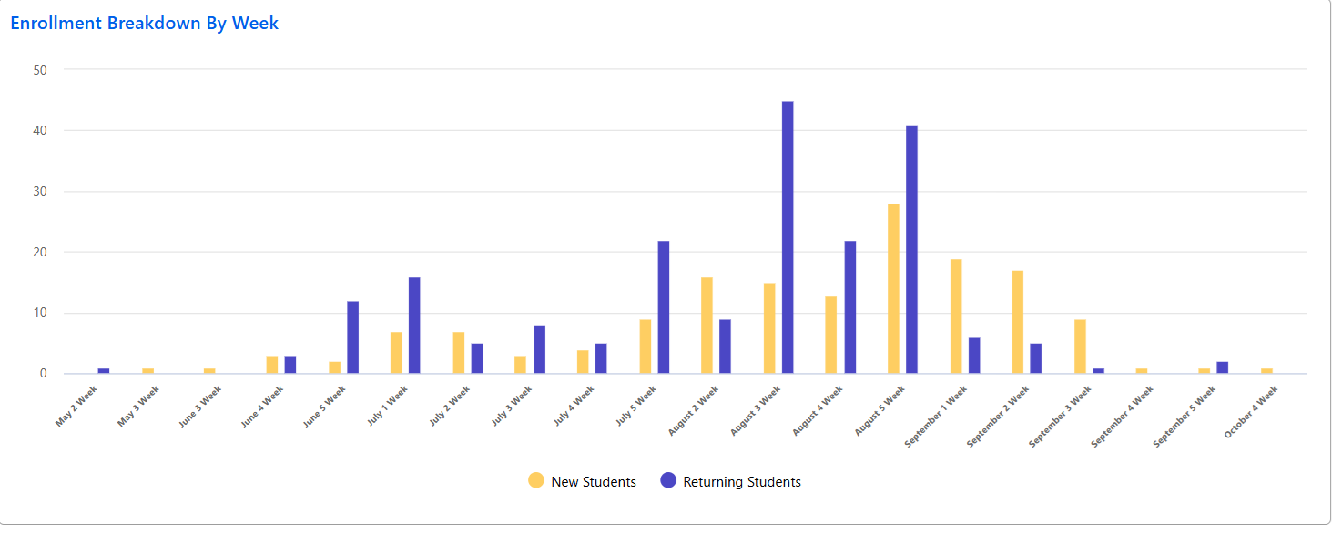

The Enrollment Breakdown By Week display provides an analysis of student enrollment trends, focusing on the categorization of new and returning students over specific weeks.

* Weekly Display:
  + Enrollment data is segmented by week, showing how the number of new and returning students changes over time.

The data is often presented through bar charts, allowing for easy comparison of weekly trends.

**Students :**

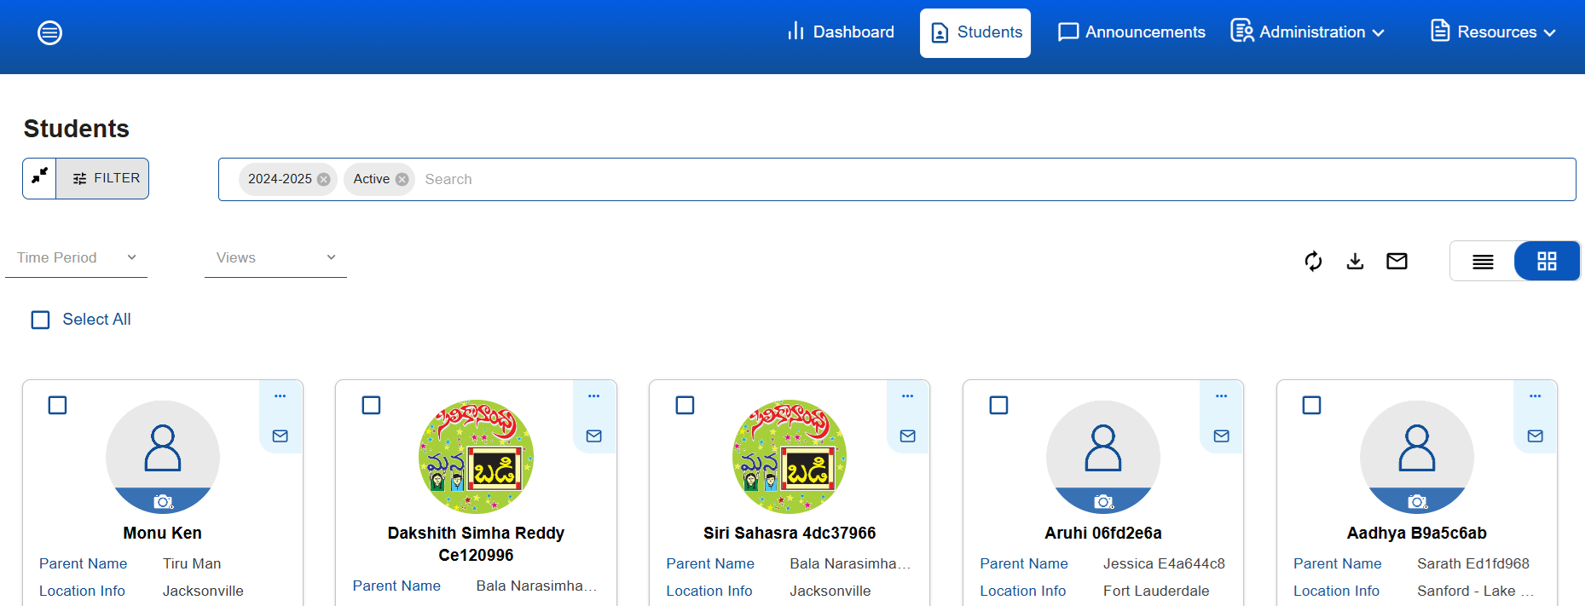

"The Student tab represents all the students included in the data, highlighting their details and relevant metrics instead of using graph representations."

"The Student tab offers two views, List View and Grid View, both accessible from the top right corner."

In the students tab, the user interface and functionality is the same as the dashboard that includes features such as a search bar, filters, time period, and view fields.

**Grid View :**

**Load More :**

In the **Students** tab, the interface displays a maximum of 100 students per page to maintain clarity and usability. Users have the option to view additional students through a **Load More** button, which loads subsequent batches of 100 students at a time. This design ensures efficient data presentation while allowing users to seamlessly navigate through larger sets of student information.

Before loading more, the total number of students will be displayed.

For Example : Total Students 100 of 363

**Select All :**

The **Students** tab includes a **Select All** checkbox, allowing users to quickly select all displayed students on the current page. Additionally, each student has an individual checkbox, enabling users to select or deselect single students as needed. This feature provides flexibility for bulk actions or individual student selection.

**Individual Student Information :**

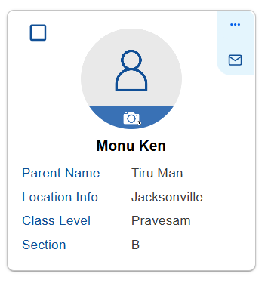

* Each individual student entry includes an **Options** menu located at the top right corner, providing various actions related to that student. Additionally, a **Send Mail** icon is available, enabling users to quickly send an email directly from the student's profile. This setup enhances user efficiency by offering convenient, on-the-spot access to key functions.
* Each individual student entry has a **checkbox** located at the top left side, allowing users to select or deselect that student easily.
* In the center of each student entry, users can see the **student's image space**, providing a visual reference. Directly below the image, the **student's name** is displayed for easy identification.
* In the student information section, beneath the **student's name**, users can view additional key details, including the **Parent Name**, **Location Info**, **Class Level**, and **Section**.
* "This structured layout provides a comprehensive overview, allowing for quick access to important student-related information at a glance.

Options :

The "Options" button typically provides features such as:

* **Password Recovery**
* **Swap Course and Location**

**Password Recovery:** This option would likely allow the user to reset or assist with the student's password recovery.

When we click the **Password Recovery** option, a password recovery pop-up will appear with the message: *"Do you want to send an email to reset the password?"* This pop-up includes two buttons: **Cancel** and **Confirm**.

If we click **Cancel**, the action will be canceled.

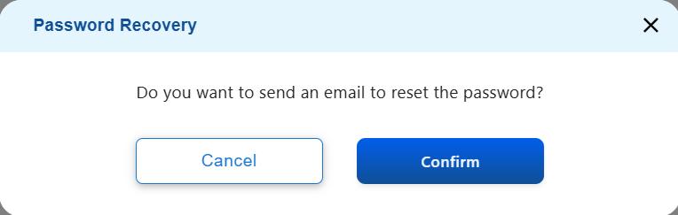

When we click **Confirm**, a pop-up appears with the message: *"Check your email to reset your password. We've sent an email to [email]@gmail.com. Click on the link in the email to reset your password. This link will be active for 48 hours."*

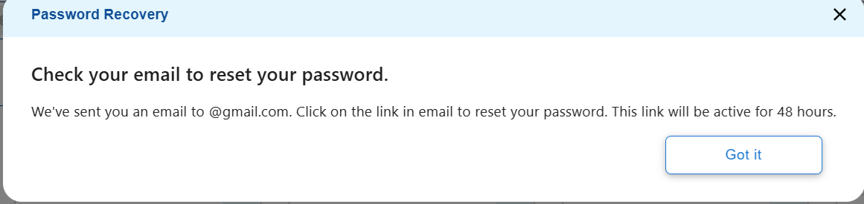

*After clicking* ***Got it****, parent will receive a password reset email formatted as follows:*

***From:*** *support@manabadi.siliconandhra.org****Time:*** *12:20 PM (3 minutes ago)****To:*** *[Recipient's email]*

***Subject: Password Reset Request***

***Dear Tiru Man,***

*Namaskaram!*

*Hope you are doing well! We’ve received a request to reset the password for the following ManaBadi student:*

***Student Name:*** *Monu Ken****Student ManaBadi Email ID:*** *monu.ken@test.mb.siliconandhra.org*

*[****Click here to reset password****]*

*Note: The above link is valid for 48 hours only.*

*Always use these student credentials to log in to the ManaBadi portal system (manabadi.siliconandhra.org), the ManaBadi Gmail account (Gmail.com), and Google Classroom (classroom.google.com). This is a single sign-on, and the same credentials will work for all platforms.*

*If you have any questions, please contact ManaBadi:*

***Email ID:*** *support@manabadi.siliconandhra.org****Contact number:*** *1 (844) 626 – BADI (2234)*

***Best wishes from ManaBadi!***

***Thanks & Regards,****SiliconAndhra ManaBadi*

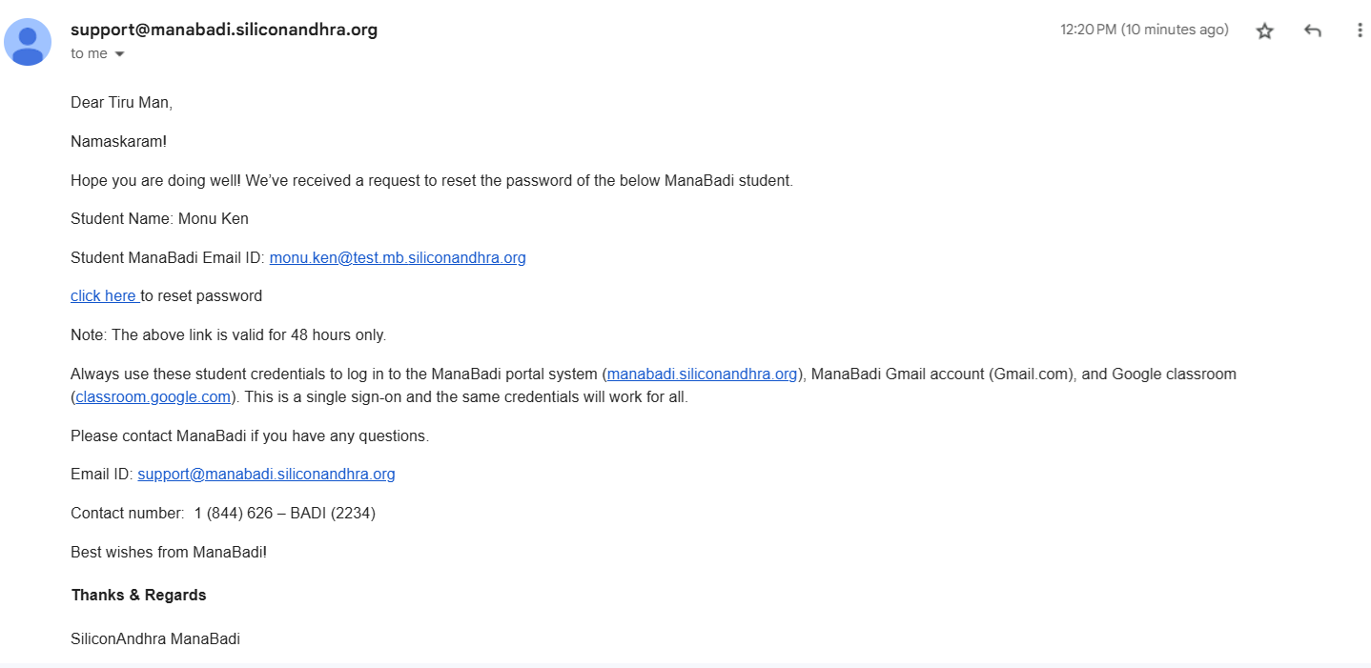

*In the email, if we click on* ***"Click here to reset password,"*** *it navigates to the Reset Password page.*

*In this pop-up, the heading reads:* ***"Please enter a new password."***

*The form includes:*

* ***New Password*** *field with the following conditions:*
  + *Must contain at least 8 characters.*
  + *Must include both lowercase (a-z) and uppercase letters (A-Z).*
  + *Must contain at least one number (0-9) and a special character.*
  + *Must not include your email address.*
* ***Confirm Password*** *field for re-entering the new password.*

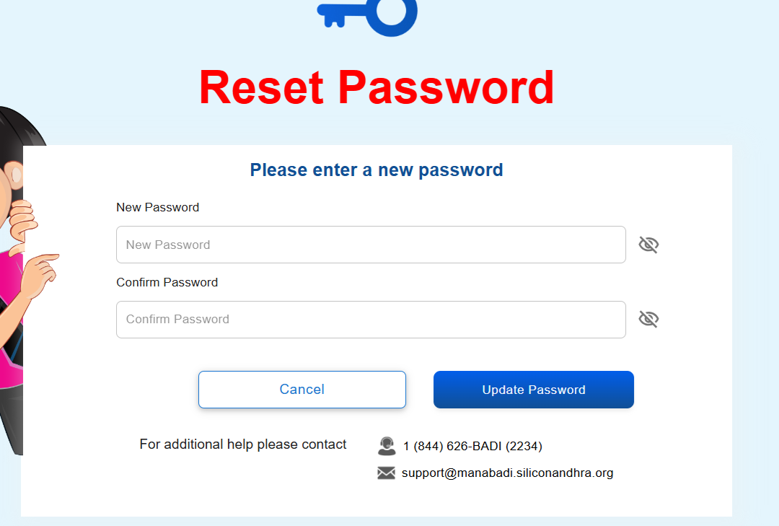

On the reset password page, there are two buttons: **Cancel** and **Update Password**.

Below the buttons, the following support message is displayed: *For additional help, please contact***1 (844) 626-BADI (2234)**[**support@manabadi.siliconandhra.org**](mailto:support@manabadi.siliconandhra.org)

**Note : This link is valid for 48 hours only.**

The **Confirm Password** and **New Password** fields must match. If they do not, an error message will be displayed: *"Passwords must match."*

After entering the **New Password** and **Confirm Password**, clicking **Update Password** will update the password. A message will then appear: *"Your password has been reset successfully."*

*You will be automatically redirected to the Login Screen,if not redirected click here.*

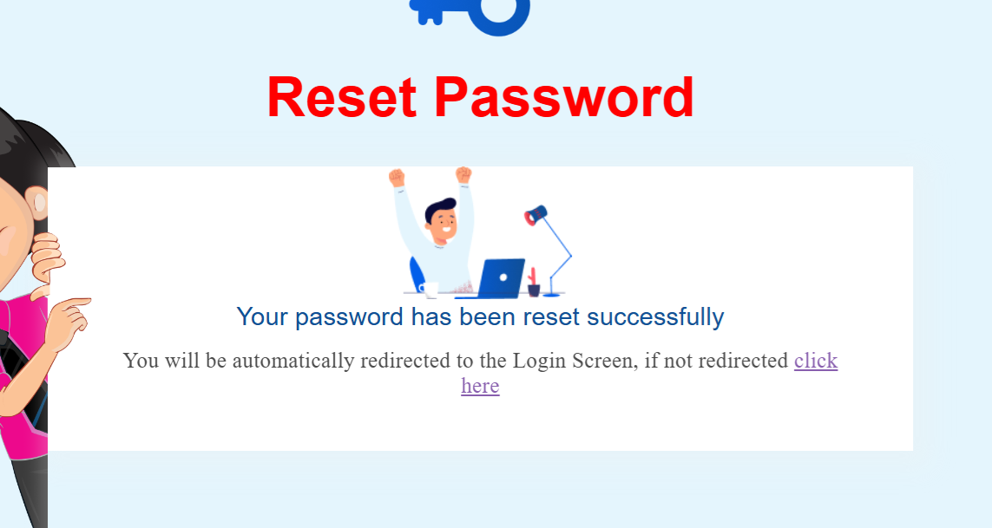

After a few seconds it navigates to the login screen.

If we click **Cancel**, the action will be canceled.

Swap Course and Location:

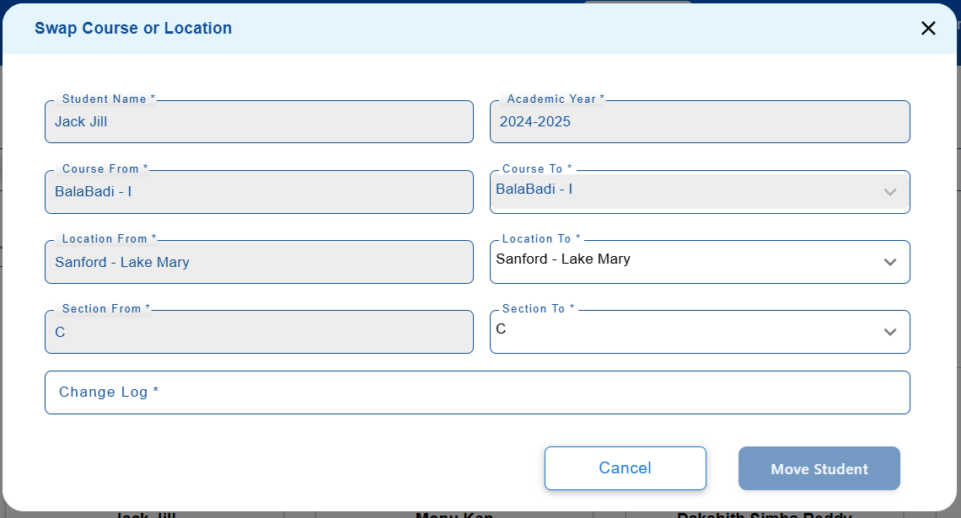

If we click **Swap Course and Location**, only the **location** will be swapped, not the course. This feature allows the user to transfer the student to a different location, but the course remains unchanged.

The **Swap Course or Location** section includes the following fields:

* **Student Name** (grayed out,not changeable)

The Student Name field displays the name of the student

* **Academic Year** (grayed out,not changeable)

The Academic Year field displays the current academic year of the student.

* **Course From** (grayed out,not changeable)

The Course From field displays the current course the student is enrolled in

* **Course To** (grayed out,not changeable)

The Course To field displays the course assigned to the student.

This field reflects the course the student is currently enrolled in.

* **Location From** (grayed out,not changeable)

The Location From field displays the current location of the student

* **Location To**

The Location To field allows the user to select the new location to which the student will be moved. This field displays the available locations based on the selected region.

* **Section From** (grayed out,not changeable)

The **Section From** field displays the current section of the student. This field is grayed out and not changeable, as it reflects the student's existing section.

* **Section To**

The Section To field allows the user to select the new section to which the student will be moved. This field will display only the available sections (A, B, and C) based on the selected location.

Additionally, there are the following options:

* **Change Log**
* **Cancel Button**
* **Move Student**
* Location To :

The **Location To** dropdown will display the active locations available under the specific region for selection.

* Section To :

The **Section To** dropdown field will display only the available sections based on the selected location.Generally, there are three sections available: **A**, **B**, and **C**.

* Change Log :

The **Change Log** field will display a record of all changes made during the **Swap Course or Location** process, including details such as the previous and updated values for location and section.

After making the changes, if we click **Move Student**, it will update the student's **location** and **section** based on the selected values.

An email to be sent to the parent after their child's location has been swapped or changed

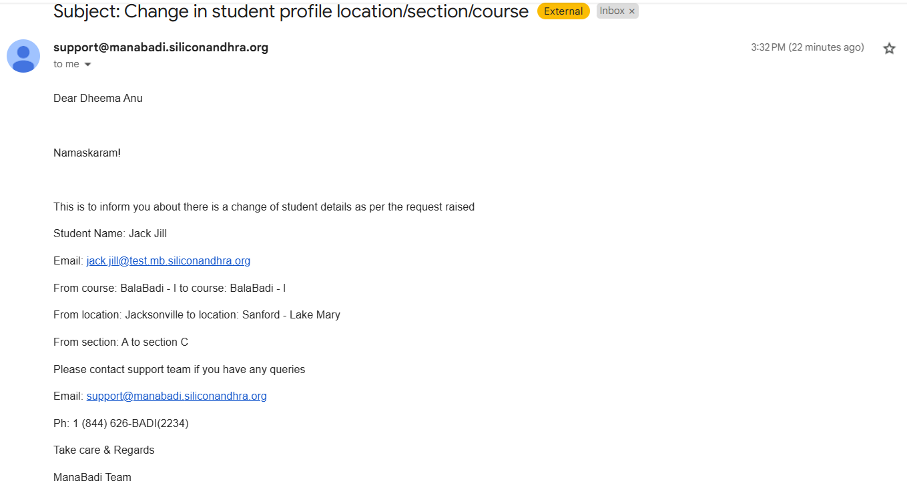

**NOTE : "Once the student has completed the course, we are unable to swap the location. The following message will be displayed: 'Cannot make changes to this student as he/she has completed the course.'"**

**Send Mail : (Individual student info)**

"Clicking the 'Send Mail' icon will navigate you to the announcement page."

"Whether for an individual student or by selecting the 'Select All' option, clicking the 'Send Mail' icon will navigate to the announcement page."

**Send Mail :**

Without selecting the student, we are able to click the send mail icon.

"In the top right corner, we will find the 'Send Mail' icon. Whether for an individual student or by selecting the 'Select All' option, clicking the icon will navigate you to the announcement page."

**List View :**

"In List View, you can see the following headings:

**Picture :**

the Picture column, which displays the student's image.

**Student Name:** (sortable)

The Student Name field displays the name of the student

Student Name (sortable), indicating that it can be organized alphabetically or by custom order

**Parent Name** : (sortable)

"The 'Parent Name' column displays the parent's name."

**Location Info :** (sortable)

"The 'Location Info' column displays the student's location details."

**Class Level :** (sortable)

"The 'Class Level' column displays the student's class level."

**Section :**  (sortable)

"The 'Section' column displays the student's section."

**Registration Date :**  (sortable)

"The 'Registration Date' column displays the student's registration date, including the month and year."

**Actions :**

"The 'Actions' column has two icons: one for 'Options' and the other for 'Send Mail.'"

If we click options , we are able to see the 'Password Recovery' and 'Swap Course and Location.'

In the list view, the user interface and functionality is the same as the grid view that includes features such as send mail,options (includes password recovery and swap Course and Location).

* Additionally, "In List View, checkboxes are available for each student before the Picture column,

**Refresh Button :**

"The 'Refresh' button is located at the top right, before the List View and Grid View buttons."

"The 'Refresh' button allows you to reload the page and view the latest updates."

**Download :**

"The 'Download' button is located at the top right, before the List View and Grid View buttons."

The download button is enabled by default.

Without selecting the student, we are able to select the download button.

"Clicking the 'Download' button will navigate to the Reports pop-up."

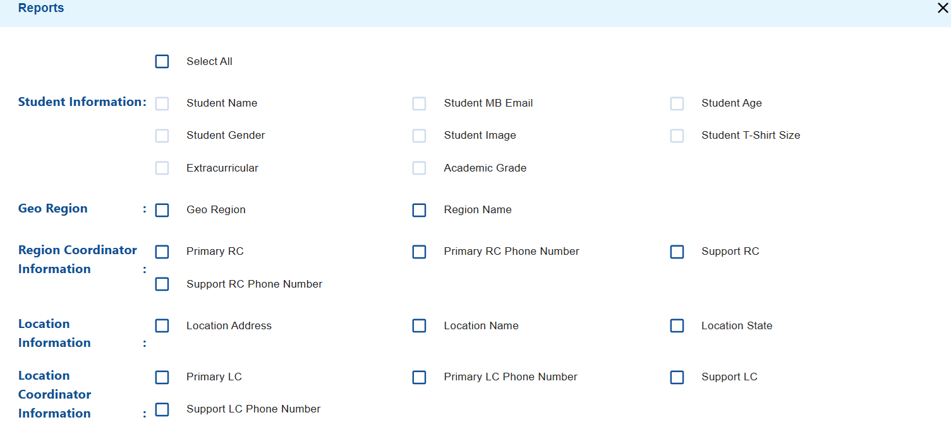

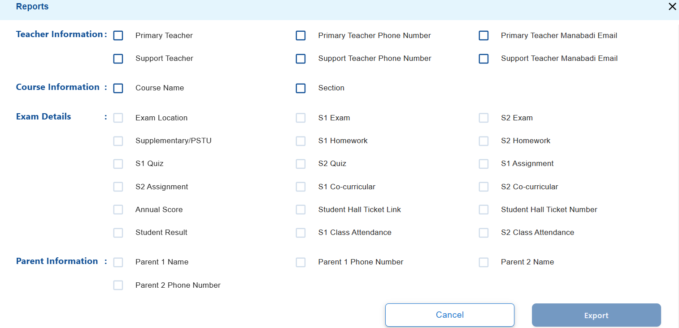

**"In the Reports pop-up, the following headings are available:"**

**Select All Checkbox :** Selecting the "Select All" checkbox selects all students in the backend, regardless of the fact that the frontend is limited to displaying only 100 students.

**Student Information:**

* Student Name
* Student MB Email
* Student Age
* Student Gender
* Student Image
* Student T-Shirt Size
* Extracurricular
* Academic Grade

These filters are available as checkboxes.

**Geo Region :**

* Geo Reg
* Region Name

These filters are available as checkboxes.

**Region Coordinator Information:**

* Primary RC
* Primary RC Phone Number
* Support RC
* Support RC Phone Number

These filters are available as checkboxes.

**Location Information :**

* Location Address
* Location Name
* Location State

These filters are available as checkboxes.

**Location Coordinator Information :**

* Primary LC
* Primary LC Phone Number
* Support LC
* Support LC Phone Number

These filters are available as checkboxes.

**Teacher Information :**

* Primary Teacher
* Primary Teacher Phone Number
* Primary Teacher Manabadi Email
* Support Teacher
* Support Teacher Phone Number
* Support Teacher Manabadi Email

These filters are available as checkboxes.

**Course Information :**

* Course Name
* Section

These filters are available as checkboxes.

**Exam Details :**

* Exam Location
* S1 Exam
* S2 Exam
* Supplementary/PSTU
* S1 Homework
* S2 Homework
* S1 Quiz
* S2 Quiz
* S1 Assignment
* S2 Assignment
* S1 Co-curricular
* S2 Co-curricular
* Annual Score
* Student Hall Ticket Link
* Student Hall Ticket Number
* Student Result
* S1 Class Attendance
* S2 Class Attendance

These filters are available as checkboxes.

**Parent Information :**

* Parent 1 Name
* Parent 1 Phone Number
* Parent 2 Name
* Parent 2 Phone Number

These filters are available as checkboxes.

* "At the bottom right side of the Reports pop-up, the 'Cancel' and 'Export' buttons are available."
* By default the Export button is disabled.
* "The 'Export' button will only be enabled once at least one filter checkbox is selected."
* "If no student is selected and the 'Download' button is clicked, the filter checkboxes for 'Student Information,' 'Exam Details,' and 'Parent Information' will be disabled."
* If a single student checkbox is selected or the "Select All" checkbox is used, clicking the download button will enable the checkboxes for 'Student Information,' 'Exam Details,' 'Parent Information,' 'Geo Region,' 'Region Coordinator Information,' 'Location Information,' 'Location Coordinator Information,' 'Teacher Information,' and 'Course Information.'
* If the "Select All" checkbox is selected in the reports pop-up, all enabled checkbox filters will be automatically checked.
* The options in the pop-up are presented as checkboxes, allowing multiple selections.for example,

Select the checkboxes for Geo Region, Primary RC, Primary LC, and Primary Teacher.

Select the checkboxes for Course Name, S1 Exam, Location Name, and Region Name.

* After selecting the filter checkboxes in the reports, clicking the export button will download the data based on the selected filters.
* After clicking the export button, a reports pop-up will appear saying, "Student’s/User’s CSV file is exporting to Google Drive. It may take a few minutes to complete."

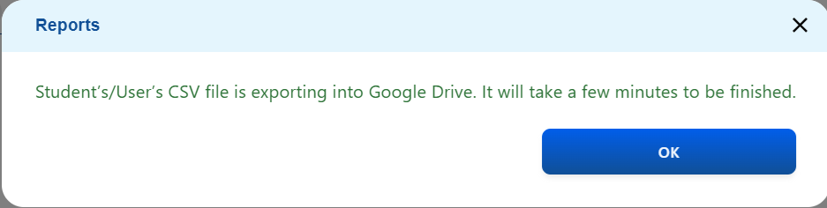

* Filters combination :

Apply the Completion Status filter to "Completed" and download the data for Student Name, Student Email, and Student Result

Apply the Academic Year filter to "2023-2024" and download the data for Student Name, Student Age, and Student Course Name.

Apply the Course filter to "Pravesam" and download the data for Student Name, Student Academic Grade, Student Result, S1 Exam Marks, and S2 Exam Marks.

* The system should restrict selecting multiple academic years from the filters, and the data should not be downloadable in such cases.
* The user can open their Google Drive and view the downloaded data in an Excel sheet.
* If the user downloads the data without selecting a student, the file name in the Excel sheet will appear in the following format(For Example): "User (2024-2025) - Tue Nov 19 2024 13:21:34 GMT+0530 (India Standard Time)."
* If the user downloads the data by selecting a student or selecting all students, the file name in the Excel sheet will appear in the following format(For Example): "Student (2024-2025) - Tue Nov 19 2024 13:31:33 GMT+0530 (India Standard Time)."
* The admin can view the coordinators' downloading file names in the "Exported Sheets" tab.

**Note:** The admin is not able to click on the file name; they can only view it.

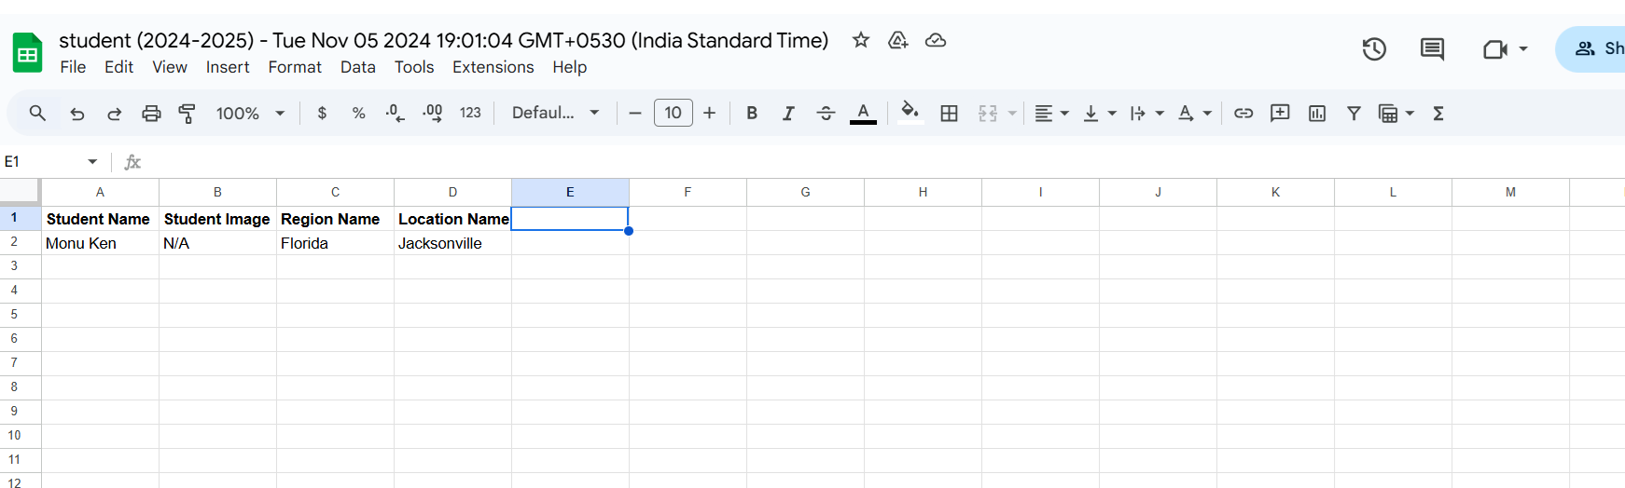

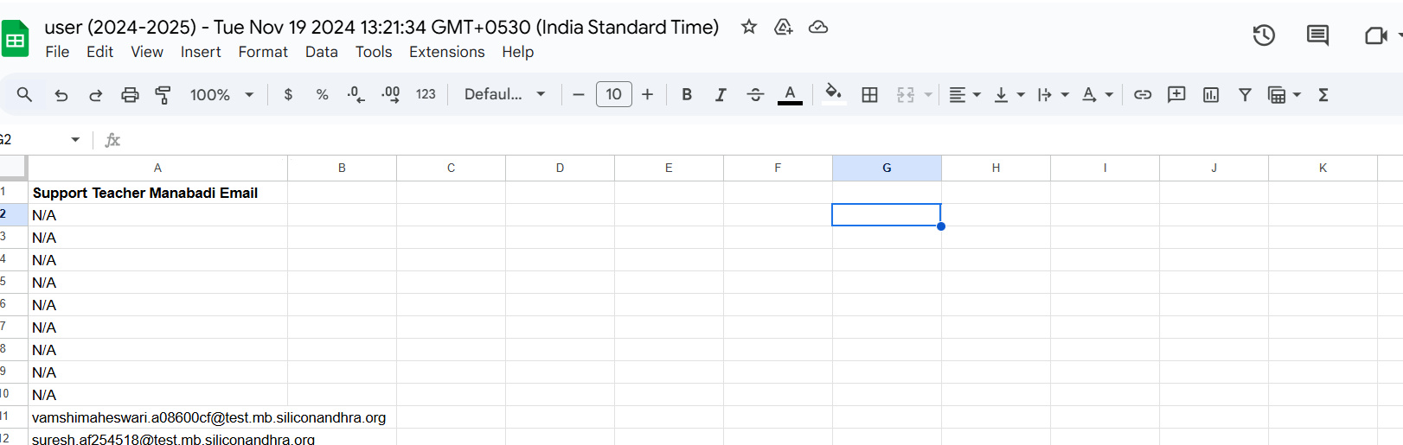

**Announcements :**

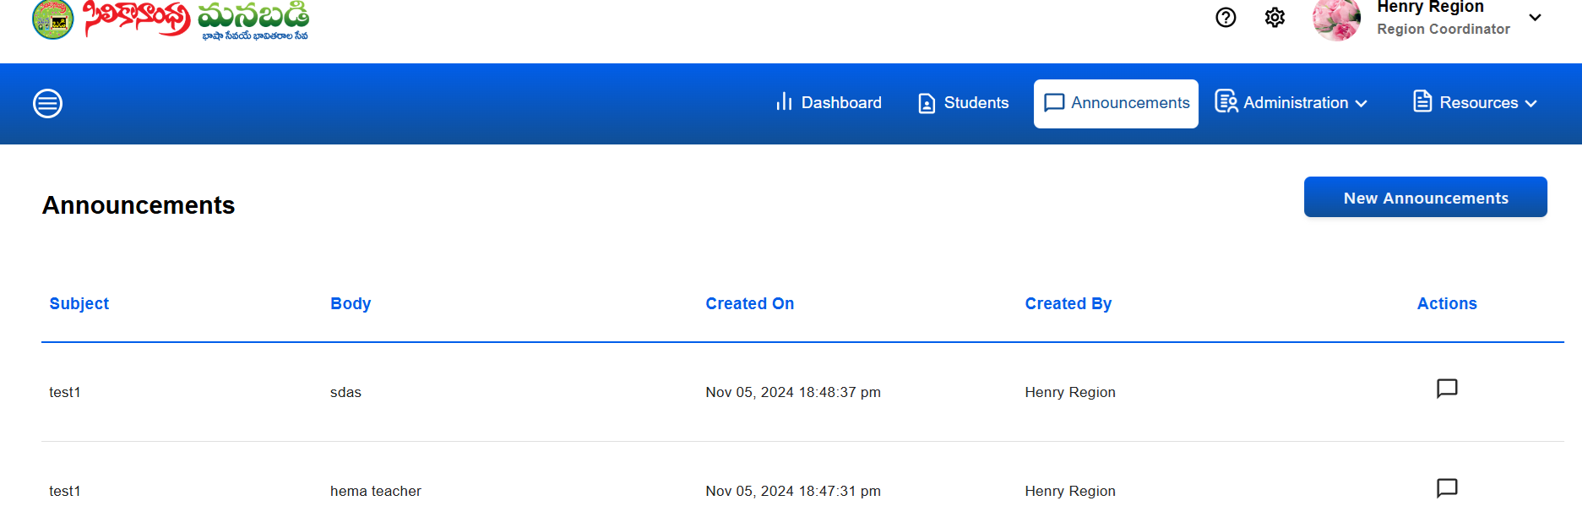

"To implement an Announcements tab, include headings such as **Subject**, **Body**, **Created On**, **Created By**, and **Actions** to organize and manage the display of announcement details effectively."

here's how it can be structured for clarity :

* **Subject:** A brief title or summary of the announcement.
* **Body:** The main content or details of the announcement.
* **Created On**: The date and time the announcement was created.
* **Created By**: The name or ID of the person who created the announcement.
* **Actions:** Interactive options like View Announcement.
* **View Announcement :**
* To implement a **"View Announcement"** button under the **Actions** column, which opens a popup to display the announcement details

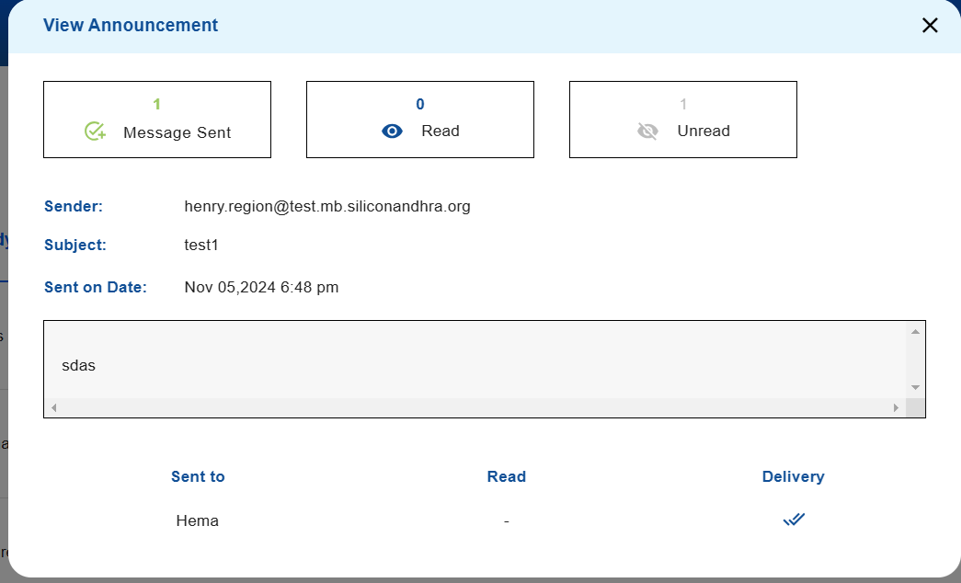

* "The **View Announcement** popup includes sections for **Message Sent**, **Read**, and **Unread** counts to provide detailed status information."along with the **Sender,** **Subject , Sent On Date(with time)and Body.**

**"Sent To"** refers to the recipient's email ID in the context of an announcement, indicating who the message was directed to.

**"Read:** The date and time when the recipient opened and read the announcement.**"**

**"Delivery:** A color-coded status indicating the delivery outcome:

* **Green Tick for successful delivery,**
* **Blue Tick for delivered but unread,**
* **Red Tick for failed delivery."**
* "The View Announcement popup features a close button in the top-right corner for easy dismissal."
* **Total Announcements :**
* The **Total Announcements** count will appear at the **bottom-right corner** of the Announcements tab.
* "Total Announcements" refers to the overall count of announcements displayed or managed within the Announcements tab.

**New Announcements :**

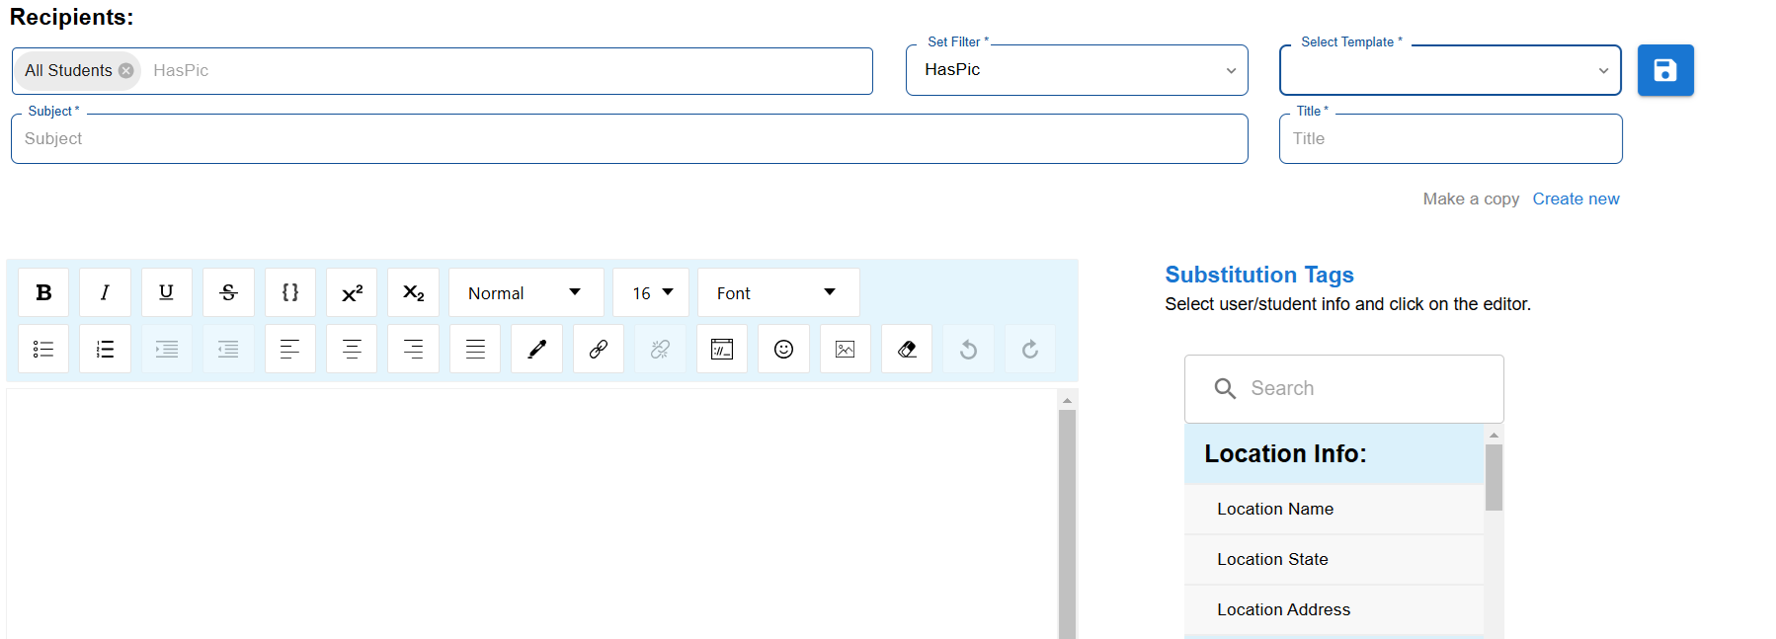

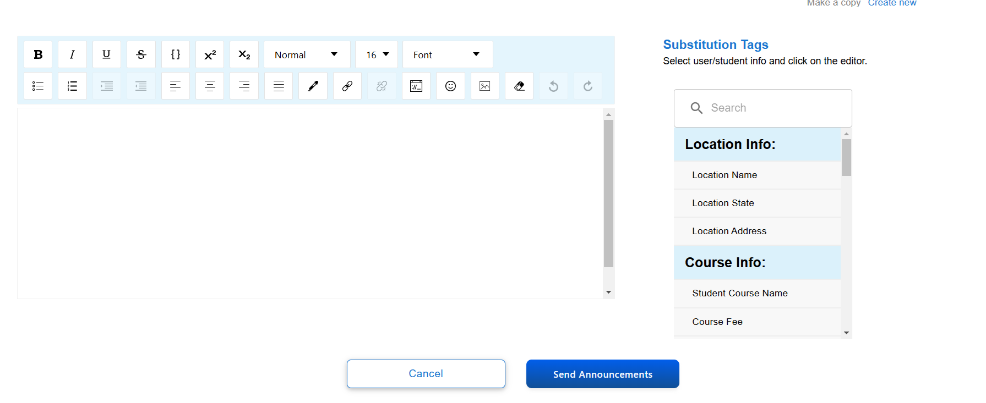

**Recipients :**

"While clicking the **New Announcements** button, users can see the **All Students** field displayed by default under the **Recipients** section."

**Set Filter :**

Set the filter dropdown with the following options:

**Role - User groups**: Choose groups like:

* + All Students
  + Location Coordinators
  + Primary Teachers
  + Support Teachers

**Region :** While selecting a region from the set filters, we can choose the entire region assigned to the respective region coordinator in the recipients.

**Academic Year :** The Academic Year filter displays all the years, including the current year, for selection**.**

**Completion Status** : The **Completion Status** filter displays options such as **Pursuing**, **Pass**, **Fail**, and other relevant statuses for selection.

**Course** : The available **courses** are displayed in the suggestion box for easy selection under recipients.

**Section :** The available sections are displayed in the suggestion box for selection under recipients.

**Location :** Under the selected Region, the available locations are displayed for selection.

**Student :** Students are displayed by their email ID.

**User** : User email IDs are displayed in the suggestion box by clicking the **User** set filter.

**Exam Center :** Exam Center displays the available exam centers for selection.

**Status :** Status is displayed with options for Active and Inactive in the suggestion box**.**

**Returning :** Returning displays options for Returning and New in the suggestion box**.**

**Registered Week** : **Registered Week** displays the month and date for filtering based on the specific registration week.

**Has Pic :** Has Pic displays options for True or False in the suggestion box.

**Subject:** A brief title or summary of the announcement.

**Select Template :** Select Template dropdown displays saved titles for quick selection.

**Save Icon :** By using the Save icon, a newly created title can be saved for future use.

**Title :** We can save our announcement under the Title field for easy reference and future use.

**Create New** : If we want to create a new title, the **Create New** option is available under the **Title** field.

**Make a Copy :** Clicking the **Make a Copy** option allows you to duplicate the announcement, including its content and settings, for editing or reuse.

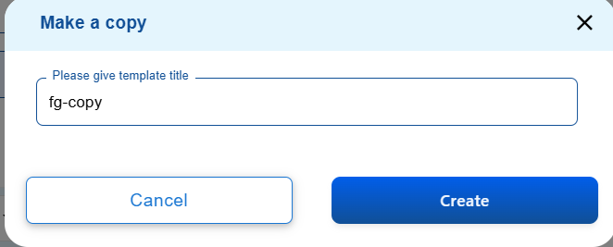

The **Make a Copy** pop-up contains a **Please give Template Title** field for entering a new title and options for **Cancel** and **Create** buttons.

The top corner of the pop-up has a **close button** symbol to exit without saving or making changes.

**Body :** The main content or details of the announcement

### **Text Formatting Toolbar :**

* Contains options for **bold**, **italic**, **underline**, **strikethrough**, **text color**, **background color**, **text alignment**, **hyperlinks**, **insert image**, and **emojis** to customize your announcement text.
* **Font Style and Size**: Adjust the font style and size to your preference.
* **Insert Substitution Tags**: Allows you to personalize the announcement with dynamic fields from the recipient’s information, such as location details or course information.

### **Substitution Tags :**

* A list of available tags is shown on the right (Location Info, Course Info,ExamDetails,Parent Info,student info).
* **Location Info Filters** (Substitution Tags):
* Location Name
* Location State
* Location Address
* **Course Info** (Substitution Tags):
* Student Course Name
* Course Fee
* Student Section
* Student Academic Grade
* **Exam Details** (Substitution Tags):
* Student Hall Ticket Link
* Semester 1 Marks
* Student Result
* Semester 2 Marks
* Supplementary Marks/PSTU Marks
* Student Average Score
* Student Hall Ticket Number
* Exam Location
* **Parent Info** (Substitution Tags):
* Parent 1 Email
* Parent 2 Email
* Parent 2 Profession
* Parent 1 Phone
* Home Address
* Parent Name
* Parent 2 phone
* Parent 1 profession
* **Student Info** (Substitution Tags):
* Students All Years Record
* Student shirt size
* Student Registration Date
* Student Gender
* Student Image
* Student DOB
* Student Name
* Student MB ID
* Student’s Current Year Record
* To use a tag, select it from the list, and it will appear in the announcement text. Tags will auto-fill with specific information for each recipient, making the message personalized.

### **Action Buttons :**

* **Cancel**: Discards the announcement and returns to the previous screen.
* **Send Announcements**: Sends the announcement to the selected recipients based on the applied filters.

While navigating from the **Students** tab, whether through the individual student email icon or the bulk email icon, it directs to the **Send Announcement** page only.And

The same feature is also available there.

**Administration :**

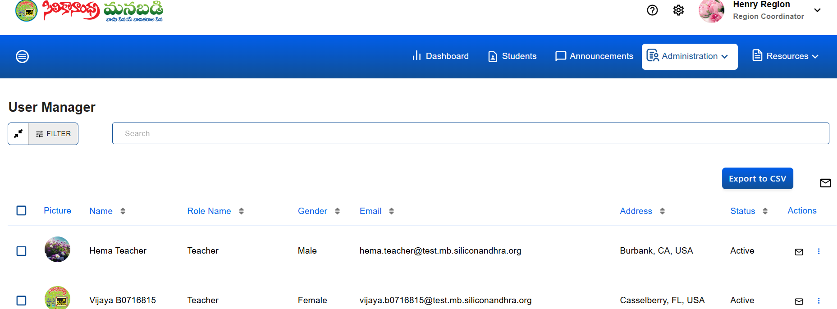

**User Manager :**

**FILTER** : When we click the filter field, it displays 'Search by Filters'.

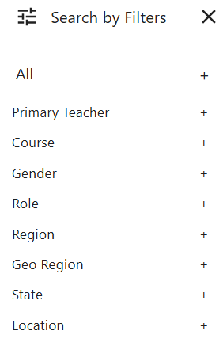

To implement filters in the **User Manager** module, include the following options:

### **Filters:**

**Primary Teacher :**

For the **Primary Teacher** filter, implementing it as a **true/false** checkbox.

### **Primary Teacher: True/False Filter**

* **True**: Filters and displays only users who are primary teachers.
* **False**: Filters and displays only users who are **not** primary teachers.
* **Default (Unchecked)**: Shows all users regardless of their primary teacher status.

### **Course Filter :**

### **Options:**

### **BalaBadi - I**

### **BalaBadi - II**

### **Pravesam**

### **Prasunam**

### **Prakasam**

### **Pramodam**

### **Prabhasam**

### **Telugu-1**

### **Telugu-2**

### **Telugu-3**

### **Telugu-4**

### **Prabodham**

### **Gender :**

Available Options :

* Male
* Female

**Role :**

Available Options :

* Region Coordinator
* Location Coordinator
* Teacher

**Region :** For a Region Coordinator, the Region field should display their assigned region.

**Geo Region :**

Under the Region field (showing the assigned region), you want to display the Geo Regions that fall under the assigned region for the Region Coordinator.

* Show a list of all Geo Regions belonging to the assigned region.

**State :**

Implemented a State Filter under the assigned Region for the Region Coordinator.

**Location :**

* + A list of locations (cities or districts) under the selected states is displayed.

**Search Bar :** The **Search Bar** allows users to quickly find specific data, whether it's related to Region, State, or Location section.. It is designed to be intuitive, allowing users to type keywords and filter results based on their input.

The **Search Bar** is prominently placed at the top ,easily accessible to users.

It is labeled with a prompt like "**Search**" to indicate its purpose.

the total number of user’s will be displayed.

For Example : Total Users 84 of 84

The **User Manager** interface can be structured to display the specified **headings** clearly and efficiently.

* Each individual user entry has a **checkbox** located at the left side, allowing users to select or deselect that user easily.

**Picture :**

the Picture column, which displays the user's profile picture.

**Name**:(Sortable)

* Full name of the user.

**Role Name:**(Sortable)

* Displays the role assigned to the user (e.g., Admin, Teacher,Location)

**Gender:**(Sortable)

* + Displays the gender of the user (e.g., Male, Female).

**Email:**(Sortable)

* Shows the user's email address.

**Address:**(Sortable)

* Displays the user's address.

**Status:**(Sortable)

* Indicates whether the user is Active or Inactive.

**Actions:**

Provides icon for performing actions such as:

**Send Mail Icon** (✉️):

* A small, clickable mail icon.

**Options :**

The "Options" button typically provides feature such as:

* **Password Recovery**

**Password Recovery:** This option would likely allow the user to reset or assist with the User's password recovery.

When we click the **Password Recovery** option, a password recovery pop-up will appear with the message: *"Do you want to send an email to reset the password?"* This pop-up includes two buttons: **Cancel** and **Confirm**.

If we click **Cancel**, the action will be canceled.

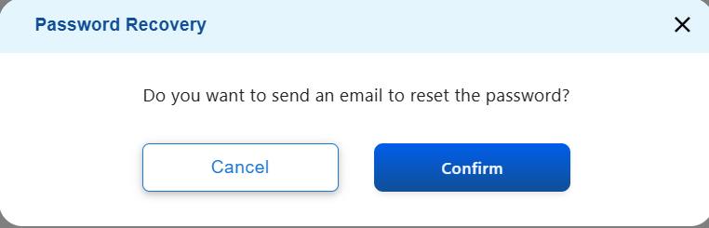

When we click **Confirm**, a pop-up appears with the message: *"Check your email to reset your password. We've sent an email to [email]@gmail.com. Click on the link in the email to reset your password. This link will be active for 48 hours."*

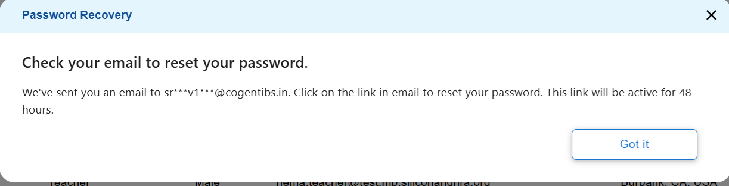

*After clicking* ***Got it****, user will receive a password reset email formatted as follows:*

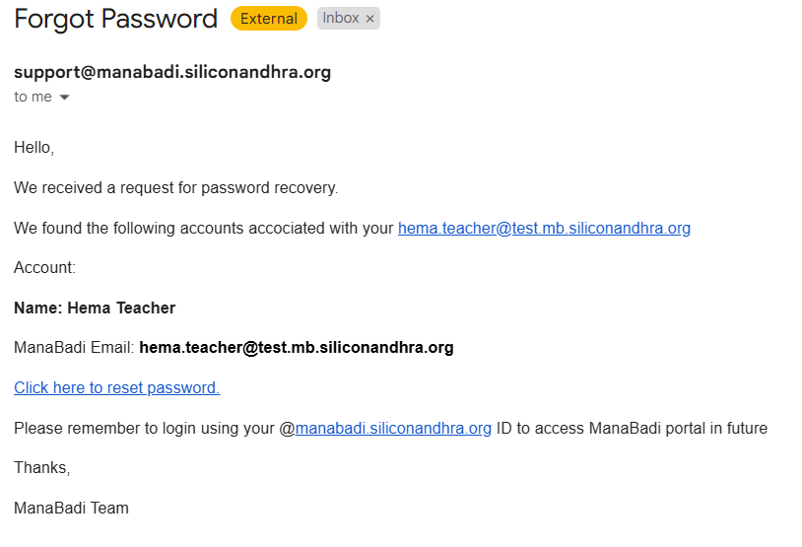

*In the email, if we click on* ***"Click here to reset password,"*** *it navigates to the Reset Password page.*

*In this pop-up, the heading reads:* ***"Please enter a new password."***

*The form includes:*

* ***New Password*** *field with the following conditions:*
  + *Must contain at least 8 characters.*
  + *Must include both lowercase (a-z) and uppercase letters (A-Z).*
  + *Must contain at least one number (0-9) and a special character.*
  + *Must not include your email address.*
* ***Confirm Password*** *field for re-entering the new password.*

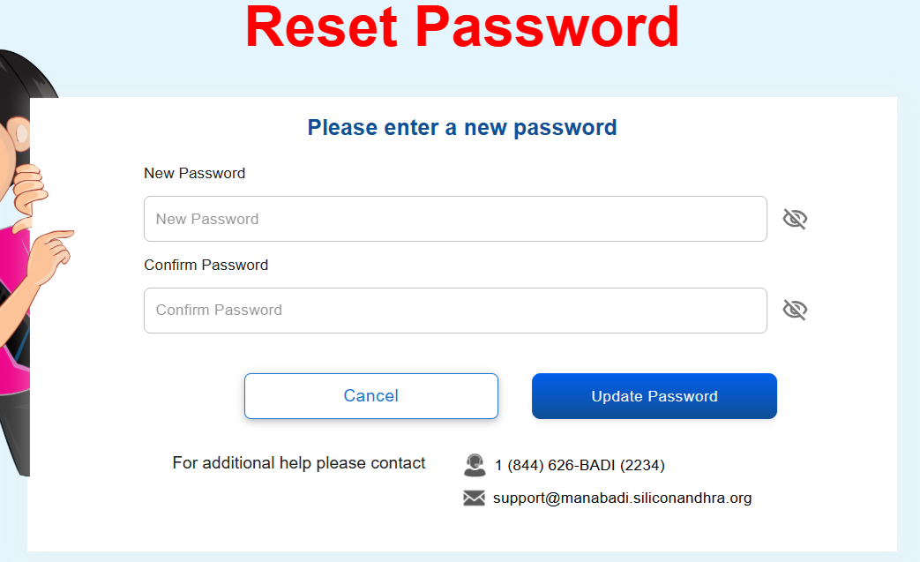

On the reset password page, there are two buttons: **Cancel** and **Update Password**.

Below the buttons, the following support message is displayed: *For additional help, please contact***1 (844) 626-BADI (2234)**[**support@manabadi.siliconandhra.org**](mailto:support@manabadi.siliconandhra.org)

**Note : This link is valid for 48 hours only.**

The **Confirm Password** and **New Password** fields must match. If they do not, an error message will be displayed: *"Passwords must match."*

After entering the **New Password** and **Confirm Password**, clicking **Update Password** will update the password. A message will then appear: *"Your password has been reset successfully."*

*You will be automatically redirected to the Login Screen,if not redirected click here.*

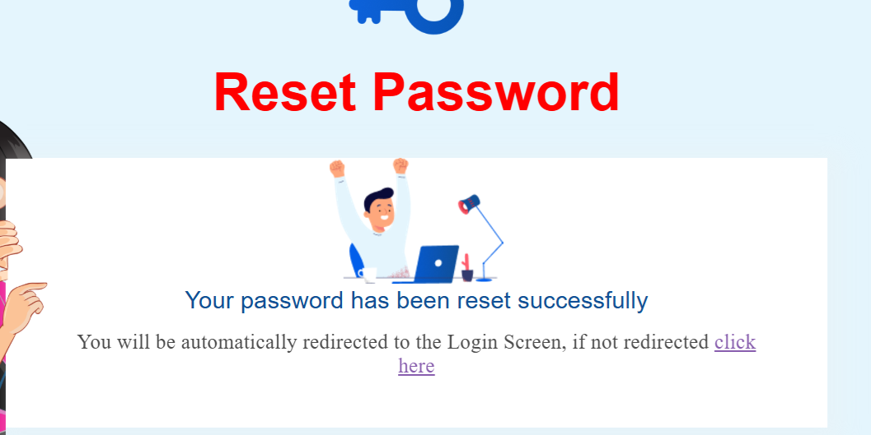

After a few seconds it navigates to the login screen.

If we click **Cancel**, the action will be canceled.

**Send Mail :**

In the top right corner, there is a Bulk Send Mail icon.

While navigating from the Administration tab, whether through the individual user email icon or the bulk email icon, it redirects to the Send Announcement page. The same feature is available on this page, except for **substitution tags**. Here, only (user-specific information) User Info : —User Contact Number, User Address, User Image, and User Name—is displayed.

**Export to CSV :**

An Export to CSV option is available on the top right side, highlighted in blue color.

Upon clicking the Export to CSV option, an Export CSV pop-up will appear.

The Export to CSV pop-up includes the following fields with check boxes: User Name, Status, Profile Photo, Manabadi Email, Role Names, Personal Email, Address, Contact Number, and Gender.

The Export to CSV pop-up includes two buttons: Cancel and Export.

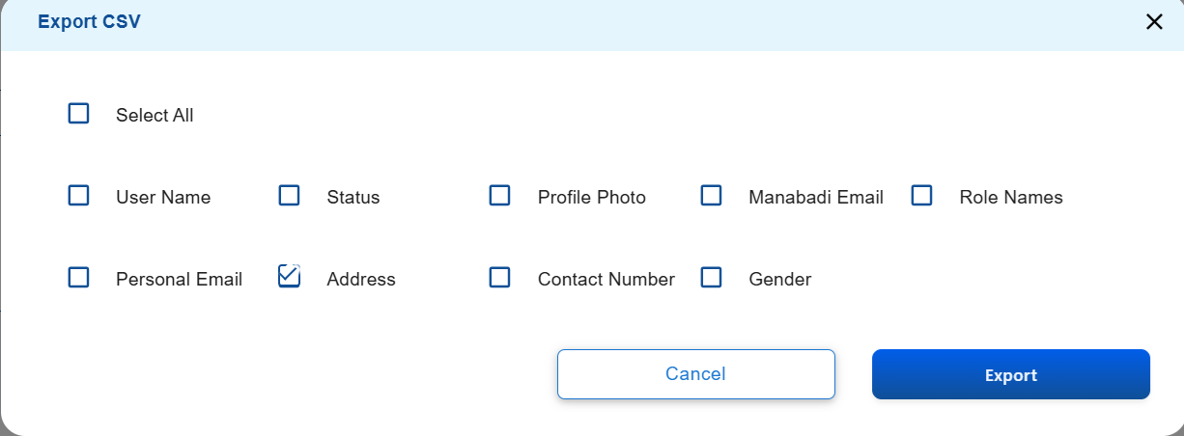

* Users are able to export data without needing to select any individual user.
* After selecting individual users or using the Select All option, clicking Export will generate a downloadable Excel sheet containing the selected data.

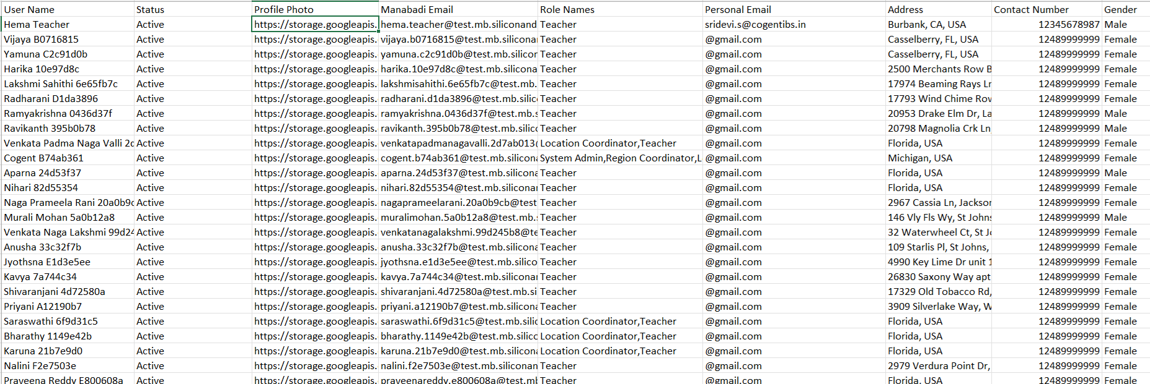

If we click **Cancel**, the action will be canceled.

The Export to CSV pop-up has a Close button in the top corner.

**Resources :**

the Resources section can be structured with two distinct options:

### **Resources**

* **Student Resources**
  + Access study materials, tools, and support designed to help students succeed academically and personally.
* **Teacher Resources**
  + Find teaching aids, professional development tools, and classroom management resources to enhance teaching effectiveness.

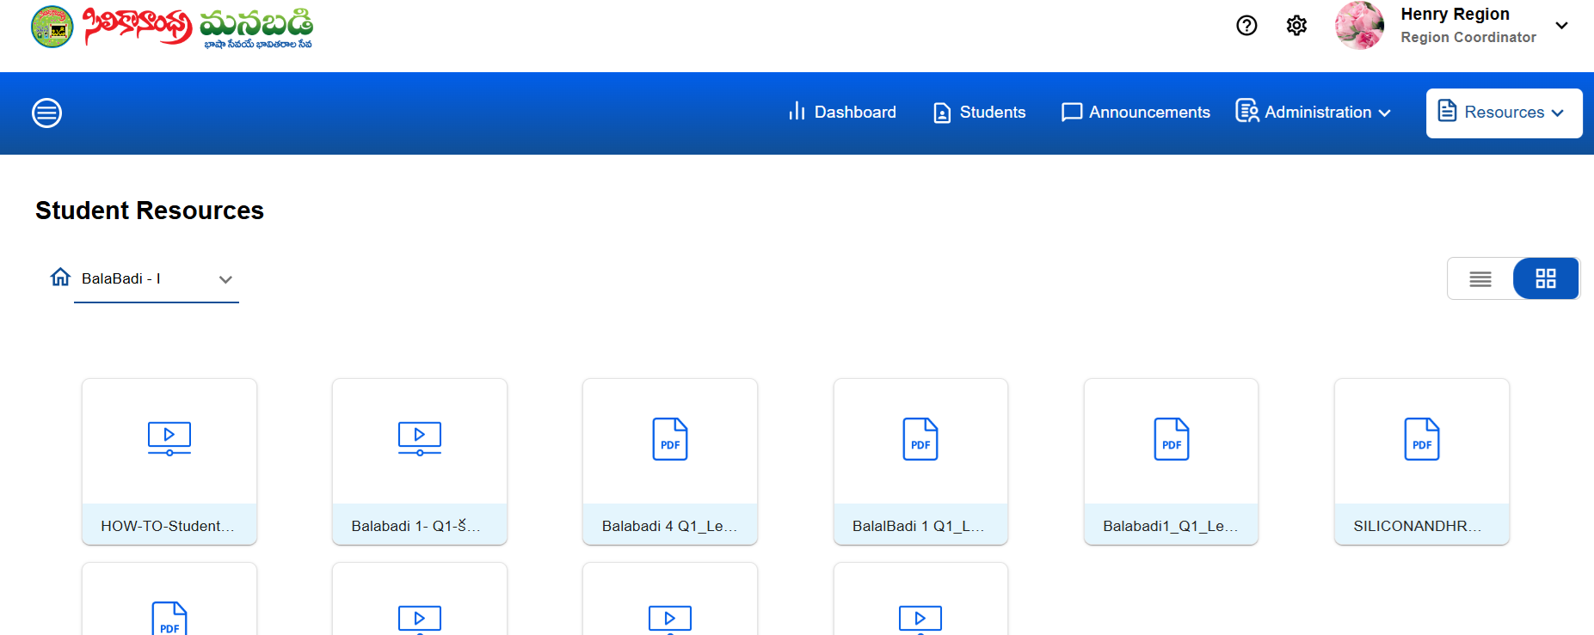

Both Student Resources and Teacher Resources offer the option to switch between List View and Grid View.

In Grid View, both Student Resources and Teacher Resources display a home icon, a course dropdown, and options for files.

In List View, both Student Resources and Teacher Resources display the following sortable columns: Name, Created On, Created By, Modified On, Modified By, File Size, and Status(Not sortable).

* **File Types**: Commonly includes PDFs and videos, though other formats may be supported depending on the system.
* At the bottom of the screen, Total Resources represents the overall count of available resources, including both Student Resources and Teacher Resources, displayed in both List View and Grid View.
* Users are able to view the resources but are not able to add files.

The Help icon and Settings icon are available in the top right corner, positioned before the Region Coordinator name.

**Help icon :**

The Help icon offers two options: **PSTU FAQs** and the **Help Site.**

**PSTU FAQs :**

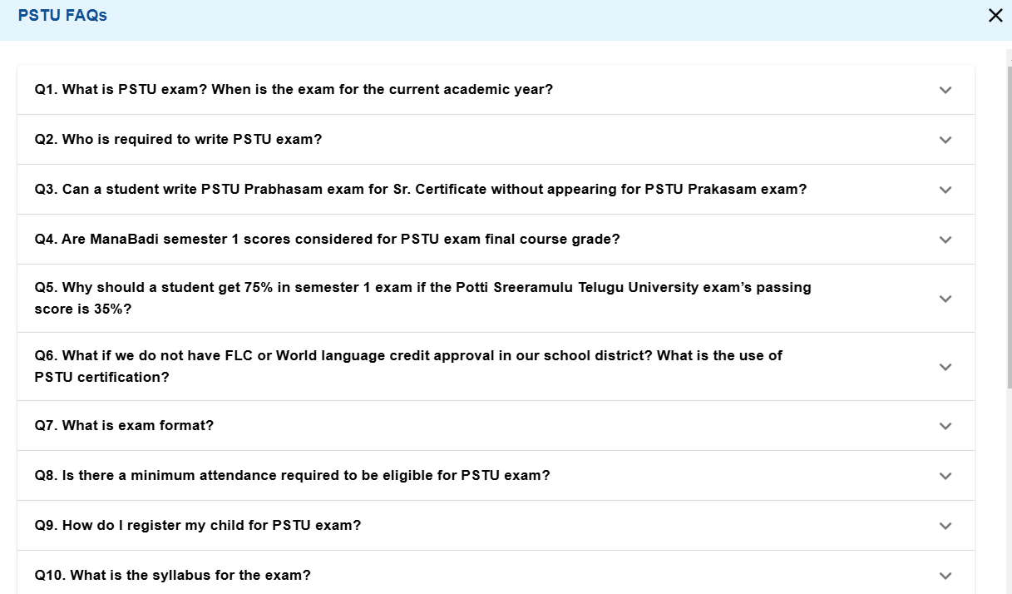

The PSTU FAQs option displays 17 questions covering various topics, including details about the PSTU course, exam information, and other related queries.

Each question in the PSTU FAQs has a dropdown for viewing the answer, and users are unable to edit or add questions.

Below the PSTU FAQs section, a message is added:  
'If you have any further questions, please call SRIDEVI GANTI at 510-364-2493 or email sridevi.ganti@manabadi.siliconandhra.org' in the pop-up.

A close button is available in the corner of the pop-up.

**Help Site :**

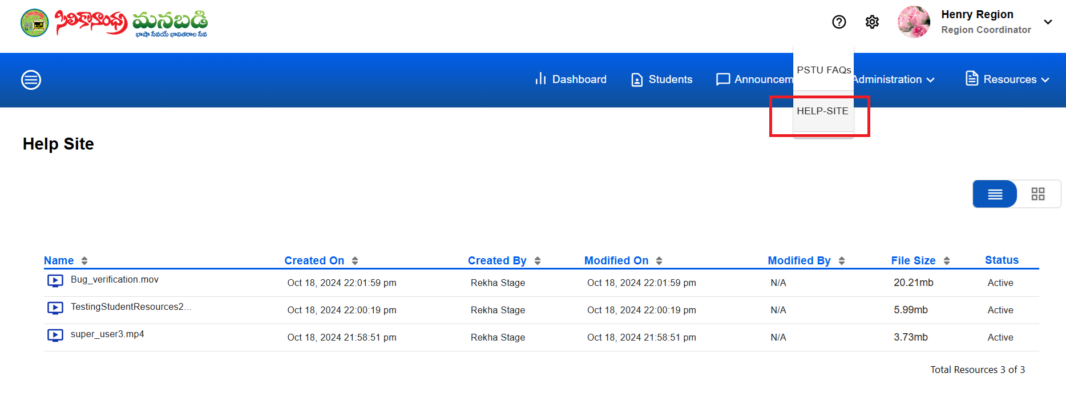

The Help Site has the same features as Resources, where users are only able to view content in both List View and Grid View.

**Settings :**

The Settings icon is visible in the top right corner.

If the Settings icon is clicked, the **Unregistered Students** option is displayed.

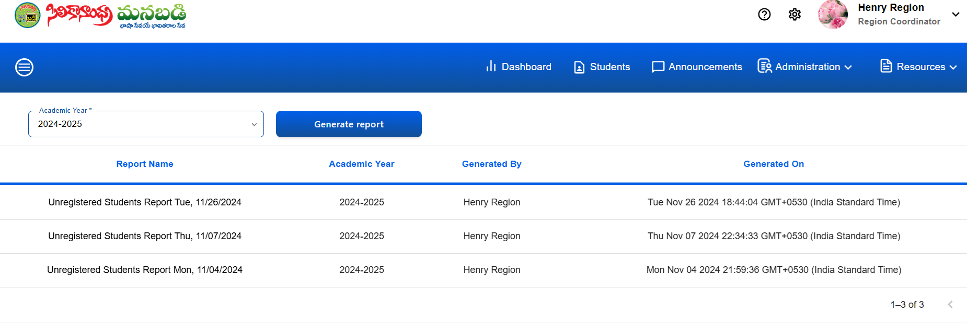

The Unregistered Students page contains an Academic Year dropdown and a Generate Report button.

"The Generate Report button is highlighted in blue color."

The Unregistered Students page has headings:

**Report Name :** The Report Name includes 'Unregistered Student Report' along with the day and date.

**Academic Year :** The Academic Year column displays the academic year for which the report was generated.

**Generated By** : The Generated By column displays the name of the user who created the report.

**Generated On :** The Generated On column displays the day, date, and time (respective time zone) in the following format:

Tue Nov 26 2024 18:52:32 GMT+0530 (India Standard Time).

After selecting the Academic Year and clicking the Generate Report button, a Waiting on Reports pop-up appears with the message: *'Please await around 30 seconds to 1 minute for unregistered students by academic year to be finished. Refresh or return to the page to see all reports.'* Once completed, the corresponding report is generated and displayed.

The following **templates** are added while downloading the unregistered student reports in the google sheet.

1.Academic Year

2.Manabadi Email

3.First Name

4.Middle Name

5.Last Name

6.Student Full Name

7.Course Name

8.Location Name

9.State

10.Region

11.Parent 1 Full Name

12.Parent 1 Contact Number

13.Parent 2 Full Name

14.Parent 2 Contact Number

The Region coordinator while downloading the unregistered students reports, getting that region related data only.

If the Report Name is clicked, able to see the data will be displayed in a Google Sheet.

The total number of unregistered student reports is displayed at the bottom, for example: 1-4 of 4.

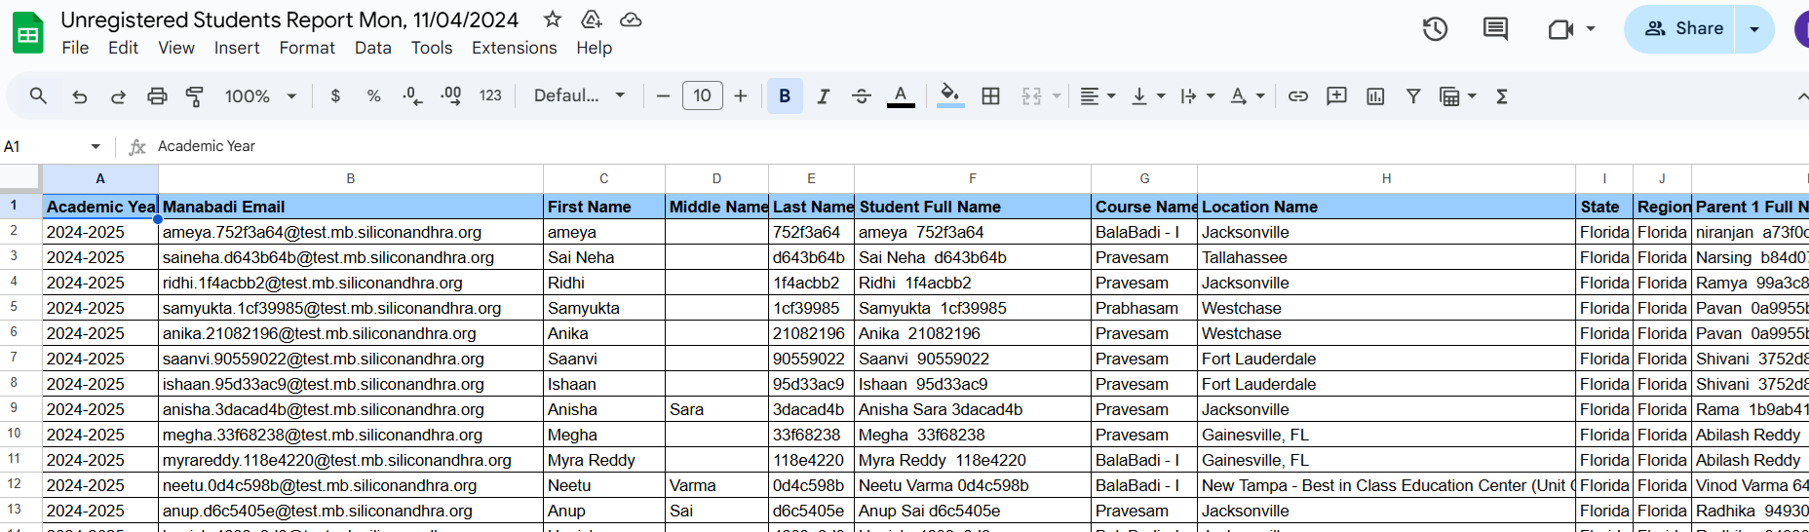

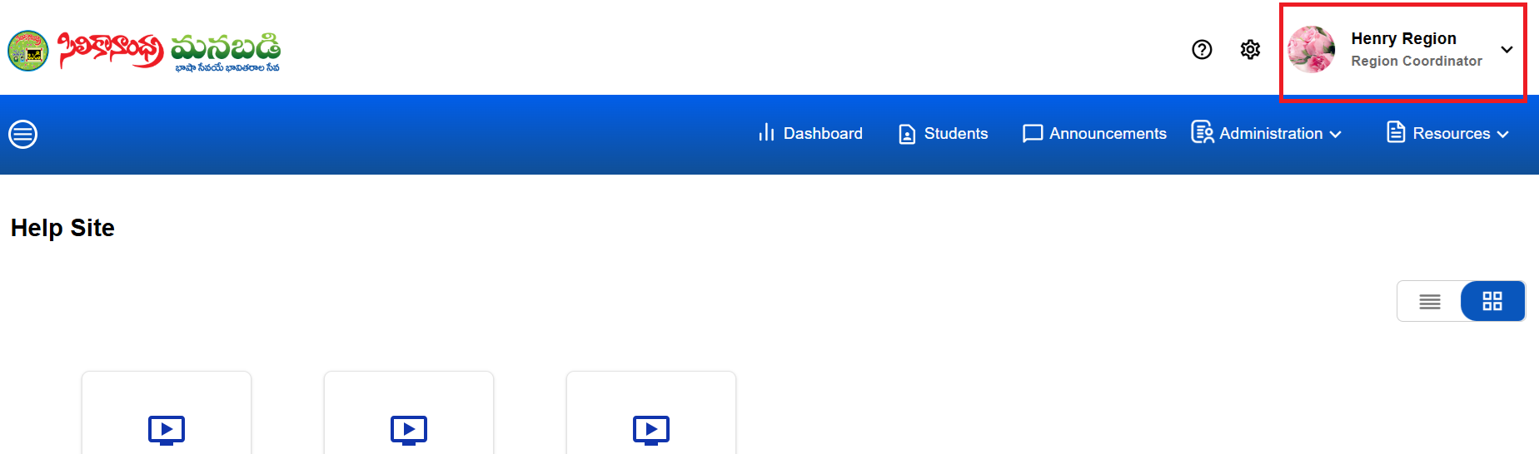

The Region Coordinator, along with their image, is present in the top right corner, with a dropdown menu.

If the dropdown is clicked, it displays the Log Out option.

"In the top left corner, the Manabadi logo is visible."

Teacher



**TEACHER PANEL DOCUMENTATION**

Login Page:

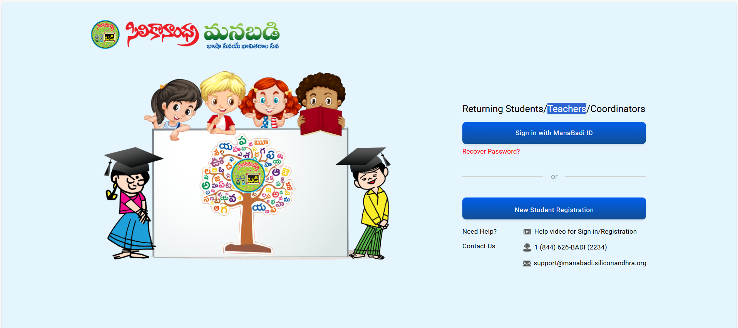

By using [Home - సిలికానాంధ్ర మనబడి (siliconandhra.org)](https://manabadi.siliconandhra.org/) this web link we can login to our portal.

You can log in to our portal using the Homepage on the SiliconAndhra ManaBadi website (siliconandhra.org).”

Dashboard:

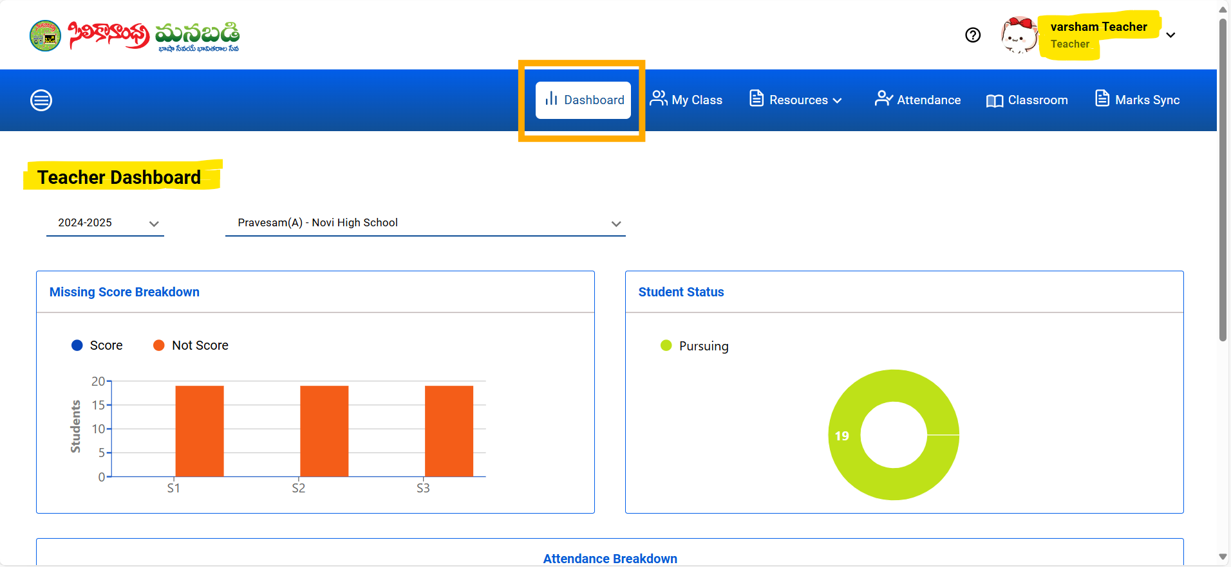

In the dashboard panel, the teacher can view the respective year along with the courses they teach and the locations they visit.

The following we will see in the dashboard:

* **Missing score breakdown:** There will be a bar graph displaying three main exams: Semester 1, Semester 2 and the Supplementary exam. If students score marks in these exams, the bar graph will show blue bars. If they do not score, the bars will appear in orange color.

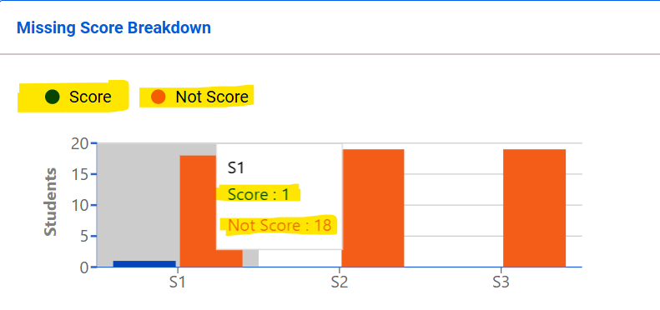

* **Student status:** In the student status section, the number of students assigned to a particular class is displayed using a pie chart for clear visualization.

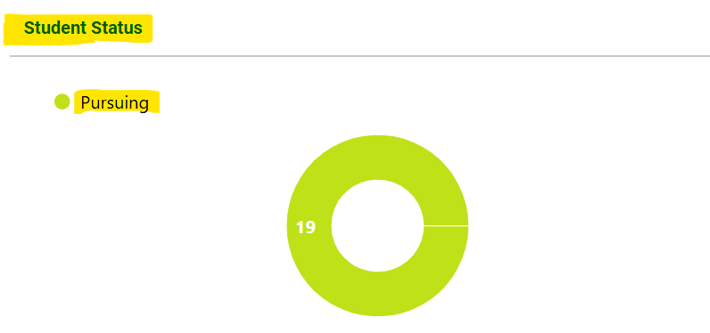

* **Attendance Breakdown:** Here, we can view the number of students attending and not attending the class for all weeks, represented visually in a bar graph.

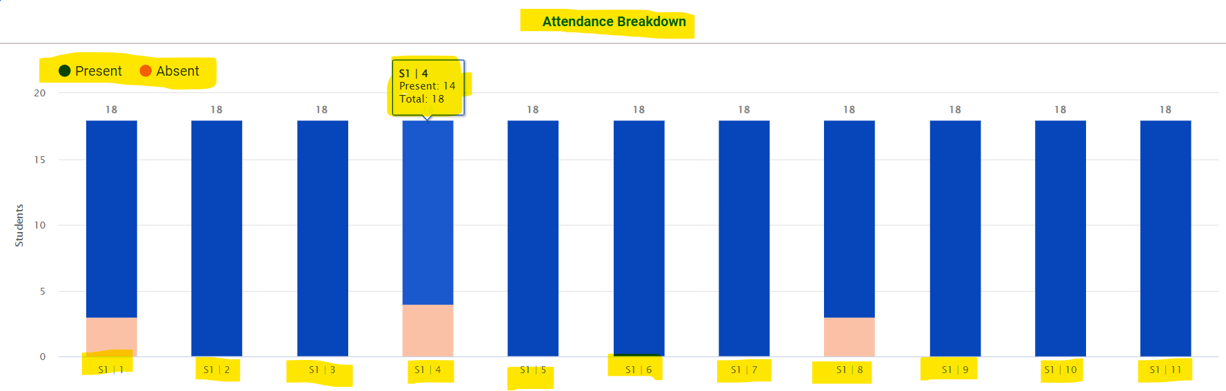

My Class:

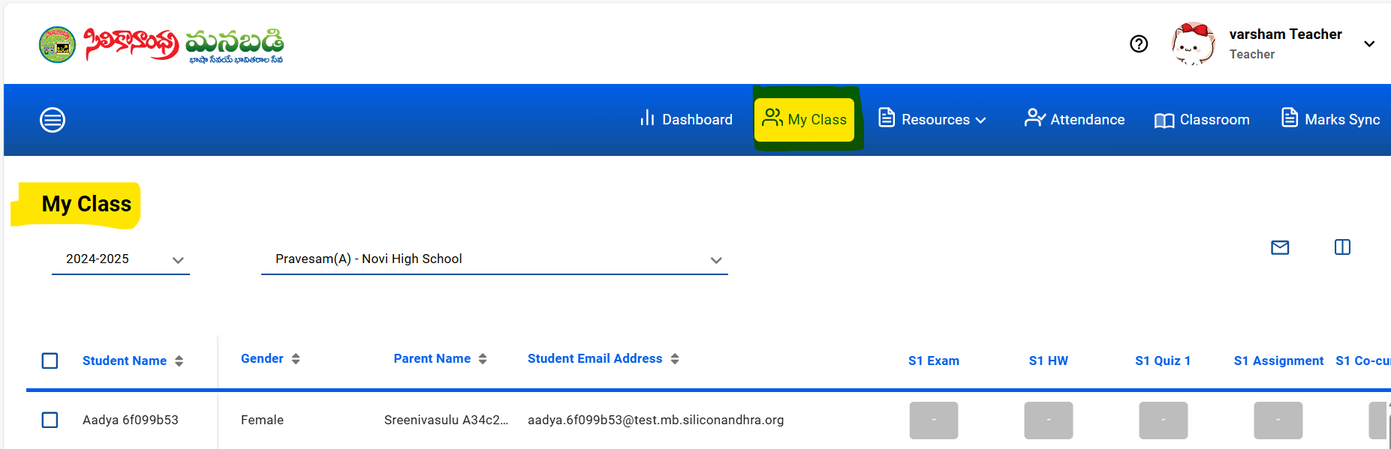

This is how my class tab is seen.,

**In my class tab, you are supposed to see the following sections:**

* **Academic year:** Academic years can be viewed by selecting them from a dropdown menu.
* **Course:** Courses and locations assigned to you can be viewed by selecting them from the course dropdown menu.
* **Announcements:** Clicking on the mail icon allows you to send announcements to all students or a specific student.
* **Customization:** Using the customization icon, you can show only the fields relevant to students.

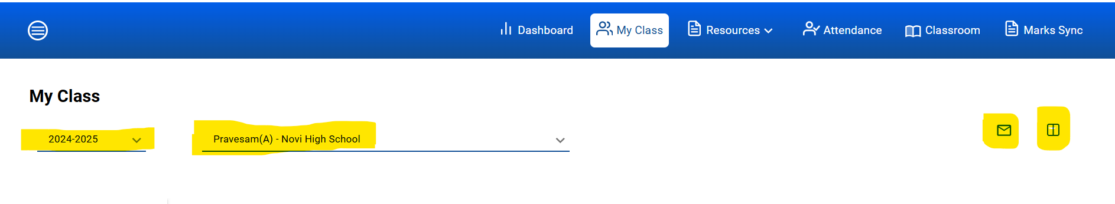

Under all these sections, you will find fields related to students.

**Here are the following fields:**

* **Check Box:** Allows you to send emails either to individual students or to the entire class.
* **Student name:** You can view the student's first and last name as provided during the registration process.
* **Gender:** (Newly added this requirement) You can view the gender of the students.
* **Parent name:** You can view the parent's first and last name as provided during the registration process.
* **Student email address:** You can view the student's email address provided by Manabadi.

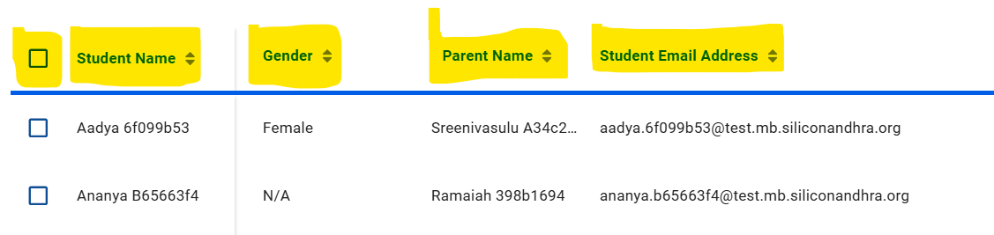

* **Semester marks:** You can update the schema marks by navigating to the respective fields and clicking on the provided box to enter the updated marks. After updating the marks, you are able to see the weightage of the marks in the assigned score panel and in the weightage marks are popped up in the update mark field.

You can see all schema marks of both the semesters represented with S1, S2 and supplementary. **Here are the following schemas in each semester:**

* **S1 Exam & S2 Exam:** You can update the student's exam marks by clicking on the update box.
* **S1 & S2 HW:** You can update the student's homework marks by clicking on the update box.
* **S1 Quiz 1 & S2 Quiz 2:** You can update the student's quiz marks by clicking on the update box.
* **S1 & S2 Assignment:** You can update the student's assignment marks by clicking on the update box.
* **S1 & S2 Co curricular:** You can update the student's co curricular marks by clicking on the update box.
* **S1 & S2 Weeks Attendance:** By marking attendance for each student in the attendance tab, the total number of weeks will be displayed in the 'This Week Attendance' section.
* **S1 & S2 Total:** You can view the total marks for all schemas in this section in each semester.
* **S1 & S2 Grade:** You can view the grade for each semester.

**After semester 2 grade, you are able to see the following sections:**

* **Supplementary:** You can update the student's supplementary marks by clicking on the update box.
* **Grade:** Based on the total S1 and S2 marks or supplementary marks, you are able to see the final grade of the student in this field.
* **GPA:** Based on the respective student grade the GPA is calculated and displayed in this field.
* **Annual score:** Based on the S1 & S2 total marks, the annual score is displayed in this field.
* **Action:** You can send announcements to individual students by clicking on the mail icon displayed under the Action column.

Announcements:

Note: There is no separate announcements tab in the teacher panel.

**How to send announcements?**

In the ‘my class’ tab you are able to see the mail icon so by using that mail icon you can send announcements to individual students or to all students.

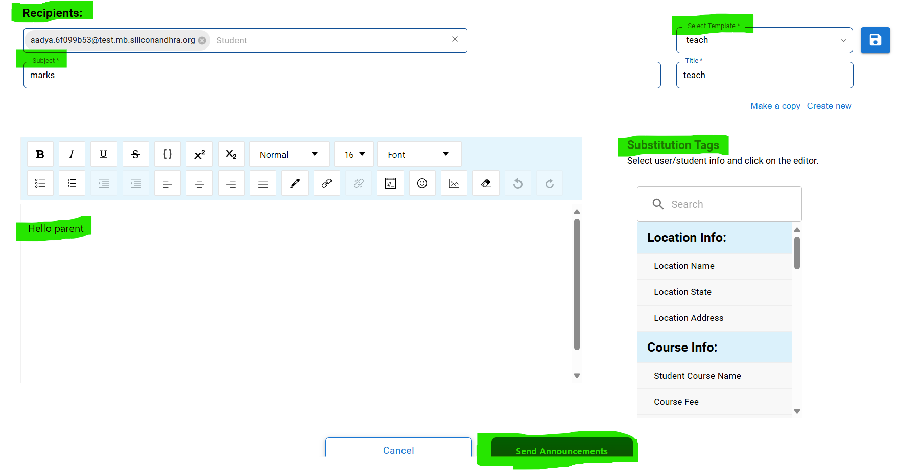

This is how you see the announcement page.

* **Recipients:** You will see the selected students' manabadi emails in the recipients list.
* **Subject:** Subject is which is related to the content.
* **Body:** Body is also related to the content and you can add substitution tags so it will make your work easy.
* **Substitution tag:** A substitution tag is a placeholder that dynamically inserts personalized content, such as a recipient's name or specific data, into the email body.

Here are the substitution tags available in announcements.

* Location name.
* Location state.
* Location address.
* Student course name.
* Course fee.
* Student section.
* Student Academic Grade.
* Student Hall Ticket Link.
* Semester 1 Marks.
* Student Result.
* Semester 2 Marks.
* Supplementary Marks/PSTU Marks.
* Student Hall Ticket Number.
* Exam Location.
* Parent1 Email.
* Parent2 Email.
* Parent2 Profession.
* Parent1 Phone.
* Home Address.
* Parent Name.
* Parent2 Phone
* Parent1 Profession.
* Student's All Years Record.
* Student Shirt Size.
* Student Registration Date.
* Student Gender.
* Student Image.
* Student DOB.
* Student Name.
* Student MB ID.
* Student's Current Year Record.

**How to create a new template?**

**Steps to create a new template.**

1. Click on create new.
2. Give your title in the title field.
3. Give subject if you require and body is optional.
4. Click on save icon which is located beside the select template field.
5. Template is created.

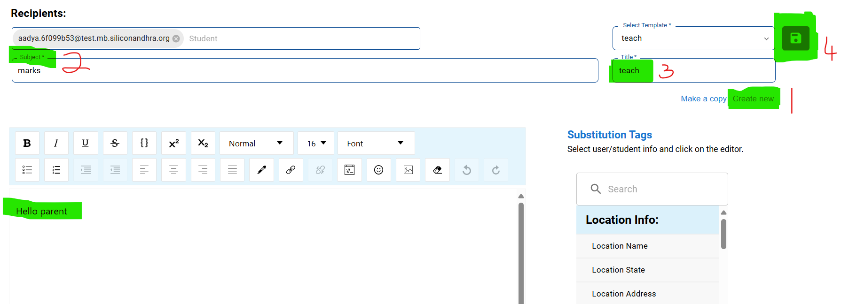

Resources:

**Student resource:** This is how a student resource tab is viewed, Here you are able to see the student resources in grid view and list view.

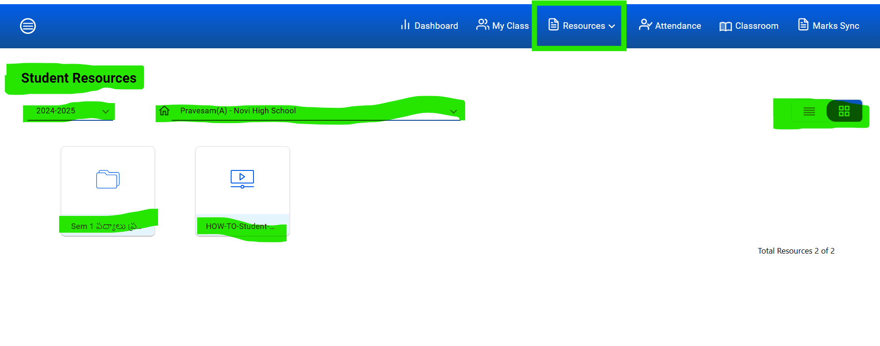

**Teacher resource:** This is how a teacher resource tab is viewed, Here you are able to see the teacher resources in grid view and list view.

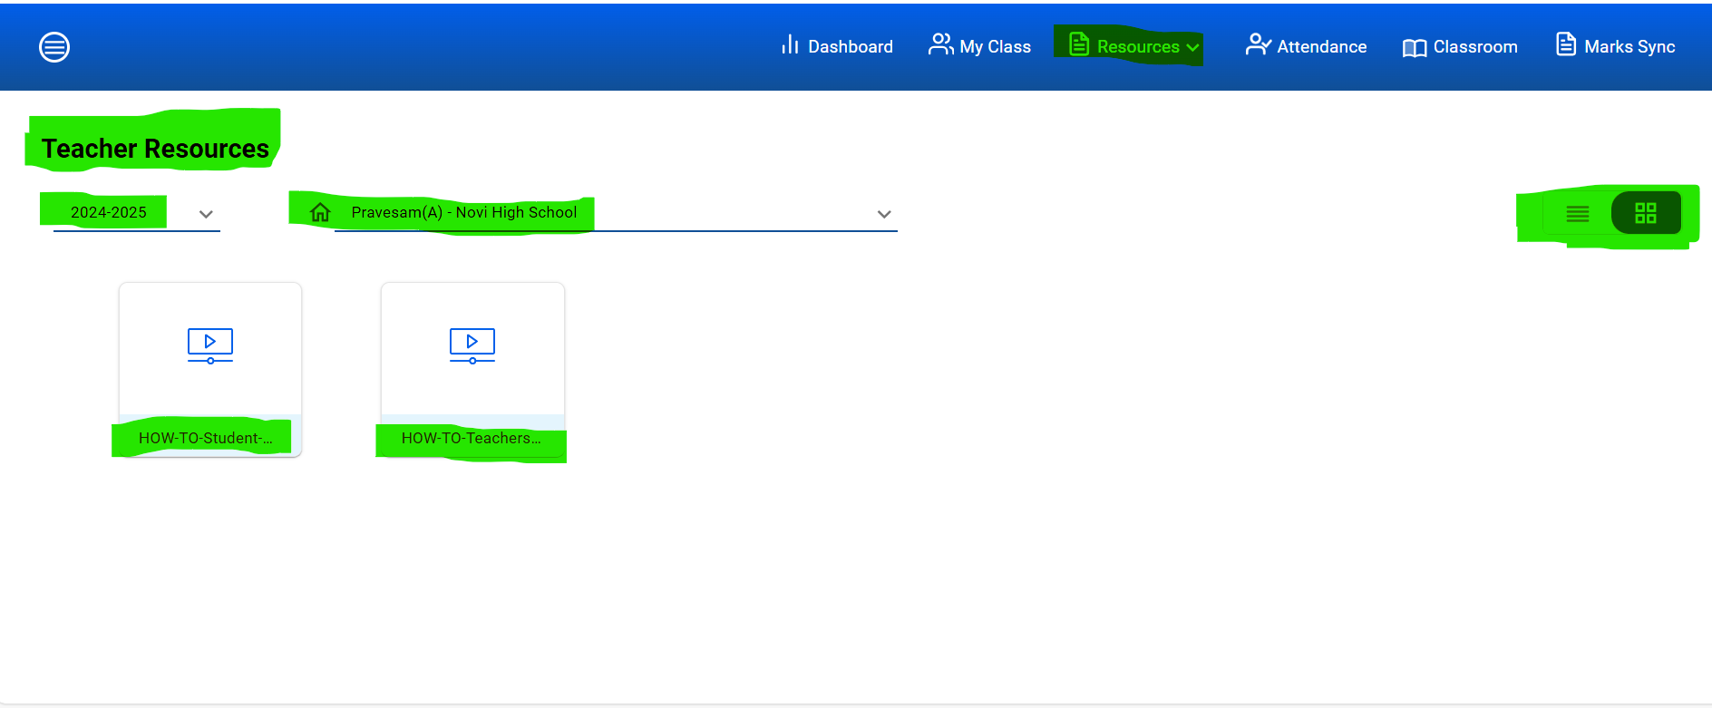

Classroom:

Classroom is one of the tabs which is not related to the portal but if you click on the classroom it will directly navigate to google classroom.

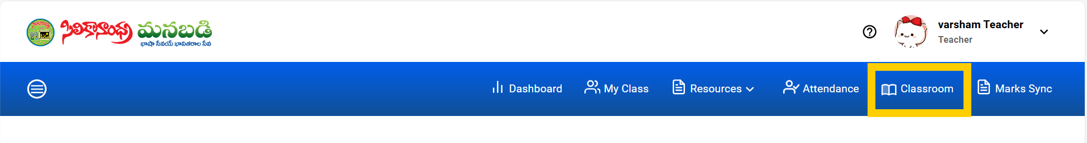

Marks Sync:

With Marks Sync, you can easily and efficiently update marks in very less time. It allows you to update marks for all schemas and all students within a single term.

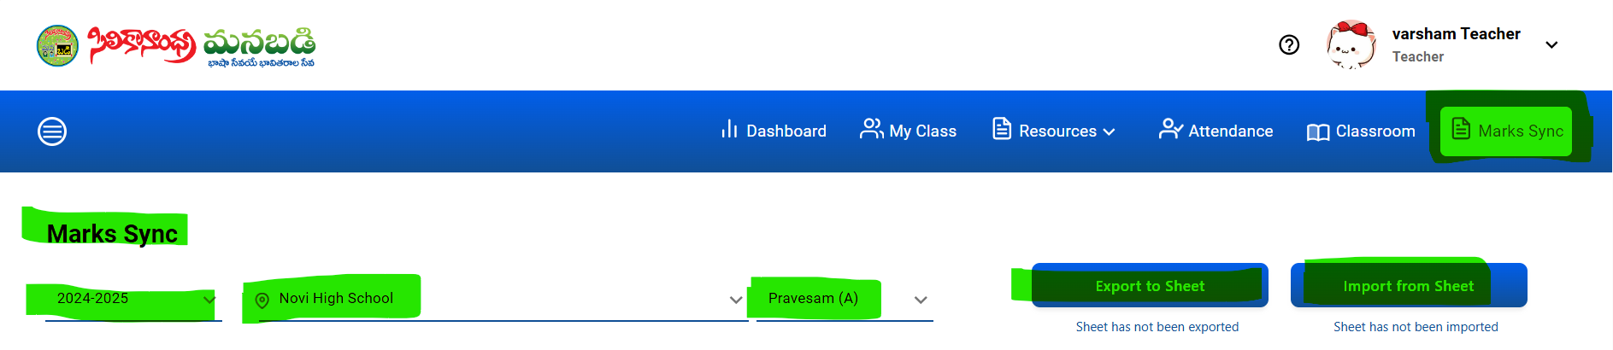

Here is the marks sync page,

* **Academic year:** Academic years can be viewed by selecting them from a dropdown menu.
* Locations: The assigned Locations can be viewed by selecting them from the location dropdown.
* **Course:** Courses assigned to you can be viewed by selecting them from the course dropdown menu.
* **Export and Import to sheet:** Here are the few steps for how to export and import the sheet.
* **Step 1:** By clicking the 'Export to Sheet' button, a pop-up message will appear stating, 'Student's CSV file has been exported to Google Drive.' Click the 'OK' button to proceed.
* **Step 2:** The CSV file will be downloaded to the respective Manabadi-related Google Drive. Open the file from the google drive.
* **Step 3:** Enter the marks you wish to update for the student.
* **Step 4:** Now, import the sheet by clicking the ‘Import from Sheet’ button. Once imported, all the students' marks will be displayed on the My Class tab and the Marks Sync page.

**Note:**

* **Please ensure that you enter at least '0' if there are no marks for a particular student. If no marks are updated, a blank space will appear next to the update marks field.**
* **Kindly complete the above process within 30 minutes; otherwise, a token error pop-up will appear.**
* **Maintain the original file structure (e.g., do not add or remove columns, change headers, or rearrange rows).**
* **Avoid unapproved changes like adding unrelated data or altering the format, as these will result in the file being rejected during import.**
* **Ensure that all required marks fields are properly filled, as missing or invalid data can prevent the import from being successful.**

**Logout:** In the top right corner, you will see your registered teacher name along with a picture and a dropdown menu. Clicking on the dropdown will display a logout option. Select 'Logout' to log out from the page.

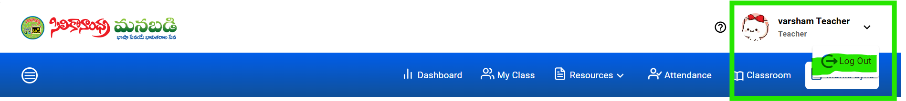

**The End…**

Admin



**Admin Panel:**

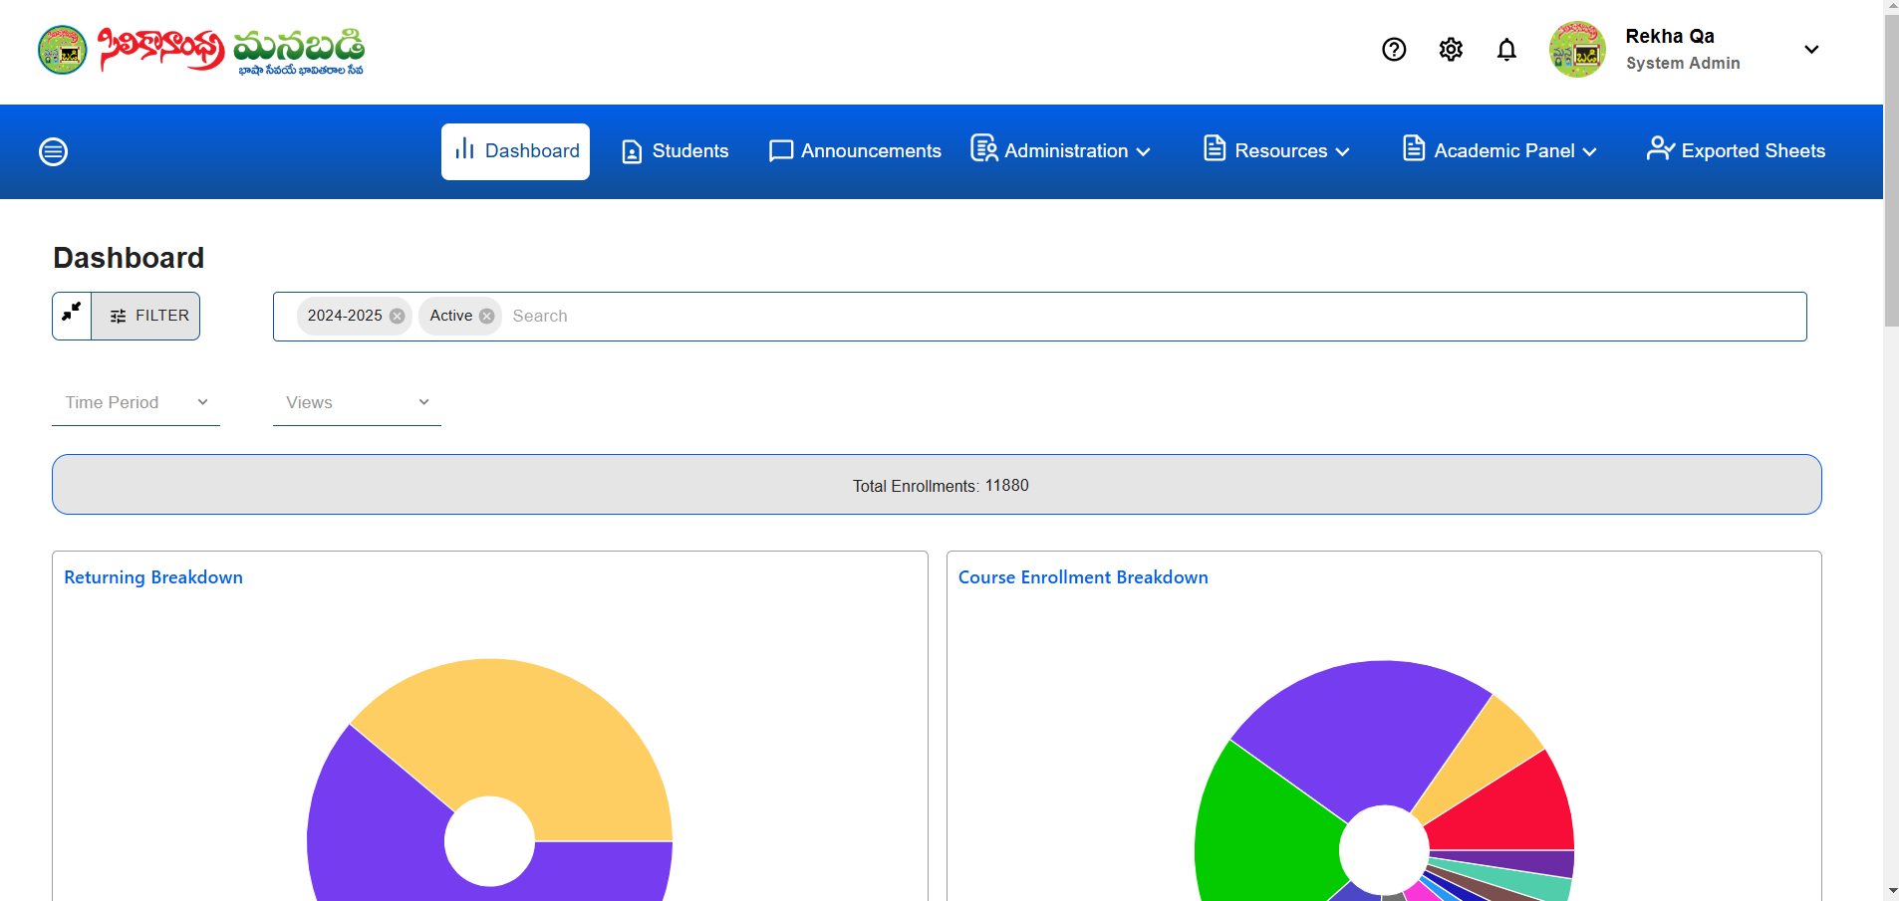

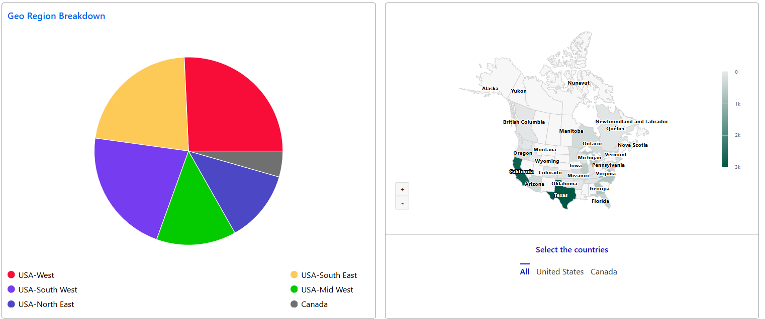

The "Admin Panel – Dashboard" is designed to provide a comprehensive view of student enrollment statistics for the System Admin. The dashboard offers dynamic and interactive insights into current and historical enrollment data, enabling better decision-making and effective data management

.

Admin assumes multiple responsibilities, serving as an Admin, Location Coordinator, and Teacher, ensuring smooth administrative operations, effective coordination across locations, and high-quality instruction for students."

**Dashboard** :

The dashboard provides a comprehensive explanation of total enrollments by utilizing multiple data visualizations and charts. This integrated use of graphical representation enables users to understand enrollment trends from multiple perspectives.

The **Search Bar** enables users to efficiently locate specific data, such as courses, enrollments, or other related information. It is designed with an intuitive interface that simplifies the search process.

**Total Enrolled Students:**The dashboard displays the total number of enrolled students for the current academic year, including canceled students when the "Inactive" filter is selected. By default, the dashboard lands on the "Active" filter for the current academic year In **search bar.**

**Time Frame Selection:** A dropdown menu on the top-left corner of the dashboard allows the admin to filter data by:

* **Year :** Display the total number of enrollments categorized by selected academic year search bar
* **Today :** Display the total number of enrollments for the current day.
* **Week :**Display the total number of enrollments for the current week.
* **Month :**Display the total number of enrollments for the current month.
* **Across Years:**  Displays historical enrollment statistics across all previous years.

**View drop down:**

The "View" dropdown works as a customizable option where users can create their views by selecting different filters and saving them By clicking **Add To My View** Once saved, users can easily access these views by clicking on the "View" dropdown. These saved views allow users to see geographical representations tailored to their specific selections. This functionality is user-specific and operates similarly to the feature available in the "Student" tab.

* **Filter Feature :** The search functionality allows users to refine results with a set of 18 filters. These filters provide flexibility in narrowing down the data based on multiple criteria.

**Label: "Search by Filters"**

Users can apply one or more of these 18 filters to refine their search and obtain specific results related to enrollments, courses, or student data.

**FILTER** : When we click the filter field, it displays 'Search by Filters'.

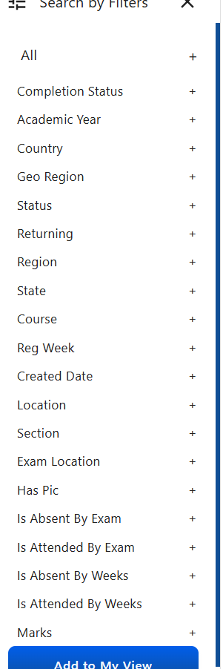

**Validation:**

The filter functionality should operate like a subset method to ensure accurate viewability. Filters dynamically adjust based on prior selections to display relevant data.

* Scenario 1: If a user selects a country (e.g., USA), they should still have the option to select additional countries (e.g., Canada) for a broader comparison.
* Scenario 2: If the user selects only one country in the filter, subsequent filters such as locations, courses, states, or statuses should display data exclusively related to the selected country.
* Scenario 3: Users should have the flexibility to filter data year-wise or choose “ALL” to view comprehensive data across all years.

The admin should have the ability to filter the complete list of student information based on the following criteria:

* **Completion Status**
* **Exam Enrollment**
* **Academic Year**
* **Country**
* **Status** (e.g., active, inactive)
* **Returning Student** (yes/no)
* **Region**
* **State**
* **Course**
* **Registered Week**
* **Created Date**
* **Center**
* **Section**
* **Marks** (greater than, less than, or equal to specified values)
* **Has Picture** (yes/no)
* **Student Name**
* **ManaBadi ID**

These filters should allow for precise and targeted retrieval of student records, enhancing data management efficiency.

**Returning Breakdown :**

This section shows the distribution of students categorized as **New** and **Returning**.The data is displayed in **Pie Chart** form.

* **New Students**: Students who are enrolling for the first time.
* **Returning Students**: Students who have previously enrolled and are returning.

The chart visually conveys the percentage of each category for easy comparison.

**Course Enrollment Breakdown :**

This section provides an overview of how many enrollments are distributed across various courses.

**Courses Displayed**:

* The pie chart shows the following courses:
  + **BalaBadi - I**
  + **BalaBadi - II**
  + **Pravesam**
  + **Prasunam**
  + **Prakasam**
  + **Pramodam**
  + **Prabhasam**
  + **Telugu-1**
  + **Telugu-2**
  + **Telugu-3**
  + **Telugu-4**
  + **Prabodham**

**T**he data is displayed in a Pie Chart, where each course is represented as a segment of the pie.

Each segment’s size corresponds to the number of enrollments in that particular course.

The chart will display the percentage of total enrollments for each course.

**Geo Region Breakdown :**

The Geo Region Breakdown pie chart visually represents the global distribution of data, categorized by region.

**Maps:** Offers a geographical visualization of enrollment data to pinpoint where enrollments are concentrated.

**Enrollment Breakdown By Week :**

The Enrollment Breakdown by Week offers an analysis of student enrollment trends, highlighting the distribution of new and returning students across specific weeks.

**Students :**

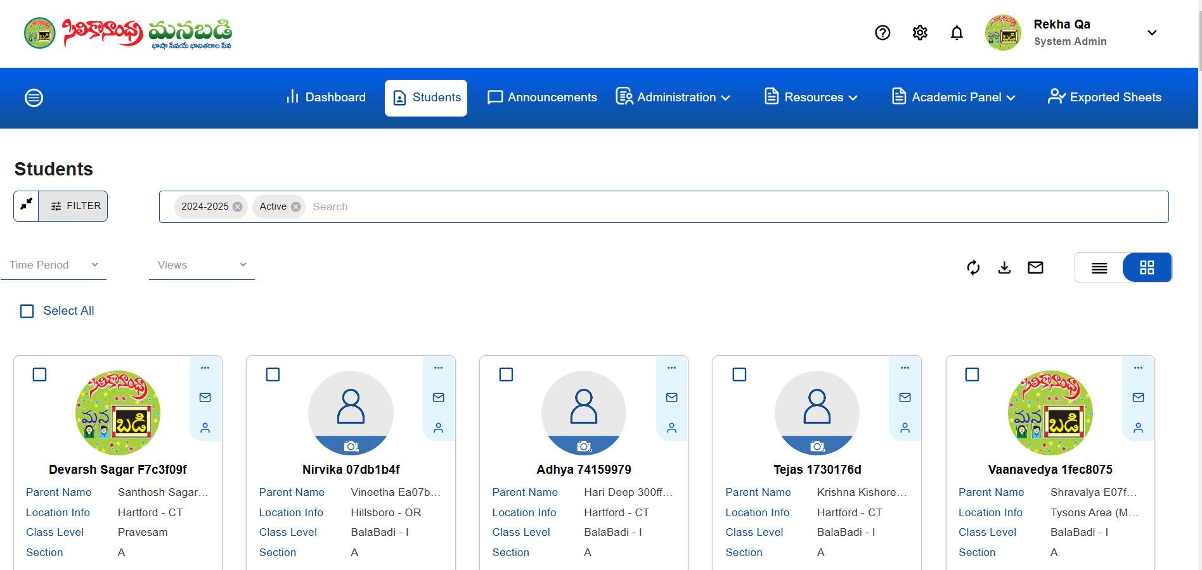

"The Student tab represents all the students included in the data, highlighting their details and relevant metrics instead of using graph representations."

The **Student** tab provides two viewing options: **List View** and **Grid View**, both accessible from the top-right corner.

In both views, you can see the student's picture, name, parent’s name, location information, course, section, and available actions. However, the **List View** includes an additional feature—the ability to view the **registration date**.

In the students tab, the user interface and functionality is the same as the dashboard that includes features such as a search bar, filters, time period, and view fields.

**Load More :**

In the **Students** tab, the interface displays a maximum of 100 students per page to maintain clarity and usability. Users have the option to view additional students through a **Load More** button, which loads subsequent batches of 100 students at a time. This design ensures efficient data presentation while allowing users to seamlessly navigate through larger sets of student information.

Before loading more, the total number of students will be displayed.

For Example : Total Students 100 of 11000

**Select All :**

The **Students** tab includes a **Select All** checkbox, allowing users to quickly select all displayed students on the current page. Additionally, each student has an individual checkbox, enabling users to select or deselect single students as needed. This feature provides flexibility for bulk actions or individual student selection.

* Each individual student entry includes an **Options** menu located at the top right corner, providing various actions related to that student. Additionally, a **Send Mail and impersonate**  icon is available, enabling users to quickly send an email directly from the student's profile. This setup enhances user efficiency by offering convenient, on-the-spot access to key functions.
* Each individual student entry has a **checkbox** located at the top left side, allowing users to select or deselect that student easily.

**Impersonate Student Functionality**

To access this feature, the user must have system admin roles and associated rights.

1. **Selecting a Student**The user can select a student from the available database within the application to impersonate.
2. **Impersonation Process**Upon clicking the impersonate control, the application redirects the user to the dashboard of the selected student. Through this feature, the admin can access all information and perform actions as if they were the student user.
3. **Limitations**The system admin cannot access external platforms such as Gmail or Google Classroom, as these redirect outside the portal. All access granted through the impersonation feature is restricted to functionalities within the portal.
4. **Ending Impersonation**A "Logout Impersonate" or "Close Student" control is available to exit the impersonation mode. Clicking this button returns the user to the admin nterface, closing the impersonated student's profile and restoring the original admin view.

**Options :**

The "Options" button typically provides features such as:

**Show Payment Info:** Displays the student's payment details.

**Password Recovery:** Allows the admin to send a password recovery link to students when requested by parents.

**Edit Parent Info:** Enables the admin to update parent details.

**Edit Student Info:** Allows the admin to modify student details.

**Swap Course and Location:** Facilitates swapping of courses, locations, and sections based on a parent’s request.

**Show Student Logs:** Provides a record of all changes made to the student's details.

**Cancel Enrollment:** Allows the admin to cancel a student’s enrollment upon a parent’s request.

**Edit Exam Details:** Enables the admin to update the exam center information for a student.

**Mark Details:** Allows the admin to view the student's marks.

**Mark as Repeat:** This option is available only if the student has a result. Upon a parent's request to repeat the course, the admin can mark the result as "repeat."

**Refresh Button :**

"The 'Refresh' button is located at the top right, before the List View and Grid View buttons."

"The 'Refresh' button allows you to reload the page and view the latest updates."

**Download :**

The 'Download' button is located at the top-right corner, positioned before the List View and Grid View buttons. By default, the download button is enabled. Without selecting a student, clicking the download button allows you to download only user-related information student related checkboxes will be disabled.. However, if you select the 'Select All' checkbox or choose individual students, the download will include data for students as well as user and location information. Clicking the 'Download' button opens the Reports pop-up for further options.

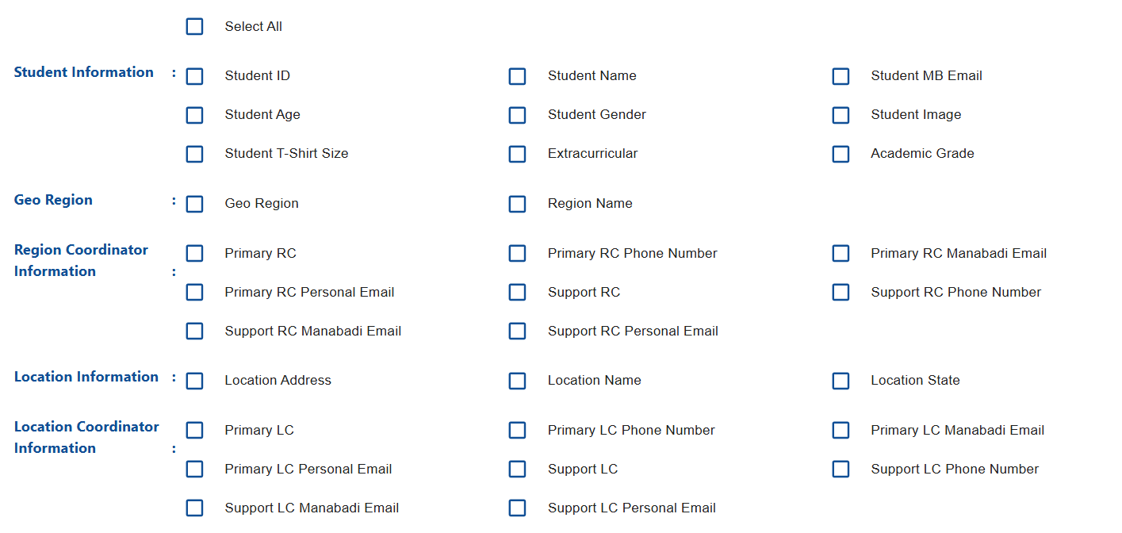

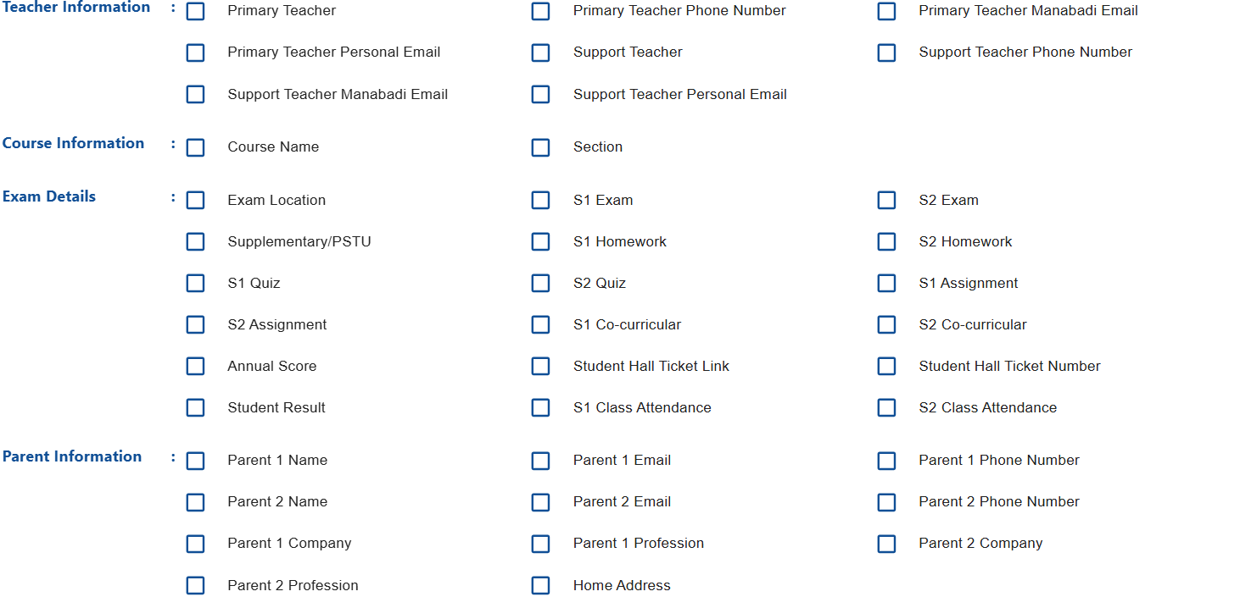

These filters are available as checkboxes.

* "At the bottom right side of the Reports pop-up, the 'Cancel' and 'Export' buttons are available."
* By default the Export button is disabled.
* "The 'Export' button will only be enabled once at least one filter checkbox is selected."
* "If no student is selected and the 'Download' button is clicked, the filter checkboxes for 'Student Information,' 'Exam Details,' and 'Parent Information' will be disabled."
* If a single student checkbox is selected or the "Select All" checkbox is used, clicking the download button will enable the checkboxes for 'Student Information,' 'Exam Details,' 'Parent Information,' 'Geo Region,' 'Region Coordinator Information,' 'Location Information,' 'Location Coordinator Information,' 'Teacher Information,' and 'Course Information.'
* If the "Select All" checkbox is selected in the reports pop-up, all enabled checkbox filters will be automatically checked.
* The options in the pop-up are presented as checkboxes, allowing multiple selections.for example,

Select the checkboxes for Geo Region, Primary RC, Primary LC, and Primary Teacher.

Select the checkboxes for Course Name, S1 Exam, Location Name, and Region Name.

* After selecting the filter checkboxes in the reports, clicking the export button will download the data based on the selected filters.
* After clicking the export button, a reports pop-up will appear saying, "Student’s/User’s CSV file is exporting to Google Drive. It may take a few minutes to complete."



* Filters combination :

Apply the Completion Status filter to "Completed" and download the data for Student Name, Student Email, and Student Result

Apply the Academic Year filter to "2023-2024" and download the data for Student Name, Student Age, and Student Course Name.

Apply the Course filter to "Pravesam" and download the data for Student Name, Student Academic Grade, Student Result, S1 Exam Marks, and S2 Exam Marks.

* The system should restrict selecting multiple academic years from the filters, and the data should not be downloadable in such cases.
* The user can open their Google Drive and view the downloaded data in an Excel sheet.
* The user can view the downloaded report on Export sheet
* If the user downloads the data without selecting a student, the file name in the Excel sheet will appear in the following format(For Example): "User (2024-2025) - Tue Nov 19 2024 13:21:34 GMT+0530 (India Standard Time)."
* If the user downloads the data by selecting a student or selecting all students, the file name in the Excel sheet will appear in the following format(For Example): "Student (2024-2025) - Tue Nov 19 2024 13:31:33 GMT+0530 (India Standard Time)."
* The admin can view the other coordinators' downloading files in the "Exported Sheets" tab.

**Note:** The admin is not able to click on the file name; they can only view it.if they want to open they need permission from original users.

**Announcements :**

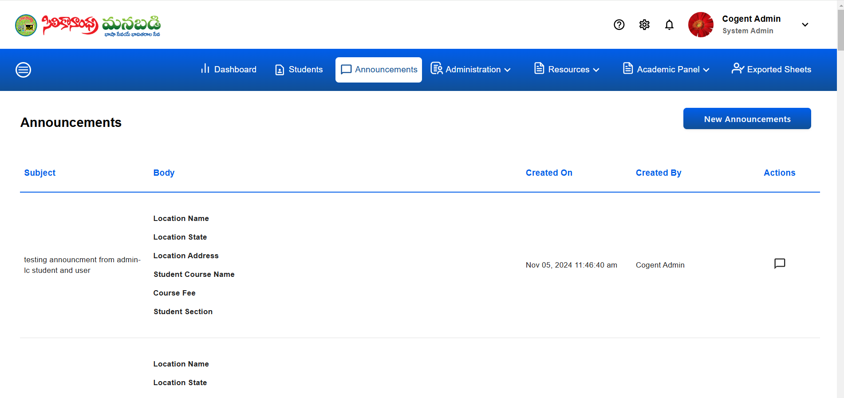

"To implement an Announcements tab, include headings such as **Subject**, **Body**, **Created On**, **Created By**, and **Actions** to organize and manage the display of announcement details effectively."

here's how it can be structured for clarity :

* **Subject:** A brief title or summary of the announcement.
* **Body:** The main content or details of the announcement.
* **Created On**: The date and time the announcement was created.
* **Created By**: The name or ID of the person who created the announcement.
* **Actions:** Interactive options like View Announcement.
* **View Announcement :**
* To implement a **"View Announcement"** button under the **Actions** column, which opens a popup to display the announcement details



* "The **View Announcement** popup includes sections for **Message Sent**, **Read**, and **Unread** counts to provide detailed status information."along with the **Sender,** **Subject , Sent On Date(with time)and Body.**

**"Sent To"** refers to the recipient's email ID in the context of an announcement, indicating who the message was directed to.

**"Read:** The date and time when the recipient opened and read the announcement.**"**

**"Delivery:** A color-coded status indicating the delivery outcome:

* **Green Tick for successful delivery,**
* **Blue Tick for delivered but unread,**
* **Red Tick for failed delivery."**
* "The View Announcement popup features a close button in the top-right corner for easy dismissal."
* **Total Announcements :**
* The **Total Announcements** count will appear at the **bottom-right corner** of the Announcements tab.
* "Total Announcements" refers to the overall count of announcements displayed or managed within the Announcements tab.

**New Announcements :**





**Recipients :**

"While clicking the **New Announcements** button, users can see the **All Students** field displayed by default under the **Recipients** section."

**Set Filter :**

Set the filter dropdown with the following options:

**Role - User groups**: Choose groups like:

* + All Students
  + Location Coordinators
  + Primary Teachers
  + Support Teachers
* **Region :** While selecting a region from the set filters, we can choose the entire region assigned to the respective region coordinator in the recipients.
* **Academic Year :** The Academic Year filter displays all the years, including the current year, for selection**.**
* **Completion Status** : The **Completion Status** filter displays options such as **Pursuing**, **Pass**, **Fail**, and other relevant statuses for selection.
* **Course** : The available **courses** are displayed in the suggestion box for easy selection under recipients.
* **Status:** The status filter displays the active and inactive students
* **Country :** country filter displays the manabadi available countries list
* **Returning:** if we select returning filter it displays the student whe are registered already existed students
* **Section :** The available sections are displayed in the suggestion box for selection under recipients.
* **Location :** Under the selected Region, the available locations are displayed for selection.
* **Student :** Students are displayed by their email ID.
* **User** : User email IDs are displayed in the suggestion box by clicking the **User** set filter.
* **Exam Center :** Exam Center displays the available exam centers for selection.
* **Status :** Status is displayed with options for Active and Inactive in the suggestion box**.**
* **Returning :** Returning displays options for Returning and New in the suggestion box**.**
* **Registered Week** : **Registered Week** displays the month and date for filtering based on the specific registration week.
* **Has Pic :** Has Pic displays options for True or False in the suggestion box.
* **Subject:** A brief title or summary of the announcement.
* **Select Template :** Select Template dropdown displays saved titles for quick selection.
* **Save Icon :** By using the Save icon, a newly created title can be saved for future use.
* **Title :** We can save our announcement under the Title field for easy reference and future use.
* **Create New** : If we want to create a new title, the **Create New** option is available under the **Title** field.
* **Make a Copy :** Clicking the **Make a Copy** option allows you to duplicate the announcement, including its content and settings, for editing or reuse.



The **Make a Copy** pop-up contains a **Please give Template Title** field for entering a new title and options for **Cancel** and **Create** buttons.

The top corner of the pop-up has a **close button** symbol to exit without saving or making changes.

**Body :** The main content or details of the announcement

### **Text Formatting Toolbar :**

* Contains options for **bold**, **italic**, **underline**, **strikethrough**, **text color**, **background color**, **text alignment**, **hyperlinks**, **insert image**, and **emojis** to customize your announcement text.
* **Font Style and Size**: Adjust the font style and size to your preference.
* **Insert Substitution Tags**: Allows you to personalize the announcement with dynamic fields from the recipient’s information, such as location details or course information.

### **Substitution Tags :**

* A list of available tags is shown on the right (Location Info, Course Info,ExamDetails,Parent Info,student info).
* **Location Info Filters** (Substitution Tags):
* Location Name
* Location State
* Location Address
* **Course Info** (Substitution Tags):
* Student Course Name
* Course Fee
* Student Section
* Student Academic Grade
* **Exam Details** (Substitution Tags):
* Student Hall Ticket Link
* Semester 1 Marks
* Student Result
* Semester 2 Marks
* Supplementary Marks/PSTU Marks
* Student Average Score
* Student Hall Ticket Number
* Exam Location
* **Parent Info** (Substitution Tags):
* Parent 1 Email
* Parent 2 Email
* Parent 2 Profession
* Parent 1 Phone
* Home Address
* Parent Name
* Parent 2 phone
* Parent 1 profession
* **Student Info** (Substitution Tags):
* Students All Years Record
* Student shirt size
* Student Registration Date
* Student Gender
* Student Image
* Student DOB
* Student Name
* Student MB ID
* Student’s Current Year Record
* To use a tag, select it from the list, and it will appear in the announcement text. Tags will auto-fill with specific information for each recipient, making the message personalized.

### **Action Buttons :**

* **Cancel**: Discards the announcement and returns to the previous screen.
* **Send Announcements**: Sends the announcement to the selected recipients based on the applied filters.

While navigating from the **Students** tab, whether through the individual student email icon or the bulk email icon, it directs to the **Send Announcement** page only.And

The same feature is also available there.

**Administration :**

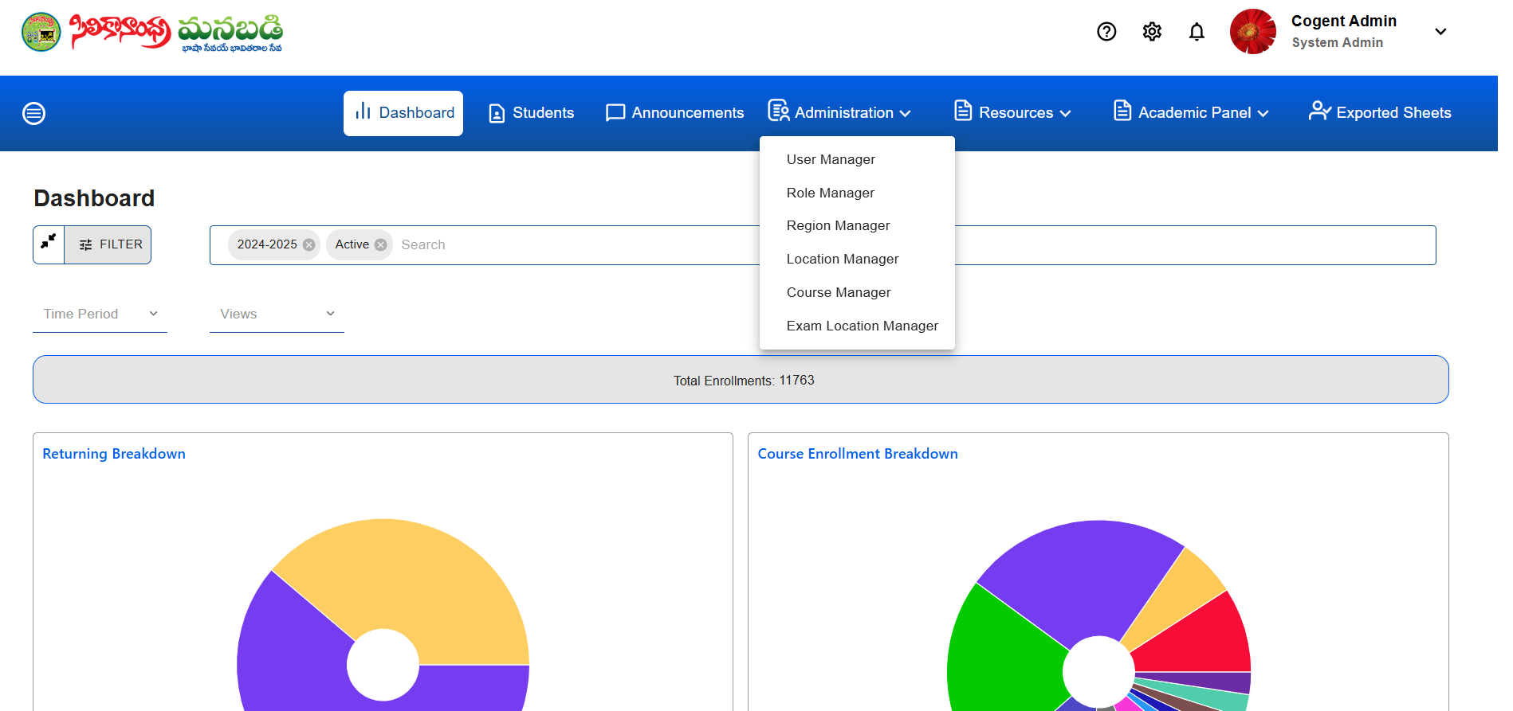

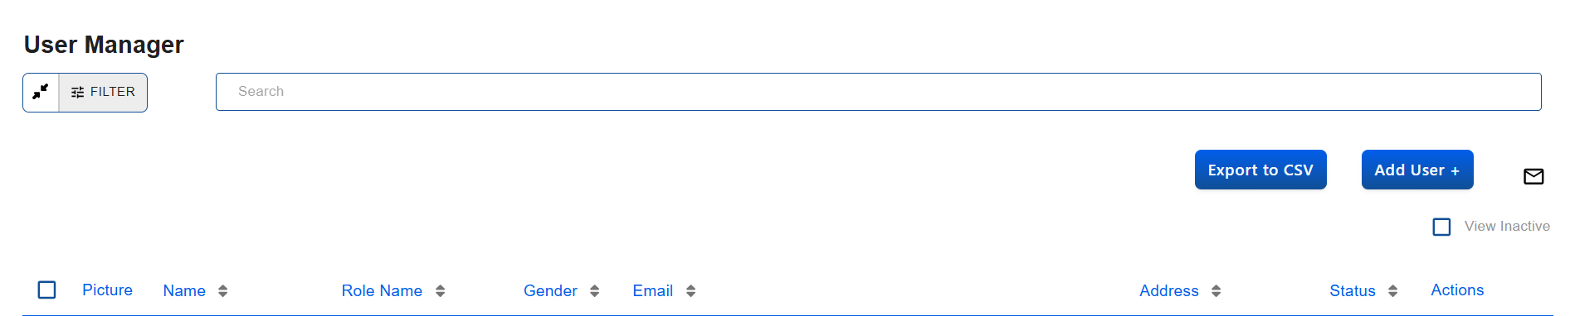

**User Manager :**

**FILTER** : When we click the filter field, it displays 'Search by Filters'.



To implement filters in the **User Manager** module, include the following options:

### **Filters:**

**Primary Teacher :**

For the **Primary Teacher** filter, implementing it as a **true/false** checkbox.

### **Primary Teacher: True/False Filter**

* **True**: Filters and displays only users who are primary teachers.
* **False**: Filters and displays only users who are **not** primary teachers.
* **Default (Unchecked)**: Shows all users regardless of their primary teacher status.

### **Coarse Filter :**

### **Options:**

### **BalaBadi - I**

### **BalaBadi - II**

### **Pravesam**

### **Prasunam**

### **Prakasam**

### **Pramodam**

### **Prabhasam**

### **Telugu-1**

### **Telugu-2**

### **Telugu-3**

### **Telugu-4**

### **Prabodham**

### **Gender :**

Available Options :

* Male
* Female

**Role :**

Available Options :

* Region Coordinator
* Location Coordinator
* Teacher

**Region :** For a Region Coordinator, the Region field should display their assigned region.

**Geo Region :**

Under the Region field (showing the assigned region), you want to display the Geo Regions that fall under the assigned region for the Region Coordinator.

* Show a list of all Geo Regions belonging to the assigned region.

**State :**

Implemented a State Filter under the assigned Region for the Region Coordinator.

**Location :**

* + A list of locations (cities or districts) under the selected states is displayed.

**Search Bar :** The **Search Bar** allows users to quickly find specific data, whether it's related to Region, State, or Location section.. It is designed to be intuitive, allowing users to type keywords and filter results based on their input.

The **Search Bar** is prominently placed at the top ,easily accessible to users.

It is labeled with a prompt like "**Search**" to indicate its purpose.

the total number of user’s will be displayed.

For Example : Total Users 84 of 84

The **User Manager** interface can be structured to display the specified **headings** clearly and efficiently.

* Each individual user entry has a **checkbox** located at the left side, allowing users to select or deselect that user easily.

**Picture :**

the Picture column, which displays the user's profile picture.

**Name**:(Sortable)

* Full name of the user.

**Role Name:**(Sortable)

* Displays the role assigned to the user (e.g., Admin, Teacher,Location)

**Gender:**(Sortable)

* + Displays the gender of the user (e.g., Male, Female).

**Email:**(Sortable)

* Shows the user's email address.

**Address:**(Sortable)

* Displays the user's address.

**Status:**(Sortable)

* Indicates whether the user is Active or Inactive.

**Actions:**

Provides icon for performing actions such as:

**Send Mail Icon** (✉️):

* A small, clickable mail icon.

**Impersonate user Functionality**

To access this feature, the user must have system admin roles and associated rights.

1. **Selecting a user**The Admin can select a user from the available database within the application to impersonate.
2. **Impersonation Process**Upon clicking the impersonate control, the application redirects the user to the dashboard of the selected user . Through this feature, the admin can access all information and perform actions as if they were the user.
3. **Limitations**The system admin cannot access external platforms such as Gmail or Google Classroom, as these redirect outside the portal. All access granted through the impersonation feature is restricted to functionalities within the portal.
4. **Ending Impersonation**"Close user" control is available to exit the impersonation mode. Clicking this button returns the user to the admin interface, closing the impersonated user profile and restoring the original admin view.

**Options :**

The "Options" button typically provides feature such as:

* **EditUser:** As a admin can edit the user
* **Calluser:** Functionality is not working
* **Password Recovery**

**Password Recovery:** This option would likely allow the user to reset or assist with the User's password recovery.

When we click the **Password Recovery** option, a password recovery pop-up will appear with the message: *"Do you want to send an email to reset the password?"* This pop-up includes two buttons: **Cancel** and **Confirm**.

If we click **Cancel**, the action will be canceled.



When we click **Confirm**, a pop-up appears with the message: *"Check your email to reset your password. We've sent an email to [email]@gmail.com. Click on the link in the email to reset your password. This link will be active for 48 hours."*

**

*After clicking* ***Got it****, user will receive a password reset email formatted as follows:*

**

*In the email, if we click on* ***"Click here to reset password,"*** *it navigates to the Reset Password page.*

*In this pop-up, the heading reads:* ***"Please enter a new password."***

*The form includes:*

* ***New Password*** *field with the following conditions:*
  + *Must contain at least 8 characters.*
  + *Must include both lowercase (a-z) and uppercase letters (A-Z).*
  + *Must contain at least one number (0-9) and a special character.*
  + *Must not include your email address.*
* ***Confirm Password*** *field for re-entering the new password.*



On the reset password page, there are two buttons: **Cancel** and **Update Password**.

Below the buttons, the following support message is displayed: *For additional help, please contact***1 (844) 626-BADI (2234)**[**support@manabadi.siliconandhra.org**](mailto:support@manabadi.siliconandhra.org)

**Note : This link is valid for 48 hours only.**

The **Confirm Password** and **New Password** fields must match. If they do not, an error message will be displayed: *"Passwords must match."*

After entering the **New Password** and **Confirm Password**, clicking **Update Password** will update the password. A message will then appear: *"Your password has been reset successfully."*

*You will be automatically redirected to the Login Screen,if not redirected click here.*



After a few seconds it navigates to the login screen.

If we click **Cancel**, the action will be canceled.

**Send Mail :**

In the top right corner, there is a Bulk Send Mail icon.

While navigating from the Administration tab, whether through the individual user email icon or the bulk email icon, it redirects to the Send Announcement page. The same feature is available on this page, except for **substitution tags**. Here, only (user-specific information) User Info : —User Contact Number, User Address, User Image, and User Name—is displayed.

**Export to CSV :**

An Export to CSV option is available on the top right side, highlighted in blue color.

Upon clicking the Export to CSV option, an Export CSV pop-up will appear.

The Export to CSV pop-up includes the following fields with check boxes: User Name, Status, Profile Photo, Manabadi Email, Role Names, Personal Email, Address, Contact Number, and Gender.

The Export to CSV pop-up includes two buttons: Cancel and Export.



* Users are able to export data without needing to select any individual user.
* After selecting individual users or using the Select All option, clicking Export will generate a downloadable Excel sheet containing the selected data.



If we click **Cancel**, the action will be canceled.

The Export to CSV pop-up has a Close button in the top corner.

**View Inactive:** view inactive checkbox if we select this check as a admin can view active and inactive users both

**Add user+:** As a admin he can add the users

**Role Manager: As a System admin, should be able to view all the roles existing in the system and should be able to create new roles**

1. **Navigation to Role Manager**:
   * On the “Admin Panel – Role Manager” screen, when the system admin clicks on **Administrative** from the top menu, a dropdown displaying all managers should appear.
   * The admin can then click on **Role Manager** to be redirected to the "Role Manager" screen.
2. **Role Manager Screen Elements**:
   * The "Role Manager" screen should display the following columns:
     + **Role Name**
     + **Status**
     + **Role Permissions**
     + **Actions**
3. **Adding New Roles**:
   * The screen should feature a **+ Add** button in the top-right corner to create a new role.
4. **Pop-up for New Role Creation**:
   * Clicking on **+ Add** will open a pop-up to create a new role.
   * The pop-up must include the following mandatory fields:
     + **Role Name**
     + **Status**
     + **Permissions** (which should allow multiple selections from a dropdown).

**Region Manger:** As a System admin, I should be able to create new regions

Geo Regions should be pre-defined based on the selected country.

#### **1. Navigation to Region Manager Page:**

* From the **top menu bar**, when the system admin clicks on **Administration**, a dropdown will appear.
* The admin can then click on **Region Manager** to be redirected to the "Region Manager" page.

#### **2. Table Columns on Region Manager Screen:**

* The table on the "Region Manager" screen should display the following columns:
  + **Region**
  + **Geo Region**
  + **Country**
  + **Coordinator**
  + **Enroll Status**
  + **Status**
  + **Courses**
  + **Actions**

#### **3. Expandable Courses List:**

* In the **Actions** column, the system admin should see an **edit icon** with a small **down arrow**.
* Clicking the arrow will expand the view to display the list of all courses assigned to the region.
* The arrow will change to an **upward arrow** to collapse the view again.

#### **4. Edit Functionality:**

* Clicking the **edit icon** will open a **pop-up form** with all fields pre-populated with existing data.
* Editable fields include:
  + **Country**: Selectable from a dropdown.
  + **Geo Region**: Auto-populated based on the selected country.
    - For the USA, 5 Geo Regions will display.
    - For **Canada**, only 1 Geo Region ("Canada") will display.
  + **Region Name**: Editable text field.
  + **Eligible Courses**: Multi-select dropdown to assign or modify courses for the region.
  + **Status**: Toggle button to set Active/Inactive.

#### **5. Coordinator Assignment:**

* The admin can view and update assigned coordinators for the region:
  + At least **one primary coordinator** is mandatory.
    - Highlighted in a different color and indicated with a **star mark**.
  + Multiple **secondary coordinators** can be assigned.
* **Validation:** A user must have the **Regional Coordinator role** before being assigned to any region.

#### **6. Eligible Courses Details Display:**

* After selecting courses in the Eligible Courses dropdown, the following details will appear in the lower section of the screen:
  + **Course Name**: Non-editable.
  + **Level**: Displays the course hierarchy.
  + **Status**: Toggle button (Active/Inactive).
  + **Fee Structure**:
    - Displays fees defined in the Course Manager.
    - Includes a dropdown to select from predefined fees.
    - Fees are **editable**, and updates override the default course fees for that region.
    - The overridden fees will display on the front-end for user registration in that region.

#### **7. Export CSV Functionality:**

* The system admin can click on the **Export CSV** button to download a CSV file.
* The exported file should include the following fields:
  + **Region**
  + **Geo Region**
  + **Country**
  + **Enroll Status**
  + **Status**

On the “Admin Panel – Region Manager” screen, when the system admin clicks on the **+ Add** icon (top-right), a pop-up with blank fields should appear.

**Country and Geo Region Selection:**

* The system admin can select a **Country** from the dropdown.
* Based on the selected country, Geo Regions will auto-populate:
  + For the USA: Five Geo Regions will display.
  + For **Canada**: Only one Geo Region ("Canada") will display.

**Region Name Input:**

* A field should allow the system admin to enter the Region Name.

#### **Eligible Courses Selection:**

* The system admin can select **Eligible Courses** from a multi-select dropdown to define course-specific fees for that region.
* A **toggle button** should allow the system admin to activate or deactivate the region status.

#### **Coordinator Assignment:**

* The system admin can assign coordinators to the region:
  + **One primary coordinator** is mandatory (highlighted with a different color and a star mark).
  + **Multiple secondary coordinators** can also be assigned.
* **Validation:**
  + The assigned coordinator must already have a **Regional Coordinator role**.

#### **Eligible Courses Details Display:**

* Upon selecting courses in the eligible courses dropdown, the following details should appear at the bottom of the screen:
  + **Course Name**: Non-editable.
  + **Level**: Displays course hierarchy levels.
  + **Status**: Toggle button (Active/Inactive).
  + **Fee Structure**:
    - Displays the fee defined in the Course Manager with a dropdown arrow.
    - Clicking the dropdown shows all predefined fees.
    - All fees are **editable**.

#### **Fee Overriding for Region:**

* System admins can change the course fee for the selected region.
* Updated fees override the default course fees and will be displayed on the front-end during registration for users in that region.

**Location manager:**

### As a System Admin should be able to view, search, and update all locations, including their addresses, assigned coordinators, class timings, and associated exam centers.

#### **1.Navigation to Location Manager Page:**

* From the **top menu header**, when the system admin clicks on **Administration**, a dropdown will appear.
* The admin can then click on **Location Manager** to be redirected to the "Location Manager" screen.

#### **2. List View of Locations:**

* The "Location Manager" screen should display all locations in a **list view** with the following columns:
  + **Center Name**
  + **Coordinators**
  + **City**
  + **Address**
  + **Actions**

#### **3. Search Functionality:**

* A **search box** at the top of the screen should allow the system admin to search locations.
* The entered text should match data across all columns and display only the relevant rows.

#### **4. Editing Location Details:**

* In the **Actions** column, the system admin should see an **edit icon**.
* Clicking the icon will open a **pop-up form** titled **"Update Center"** with pre-populated details.

#### **5. Editable Fields in the Update Center Pop-up:**

* **Center Name**: Editable text field.
* **Center Address**: Dropdown with suggested addresses for selection.
* **Shipping Address**: Dropdown with suggested addresses for selection.
* **Exam Center**: Dropdown for changing the associated exam center.
* **Region**: Dropdown for selecting a single region (only one region can be selected).
* **Coordinators**:
  + Dropdown to assign or change coordinators.
  + A **primary coordinator** must be selected (mandatory).
* **Primary Accessibility**: Toggle to set primary accessibility.
* **Class Timings**: Editable fields for updating timings.
* **Active Courses**: Multi-select dropdown for selecting or updating courses.

#### **6. Validation Rules:**

* **Region Selection**: Only one region can be selected per location.
* **Coordinator Contact Number**:
  + The contact number displayed should correspond to the selected **primary coordinator**.
  + If the primary coordinator is changed, the contact number should automatically update to match the new coordinator’s details.

#### **1. Navigation to Location Manager Page:**

* From the **top menu header**, when the system admin clicks on **Administration**, a dropdown will appear.
* The admin can then click on **Location Manager** to be redirected to the "Location Manager" screen.

#### **2. Adding a New Location:**

* Clicking the **+ Add** icon in the top-right corner of the "Location Manager" screen will open a **pop-up form** titled **"Add Center"**.
* The form will display **empty fields** for the admin to enter new location details.

#### **3. Add Center Form Fields:**

* **Center Name**: Text input field (mandatory).
* **Status**: Toggle button (default is "Active").
* **Center Address**: Dropdown to pick suggested addresses (mandatory).
* **Shipping Address**: Dropdown to pick suggested addresses (mandatory).
* **Region**: Dropdown to select one region (mandatory).
* **Coordinators**:
  + Dropdown to assign coordinators (at least one is mandatory).
  + By default, the first coordinator is set as **Primary Coordinator**, indicated by a **star icon**.
  + Admin can switch the primary coordinator by changing the star icon.
  + **Phone Number**: Automatically displayed based on the selected primary coordinator and is non-editable.

#### **4. Field Validations:**

* Fields marked with an **asterisk** (as shown in the mockup) are mandatory.
* If a required field is missed, an **error message** should be displayed.
* **Region Selection**: Only one region can be selected.
* **Phone Number**: Changes dynamically based on the selected primary coordinator.

#### **5. Assigning Exam Center:**

* System admin can select an **exam center** from a predefined drop down.
* The status of the exam center can be toggled as **Active** or **Inactive**.

#### **6. Managing Active Courses:**

* System admin can select **active courses** using a **multi-select dropdown**.
* **Validation:**
  + The courses selected will be displayed during registration or enrollment when this location is chosen.
  + The dropdown should show courses in a **hierarchy** based on class levels.

**Course manager:** As a System Admin should be able to view, edit, or add courses, define fees, manage discounts, and export course details in a CSV format.

* Any changes made to courses or fees must reflect across the portal, including the backend and frontend.
* Course and fee updates should sync with the registration and enrollment workflows.

#### **1. Navigation to Course Manager Screen:**

* From the **top menu header**, when the system admin clicks on **Administration**, a drop down appears.
* The admin can click on **Course Manager** to be redirected to the "Course Manager" screen.

#### **2. Viewing the Course List:**

* The **"Course Manager"** screen displays all available courses in a **tabular layout** with the following columns:
  + **Course Name**
  + **Base Course (Yes/No)**
  + **Status (Active/Inactive)**
  + **Fee Structure (Course Fee)** with a **dropdown arrow** to show additional fee details.
  + **Actions**: Includes **Edit Icon** and **Dropdown Arrow**.
  + Export CSV option and **+ Add Icon** on the top-right corner.

#### **3. Course Fee Dropdown:**

* When the system admin clicks the **dropdown arrow** under the Fee Structure column:
  + A pop-up dropdown appears displaying:
    - **Exam Fee**
    - **Registration Fee**
    - **Repeating Discount**
    - **Sibling Discount**
    - **Late Fee**
  + Moving the cursor out of the pop-up should close it, reverting to the collapsed dropdown arrow view.

#### **4. Editing a Course:**

* Clicking the **Edit Icon** in the Actions column opens a **pop-up form** titled **"Edit Course"** with pre-populated details.
* Editable fields include:
  + **Course Name**
  + **Base Course (Yes/No)** toggle.
  + **Status (Active/Inactive)** toggle.
  + **Fees**:
    - **Course Fee**, **Exam Fee**, **Registration Fee**, **Repeating Discount**, **Sibling Discount**, and **Late Fee**.
  + **Next Possible Courses**: Multi-select dropdown.

##### **Validations for Editing a Course:**

* **Mandatory Fields:** All fields are mandatory except the **Next Possible Courses** field. Use "0" for fields that should not apply.
* **Fee Validation:** Only numeric values with two decimal places (e.g., 21.24) are allowed. Symbols like $, %, etc., are not permitted.
* **Status Impact:**
  + Active courses are displayed during registration.
  + Inactive courses are hidden during registration.
* **Next Possible Courses:** Dropdown should show courses in the hierarchy:
  + **BalaBadi – I → BalaBadi – II → Pravesam → Prasunam → Prakasam → Pramodam → Prabhasam.**
  + If two courses are selected, students can choose either as the next course.

##### **Fee Update Impact:**

* **Course Fee:** Reflects on the registration fee.
* **Exam Fee:** Applies only to **Prakasam** and **Prabhasam** and is displayed in the PSTU exam fee during registration.
* **Registration Fee:** Applies only to **Pravesam** (current fee: $50).
* **Repeating Discount:** Applied when students repeat the same course (manually calculated and entered by the admin).
* **Sibling Discount:** Available only for USA students.

#### **5. Adding a New Course:**

* Clicking the **+ Add Icon** in the top-right corner opens a **"Create Course" pop-up** with the following fields:
  + **Course Name (mandatory)**
  + **Base Course (Yes/No)** toggle.
  + **Status (Active/Inactive)** toggle.
  + **Fees:** Course Fee, Exam Fee, Registration Fee, Repeating Discount, Sibling Discount, Late Fee (all mandatory).
  + **Next Possible Courses:** Multi-select dropdown (optional).
* Once created, the new course should appear in the **Course List** and in the **Next Possible Courses** dropdown for other courses.

#### **6. Exporting Course Data:**

* Clicking the **Export CSV** option downloads a file with the following columns:
  + **Course Name**
  + **Level**
  + **Status**
  + **Course Fee**

**Exam Location Manger:** As a System Admin should be able to view, update, and create new exam centers to manage exam-related operations efficiently

**Resources :**

the Resources section can be structured with two distinct options:

### **Resources**

* **Student Resources**
  + Access study materials, tools, and support designed to help students succeed academically and personally.
* **Teacher Resources**
  + Find teaching aids, professional development tools, and classroom management resources to enhance teaching effectiveness.



Both Student Resources and Teacher Resources offer the option to switch between List View and Grid View.

In Grid View, both Student Resources and Teacher Resources display a home icon, a course dropdown, and options for files.

In List View, both Student Resources and Teacher Resources display the following sortable columns: Name, Created On, Created By, Modified On, Modified By, File Size, and Status(Not sortable).

* **File Types**: Commonly includes PDFs and videos, though other formats may be supported depending on the system.
* At the bottom of the screen, Total Resources represents the overall count of available resources, including both Student Resources and Teacher Resources, displayed in both List View and Grid View.
* Users are able to view the resources but are not able to add files.

The Help icon and Settings icon are available in the top right corner, positioned before the Region Coordinator name.

**Help icon :**

The Help icon offers two options: **PSTU FAQs** and the **Help Site.**

**PSTU FAQs :**



The PSTU FAQs option displays 17 questions covering various topics, including details about the PSTU course, exam information, and other related queries.

Each question in the PSTU FAQs has a dropdown for viewing the answer, and users are unable to edit or add questions.

Below the PSTU FAQs section, a message is added:  
'If you have any further questions, please call SRIDEVI GANTI at 510-364-2493 or email sridevi.ganti@manabadi.siliconandhra.org' in the pop-up.

A close button is available in the corner of the pop-up.

**Help Site :**



The Help Site has the same features as Resources, where users are only able to view content in both List View and Grid View.

**Settings :**

The Settings icon is visible in the top right corner.

If the Settings icon is clicked, the **Unregistered Students** option is displayed.



The Unregistered Students page contains an Academic Year dropdown and a Generate Report button.

"The Generate Report button is highlighted in blue color."

The Unregistered Students page has headings:

**Report Name :** The Report Name includes 'Unregistered Student Report' along with the day and date.

**Academic Year :** The Academic Year column displays the academic year for which the report was generated.

**Generated By** : The Generated By column displays the name of the user who created the report.

**Generated On :** The Generated On column displays the day, date, and time (respective time zone) in the following format:

Tue Nov 26 2024 18:52:32 GMT+0530 (India Standard Time).

After selecting the Academic Year and clicking the Generate Report button, a Waiting on Reports pop-up appears with the message: *'Please await around 30 seconds to 1 minute for unregistered students by academic year to be finished. Refresh or return to the page to see all reports.'* Once completed, the corresponding report is generated and displayed.

The following **templates** are added while downloading the unregistered student reports in the google sheet.

1.Academic Year

2.Manabadi Email

3.First Name

4.Middle Name

5.Last Name

6.Student Full Name

7.Course Name

8.Location Name

9.State

10.Region

11.Parent 1 Full Name

12.Parent 1 Contact Number

13.Parent 2 Full Name

14.Parent 2 Contact Number

The Region coordinator while downloading the unregistered students reports, getting that region related data only.

If the Report Name is clicked, able to see the data will be displayed in a Google Sheet.

The total number of unregistered student reports is displayed at the bottom, for example: 1-4 of 4.

